**A PROJECT REPORT**

**on**

Dine Devine

#### at TECHPILE TECHNOLOGY PVT. LTD., LUCKNOW



**Submitted Towards Partial Fulfillment of**

**Three-Year diploma in Computer Science and Engineering**

**Under the supervision of Mr. Rahul Soni**

# SUBMITTED TO: SUBMITTED BY:

**Dhirendra Mishra Shivansh Mani Tripathi**

# Mahamaya Polytechnic of Information Technology Harihar pur,

# Gorakhpur.

**Session 2023-2024**



**Enroll: TechpileST240846**

# COMPLETION CERTIFICATE

This is to certify that  **Mr. Shivansh Mani Tripathi** of **DIPLOMA (Computer Science and Engineering)** from  **Mahamaya Polytechnic Of Information Technology** (Institute/University) was working on the project entitled “**Dine Devine**” developed on **"Python with Django"** in Techpile Technology Pvt. Ltd. He was engaged with us during **6 August** to **20 September** for a period of **45days.**

He has done an excellent job during his engagement with the Software Development & Testing Division of the company. He has completed his project during the training tenure. His performance has been good and satisfactory.

I would like to take this opportunity to express my appreciation to  **Shivansh Mani Tripathi** for his work and wish him all the very best for his future endeavors.

**Regards, Divya Rai**

**PROJECT MANAGER**

**Techpile Technology Pvt. Ltd.**

**Lucknow (U.P.) Signature**

# PREFACE

Summer training is an important part of the engineering curriculum. The Diploma course summer training helps a student in getting acquainted with the manner in which his knowledge is being practically used outside his institute and this is normally different from what he has learnt from books. Hence, when the student switches from the process of learning to that of implementing his knowledge, he finds an abrupt change. This is exactly why summer training session during the Diploma curriculum becomes all the more important. Summer training is prescribed for the student of Technical College as a part of the three-year diploma course of engineering by the AICTE. We are required to undergo summer training for a period of 45 days after the completion of the 2nd year.

This training report describes in detail the training after the 2nd year session, which I completed at the ***Techpile Technology Pvt. Ltd.*** This report also gives the information about the organization and it’s working along with the project undertaken in the training period.

The fundamental step used in **SDLC** process is based on the ISO 9001 guidelines. My aim was to follow the ISO guidelines and develop a perfect system.

The system development was organized into 5 major parts:

1. **Requirement Gathering**
2. **Documentation/Design**
3. **Development**
4. **Coding**
5. **Testing**

# ACKNOWLEDGEMENT

Apart from my effort, the success of the project depends largely on the encouragement and guidelines of many others. We take this opportunity to express our gratitude to the people who express have been instrumental in the successful completion of this project.

I would like to express my deep and sincere gratitude to my supervisor Mr. **Rahul Soni** Sir **(**Techpile Technology Pvt. Ltd...), who gave me his full support and encouraged me to work in an innovative and challenging project for educational field. His wide knowledge and logical thinking gave me right direction all the time.

I am deeply grateful my project coordinator for his help and support provided at every step of the project.

Last but not the least, I thank to all employees of **Techpile Technology Pvt. Ltd.** for their support and co-operation.

***Shivansh Mani Tripathi***

# DECLARATION

This is to certify that the project report entitled “” is done by me is an authentic work carried out for the partial fulfillment of the requirements for the award of the Diploma in **“(Computer Science and Engineering )”** under the guidance of **Mr.** **Rahul Soni**. The matter embodied in this project work has not been submitted earlier for award of any degree or diploma to the best of my knowledge and belief.

**Shivansh Mani Tripathi**

**INDEX**

**PAGE**

1. Introduction 11-14
   1. Overview of Organization 11
   2. Introduction 11
   3. Objectives 12
   4. Project Overview… 12
   5. Project Scope 12
   6. Problem Definition 13
2. System Analysis 15-25
   1. Objective 15
   2. SDLC Phases 15-19
      1. Preliminary Investigation 15-17
      2. System Analysis 17
      3. System Design 17
      4. Coding 18
      5. Testing 18
      6. Implementation 18
      7. Maintenance 19
   3. Process Description 20
   4. Project Model Used… 20-21
   5. ER-Diagram 22-23
   6. Data Flow Diagram 24-25
3. Software Hardware Requirement Specification 26-27
   1. Server-Side Hardware Requirement 26
   2. Server-Side Software Requirement 26-27
   3. Support Maintenance 27
4. **System Design Approach ………………………………………………………..28-29**
   1. Top-Down Designing 28
   2. Bottom –Up Designing… 29
   3. Following Approach 29
5. Backend Design 30-39
   1. Description of Classes and Methods (model.py) .30-36
   2. Defined urls (urls.py) .36-37
6. Data Modeling .38-44
   1. List of Table…………………………………………………………………………………....38-39
   2. Structure of Tables 39-44
7. Testing 45-49
8. Input-Output Forms 49-77
   1. Project Screenshot 49-56
   2. Project Coding 56-77
9. Future Scope 77
10. Conclusion 77

**LIST OF TABLES**

**PAGE**

1. **Group Table…** **38**
2. **User Table 38**
3. **Category Table 38**
4. **Contact Us Table…** **38**
5. **MainCate Table 38**
6. **MCartTable 38**
7. **MOrderTable 38**
8. **MyProduct Table 38**
9. **Register Table 38**

**LIST OF FIGURES**

**PAGE**

1. SOFTWARE DEVELOPMENT LIFE CYCLE__________________________________________19
2. DEVELOPMENT PHASES 21
3. E-R DIAGRAM 23
4. ZERO LEVEL DATA FLOW DIAGRAM_______________________________________________25
5. TOP-DOWN APPROCH____________________________________________________________28
6. BOTTOM-UP APPROCH___________________________________________________________29
7. STRUCTURE OF TABLES _39-44
   1. GROUP TABLE_________________________________________________________________39
   2. USER TABLE__________________________________________________________________39
   3. CATEGORY TABLE__________________________________________________________39-40
   4. CONTACT US TABLE___________________________________________________________40
   5. MAIN CATE TABLE______________________________________________________________41
   6. MCART TABLE______________________________________________________________41-42
   7. MORDER TABLE_______________________________________________________________42
   8. MY PRODUCT TABLE__________________________________________________________43
   9. REGISTER TABLE___________________________________________________________43-44
   10. SLIDER TABLE_______________________________________________________________49
8. INPUT-OUTPUT FORMS(SCREENSHOTS)_________________________________________49-56
   1. HOME________________________________________________________________________49-51
   2. ABOUTUS____________________________________________________________________51-52
   3. PRODUCT_________________________________________________________52-53
   4. MY ORDER_____________________________________________________________________53
   5. CONTACT US___________________________________________________________________54
   6. SIGN UP________________________________________________________________________54
   7. SIGN IN________________________________________________________________________55
   8. PROFILE_______________________________________________________________________55
   9. MY CART______________________________________________________________________56

# INTRODUCTION

#### Overview of Organization

Techpile is founded by some young engineers who have mastered the IT sector, whose objective is to achieve the highest position in the IT sector across the country. Who are trying to achieve this objective by cooperating in various fields.

Techpile is an organization working in both software development and software training. which aims to make all the specials of its client successful through their coding as well as to make students more competent to work with a well reputed organization.

We are proud of our high-quality standards. These standards allow us to provide our customers with reliable and error-free software applications, regardless of complexity. Our top-notch developers use the latest software methodologies and technologies. This means that they can concentrate on our clients' business goals and keep them involved in every stage through the entire project. Our meticulous approach has helped us build our excellent track record with no failed or aborted projects. We are in the business of change, managing complexity with an unparalleled insight, looking beyond the horizon of IT with resources focused on solutions. Becoming successful is a skill but one cannot perfect it without practice.

### INTRODUCTION

**Dine Divine** is a premier dining establishment that blends exquisite culinary experiences with a focus on exceptional service and ambiance. The restaurant is designed to offer a divine fusion of taste, elegance, and comfort, creating an unforgettable experience for every guest. At **Dine Divine**, the menu features innovative dishes crafted from the finest ingredients, combining both contemporary and classic flavors to cater to diverse palates.

### OBJECTIVES:

The objective of the project is to develop a web application that allows customers to seamlessly explore and order from **Dine Devine** Restaurant. To build this web application, comprehensive web support is required to ensure an efficient and user-friendly online dining experience. The core objective is to create a complete web-based application that offers easy navigation, menu browsing, and ordering functionality. This web application will be implemented within an web application using WebView, providing a smooth and intuitive interface for customers to interact with the restaurant online.

### PROJECT OVER VIEW:

The central concept of the web application is to allow customers to virtually browse and order meals from Dine Devine Restaurant using the internet. This will enable customers to explore the menu, select dishes, and place orders for their desired items from the restaurant. The information related to the menu, including dish details, pricing, and availability, will be stored in a relational database management system (RDBMS) on the server side. This ensures efficient data management and real-time updates for an optimal dining experience, both online and in-store.

The web application is designed to streamline the ordering process at Dine Devine Restaurant. Customers can browse the menu, place orders, and have their meals delivered to the address they provide. The system consists of two primary modules: one for customers to explore the menu and place orders, and another for restaurant staff to manage and update menu items, customer details, and order statuses. The restaurant staff, acting as administrators, manage the database that stores all relevant information regarding the menu, customer orders, and inventory. The web application is hosted on the web, and each transaction updates the database in real time, ensuring accuracy in menu availability and order fulfillment.

The customer interface pulls data from the database based on the user’s selection from the menu. Each transaction is processed through a secure system, ensuring data integrity. Staff can input and modify data through dedicated screens, allowing for efficient management of the menu and customer orders. Additionally, authorized personnel can generate reports for inventory, sales, and customer analytics, ensuring comprehensive control over restaurant operations and service quality

### PROJECTSCOPE:

This system is designed to be adaptable and scalable, making it suitable not only for Dine Devine Restaurant but also for other restaurants or food establishments, whether they are local outlets or part of a larger chain. The web application offers the flexibility to handle orders 24/7, allowing customers to place their orders at any time. It also includes an integrated home delivery system, ensuring convenience and customer satisfaction by delivering meals directly to their homes.

### PROBLEM DEFINITION

In this section we shall discuss the limitation and drawback of the existing system that forced us to take up this project. Really that work was very typical to manage the daily errors free records and adding or removing any node from server. This problem produces a need to change the existing system. Some of these shortcomings are being discussed below: -

#### Low Functionality

With the existing system, the biggest problem was the low functionality. The problem faced hampered the work. For small task like adding any new node to server or deleting a node or keeping daily record we have to appoint minimum two or three employee.

#### Erroneous Input and Output

In the existing system, humans performed all the tasks. As in the human tendency, error is also a possibility. Therefore, the inputs entered by the person who is working in the Company, in the registers may not be absolutely foolproof and may be erroneous. As a result of wrong input, the output reports etc. Will also be wrong which would in turn affect the performance.

#### Portability Problem

System that existed previously was manual. As a result, the system was less portable. One has to carry the loads of many registers to take the data from one place to another. A big problem was that the system was less flexible and if we wanted to calculate yearly or monthly maintenance report or efficiency report, then it was a big headache.

#### Security-

Security concerns were also one of the motives of the Company for the need of software. In the registers, the data is not secure as anybody can tamper with the data written in the registers. While in this software, just a password makes it absolutely secure from the reach of unauthorized persons.

#### Data Redundancy

In the case of manual system, the registers are maintained in which, a lot of data is written.

#### Processing Speed

In manual system maintaining a register and performing the necessary calculation has proved to be a troublesome job, which takes a lot of time and may affect the performance of the Company. But with this software we can have all the tasks performed in a fraction of second by a single click thus making the troublesome job much easier.

#### Manual Errors

When a number of tough tasks are prepared by the humans like preparation of reports, performing long calculation then some human errors are obvious due to a number of factors like mental strain, tiredness etc. But as we all know that computer never get tired irrespective of the amount of work it has to do. So, this software can nullify the probability of manual error that improve the performance.

#### Complexity in Work

In manual system whenever a record is to be updated or to be deleted a lot of cutting and overwriting needs to be done on the registers that are concerned that are deleted or updated record, which makes the work very complex

# SYSTEM ANALYSIS

#### Objective:

It is a process of collecting and interpreting facts, identifying the problems, and decomposition of a system into its components.

System analysis is conducted for the purpose of studying a system or its parts in order to identify its objectives. It is a problem-solving technique that improves the system and ensures that all the components of the system work efficiently to accomplish their purpose.

**Analysis specifies what the system should do.**

#### SDLC Phases:

System Development Life Cycle (SDLC) mainly consists of the following 7 phases which can be detailed: -

#### Preliminary Investigation:

This is the first phase of the system development life cycle. In this phase we tend to find out the needs of the client –what exactly does the client want? Before the development of any system the important point is to know the needs, objectives and scope of the system

#### Feasibility Study:

Feasibility study is the step of preliminary study of the system development life cycle. Things are always easy at the beginning in any software process. In fact, nothing is in feasible with unlimited time and resources. But it is not the fact. So, practically we have to do in limited resources in a restricted time margin. So, for the system to be feasible, following points we have to consider.

The feasibility study is conducted to check whether the candidate system is feasible. The system which is selected to be the best against the criteria is there after designed and developed. The feasibility study takes in to consideration, the risks involved in the project development beforehand. Therefore, in this phase we have to do feasibility study which is the test of the website according to its work ability, impact on the organization, ability to meet user need and effective use of resources.

We do the feasibility study for website to analyze the risks, costs and benefits relating to economics, technology and user organization. There are several types of feasibility depending on the aspect they cover. Import of these includes:

#### Technical Feasibility:

This is an important outcome of preliminary investigation. It comprises of following questions:

* + Can the work of project bed one with the current equipment, existing software and available man power resource?
  + If Technology is required what are the possibilities that it can be developed?

#### Economic Feasibility:

It deals with question related to the economy. It comprises of the following questions: -

* + Are there sufficient benefits in creating the system to make the cost acceptable?
  + Are the costs of not creating the system so great that the project must be undertaken?

#### Legal Feasibility:

It deals with the question related to the legal issues. It comprises of the following questions: -

* Contract Signing
* Software License agreement
* Issues related to cyber laws.
* Legal issues relating to the man power contract.

#### Operational Feasibility:

The operational feasibility consists of the following activity: -

* Will the system be useful if it is developed & implemented?
* Will there be resistance from employee?

#### Social & Behavioral Feasibility:

It deals with the various issues related to the human behavior like: -

* Whether the user be able to adapt a new change or not?
* Whether the ambiance we are providing suits the user or not?

#### Request Approval:

Request approval is the preliminary steps of the system development lifecycle. Request approval is the phase in which all the requirements which would be provide in the system are stated. The request approval is a sort of agreement between the client and the company which is building this software. Both the parties should be mutually agreed on the stated requirements.

#### System Analysis:

System analysis is the phase following the phase of the request approval. In this phase we tend to analyze the overall system which we have to build. System analysis is the crucial part in SDLC.

#### System Design:

System design means the designing of the system. The System can be done in either of the following two ways: -

* Logical System Design
* Physical System Design

#### Coding:

Coding is the phase in which a developer codes using any programming languages. Coding constitutes only20 % of the whole project and which is easier to write. The coding work is also done in the teams; development of the system is usually done under the modular programming style, which can be either top-down approach or bottom-up approach.

#### Testing:

Testing is the phase in which the system that has been developed is tested. Testing comprises of the 60%ofthe overall development of the system. Testing of the system is important because testing aims to uncover the different errors in the system. There are various different testing techniques that can be used for the testing of the system.

#### Implementation:

Implementation process involved the installation of software on user’s side. Implementation process actually depends on type of a system & various. Opting for suitable conversion approach is a step implementation. The conversion processes are as follows:-

* Parallel Conversion
* Direct Conversion Approach
* Pilot Conversion Approach
* Phase In Conversion Approach

#### Maintenance:

Merely developing the system is not important but also maintenance is important. The company that has built the system provides for some time free of cost maintenance to the client and after that period it is usually a paid service.

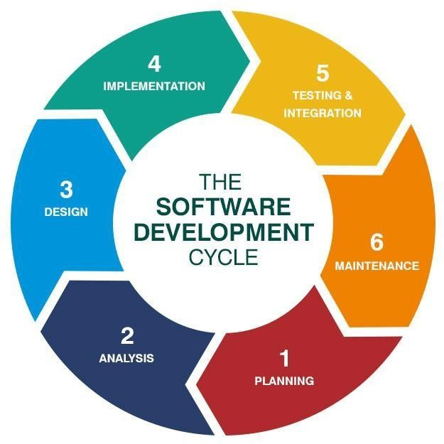

## Process Description

Gantt charts mainly used to allocate resources to activities. The resources allocated to activities include staff, hardware, and software. Gantt charts (named after its developer Henry Gantt) are useful for resource planning. A Gantt chart is special type of bar chart where each bar represents an activity. The bars are drawn along a timeline. The length of each bar is proportional to the duration of the time planned for the corresponding activity.

Gantt chart is a project scheduling technique. Progress can be represented easily in a Gantt chart, by coloring each milestone when completed. The project will start in the month of January and end after 4 months at the beginning of April.

# PROJECT MODEL USED

#### Iterative Enhancement Model

* This model has the same phases as the waterfall model, but with fewer restrictions. Generally, the phases occur in the same order as in the waterfall model, but they may be conducted in several cycles.
* Useable product is released at the end of the each cycle, with each release providing additional functionality. Customers and developers specify as many requirements as possible and prepare a SRS document. Developers and customers then prioritize these requirements. Developers implement the specified requirements in one or more cycles of design, implementation and test based on the defined priorities.

The procedure itself consists of the initialization step, the iteration step, and the Project Control List. The initialization step creates a base version of the system. The goal for this initial implementation is to create a product to which the user can react. It should offer a sampling of the key aspects of the problem and provide a solution that is simple enough to understand and implement easily. To guide the iteration process, a project control list is created that contains a record of all tasks that need to be performed. It includes such items as new features to be implemented and areas of redesign of the existing solution. The control list is constantly being revised as a result of the analysis phase.

The iteration involves the redesign and implementation of iteration is to be simple, straightforward, and modular, supporting redesign at that stage or as a task added to the project control list. The level

of design detail is not dictated by the iterative approach. In a light-weight iterative project the code may represent the major source of [documentation](http://en.wikipedia.org/wiki/Software_documentation) of the system; however, in a critical iterative project a formal [Software Design Document](http://en.wikipedia.org/wiki/Software_Design_Document) may be used. The analysis of an iteration is based upon user feedback, and the program analysis facilities available. It involves analysis of the structure, modularity, [usability,](http://en.wikipedia.org/wiki/Usability) reliability, efficiency, & achievement of goals. The project control list is modified in light of the analysis results.

### PHASES:

Incremental development slices the system functionality into increments (portions). In each increment, a slice of functionality is delivered through cross- discipline work, from the requirements to the deployment. The unified process groups increments/iterations into phases: inception, elaboration, construction, and transition.

* Inception identifies project scope, requirements (functional and non-functional) and risks at a high level but in enough detail that work can be estimated.
* Elaboration delivers a working architecture that mitigates the top risks and fulfills the non- functional requirements.
* Construction incrementally fills-in the architecture with production-ready code produced from analysis, design, implementation, and testing of the functional requirements.
* Transition delivers the system into the production operating environment.

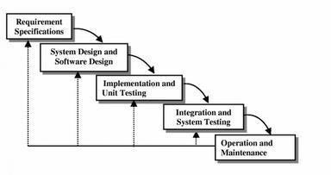

## ER-Diagram Introduction:

I[n software engineering, an](http://en.wikipedia.org/wiki/Software_engineering) entity-relationship model (ERM) is an abstract and conceptual representation of [data.](http://en.wikipedia.org/wiki/Data) Entity-relationship modeling is a [database](http://en.wikipedia.org/wiki/Database_model) [modeling](http://en.wikipedia.org/wiki/Database_model) [method,](http://en.wikipedia.org/wiki/Database_model) used to produce a type [of conceptual schema](http://en.wikipedia.org/wiki/Conceptual_schema) o[r semantic data model of](http://en.wikipedia.org/wiki/Semantic_data_model) a system, often [a relational database, a](http://en.wikipedia.org/wiki/Relational_database)nd its require[ments in a top-down](http://en.wikipedia.org/wiki/Top-down) fashion. Diagrams created by this process are called entity-relationship diagrams, ER diagrams, or ERDs. ER Diagrams depicts relationship between data objects. The attribute of each data objects noted in the entity-relationship diagram can be described using a data object description. Entity relationship diagram is very basic, conceptual model of data and it is fundamental to the physical database design. This analysis is then used to organize data as relations, normalizing relations, and obtaining a Relational database.

The entity-relationship model for data uses three features to describe data. These are:

1. Entities which specify distinct real-world items in an application.
2. Relationship, which connect entities and represent meaningful dependencies between them.
3. Attributes which specify properties of entities & relationships.

## E-R Diagram

* + - 1. **Data Flow Diagram**

#### Introduction:

DFD is an acronym for the word Data Flow Diagram. DFD is ppictorial representation of the system. DFD is a graphical representation of the ―flow of data through the information system. DFD are also used for the visualization of data processing (structured design). ADFD provides no information about the timings of the process, or about whether process will operate in parallel or sequence. DFD is an important technique for modeling system’s high-level detail by showing how input data is transformed to output results through a sequence of functional transformations. DFD reveal relationships among between the various components in a program or system. The strength of DFD lies in the fact that using few symbols we are able to express program design in an easier manner. ADFD can be used to represent the following:-

* External Entity sending and receiving data. Process that changes the data.
* Flow of data within the system. Data Storage locations.

#### Uses of DFD:

The main uses of data flow diagrams are as follows: -

DFD is a method of choice for representation of showing f information through a system because of the following reasons:-

* DFDs are easier to understand: - by technical and non-technical audiences.
* DFDs can provide a high-level system over view, complete with bound a rise and connections to other system.
* DFDs can provide a detailed representation of system components.

1. **Level DFD**

Request

for Login

Request for

Registration

Restaurant Management

System

Response

Response

ADMIN

USER

1. **Level DFD**

**­**

Generate

Shopping Cart

Restaurant

Management

System

Generate

Product Cart

Generate System User Report

System User Management

Check user login details

Login Management

Generate Shipment Report

Shipment Management

Product Management

Shopping Cart Management

Category

Management

Order Management

# SOFTWARE HARDWARE REQUIREMENT SPECIFICATION

A requirements specification for a software system is a complete description of the behavior of a system to be developed and it includes a set of use cases that describe all the interactions the users will have with the software. In addition to use cases, the SRS also contains non-functional requirements.

Non-functional requirements are requirements which impose constraints on the design or implementation (such as performance engineering requirements, quality standards, or design constraints). Requirements are a sub-field of software engineering that deals with the elicitation, analysis, specification, and validation of requirements for software.

The software requirement specification document enlists all necessary requirements for project development. To derive the requirements, we need to have clear and thorough understanding of the products to be developed. This is prepared after detailed communications with project team and the customer.

### SERVER-SIDE HARDWARE REQUIREMENT:

* AMD Althorn 64 with processor speed 2.8 or more
* 256 DDR Ram
* 40 GB Hard disks
* Network Interface card
* IIS
* CD-Drive

### SERVER-SIDE SOFTWARE REQUIREMENT:

* Windows
* Python 3.7 and PyCharm IDE 2021.3
* SQLite

### CLIENT-SIDE HARDWARE REQUIREMENT:

* Processor Dual core-based computer
* 2 GB Minimum RAM
* 20 GB HDD
* 100 Mbps LAN
* Web Browser

**TO DEVELOP THIS PROJECT THE VARIOUS SOFTWARE RESOURCES ARE USED.**

* Front End -HTML-CSS & Bootstrap
* Back End -SQLite
* Web Server -Apache Server
* Technology -Python technology
* Code-Behind Language -Python
* IDE -PyCharm

# SUPPORT AND MAINTENANCE: -

One-year free support for rectifying system bugs including front end and beck end will be provided. During warranty period Software Engineers will be responsible for removing bugs and improving it. After one year support can be extended @ 20% of the total product deployment cost.

# SYSTEM DESIGN APPROACH

#### Top– Down designing:

The top - down designing approach started with major components of the system. It is a stepwise refinement which starts from an abstract design, in each steps the design is refined two or more concrete levels until we reach a level where no – more refinement is possible or not needed.

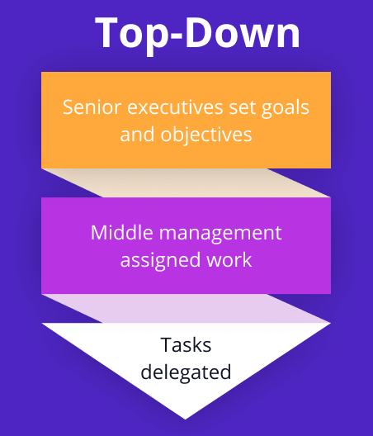

#### Bottom – Up designing:

In bottom – up designing the most basic and primitive components are designed first, and we proceed to higher level components. We work with layers of abstractions and abstraction are implemented until the stage is reached where the operations supported by the layer is complete.

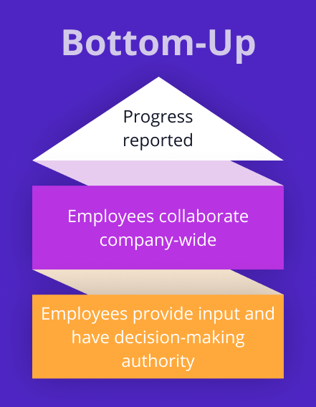

#### Following Approach:

In this project we are following **Mixed Approach** i.e. A combination of top – down and bottom – up. We are developing some of the components using top – down designing approach (e.g., the Webpages) and some components in bottom – up designing approach (e.g., the middle tier classes).

# BACKEND DESIGN

* + - 1. **Description of Classes and Methods (model.py)**
         1. **VIEWS.PY**

1. from django.shortcuts import render  
   from django.http import HttpResponse  
   from datetime import datetime  
   from django.db import connection  
   from .models import *  
   # Create your views here.  
     
   def index(request):  
    data=tbl_category.objects.all().order_by('-id')[**0**:**12**]  
    pdata=tbl_product.objects.all().order_by('-discount_price')[**0**:**12**]  
    sdata=tbl_slider.objects.all().order_by('-id')[**0**:**3**]  
    md={"cdata":data**,**"productdata":pdata**,**"sliderdata":sdata}  
     
    return render(request**,**'index.html'**,**md)  
     
   def foods(request):  
    cid=request.GET.get('pid')  
    if cid is not None:  
    pdata=tbl_product.objects.all().filter(category=cid)  
    else:  
    pdata = tbl_product.objects.all().order_by('-id')  
     
    cdata=tbl_category.objects.all().order_by('-id')  
     
    mydict={"categorydata":cdata**,**"productdata":pdata}  
    return render(request**,**'foods.html'**,**mydict)  
     
   def home(request):  
    return render(request**,**'index.html')  
     
   def about(request):  
    return render(request**,**'about.html')  
     
   def FAQs(request):  
    return render(request**,**'FAQs.html')  
     
   def register(request):  
    if request.method=="POST":  
    name=request.POST.get('name')  
    email=request.POST.get('email')  
    passwd=request.POST.get('passwd')  
    address=request.POST.get('address')  
    mobile=request.POST.get('mobile')  
    city=request.POST.get('city')  
    pincode=request.POST.get('pincode')  
    picture=request.FILES['fu']  
    x=tbl_register.objects.all().filter(email=email).count()  
    if x==**1**:  
    return HttpResponse("<script>alert('You are already registered..');location.href='/register/'</script>")  
    else:  
    tbl_register(name=name**,**email=email**,**password=passwd**,**address=address**,**mobile=mobile**,**city=city**,**pincode=pincode**,**picture=picture).save()  
    return HttpResponse("<script>alert('Thanks for Register with us...');location.href='/register/'</script>")  
     
    return render(request**,**'register.html')  
     
   def login(request):  
    if request.method=="POST":  
    email=request.POST.get('userid')  
    passwd=request.POST.get('passwd')  
    x=tbl_register.objects.all().filter(email=email**,**password=passwd).count()  
    if x==**1**:  
    y=tbl_register.objects.all().filter(email=email)  
    request.session['userpic']=str(y[**0**].picture)  
    request.session['username']=str(y[**0**].name)  
    request.session['user']=email  
    cartitems=tbl_cart.objects.all().filter(userid=email).count()  
    request.session['cartitems']=cartitems  
    return HttpResponse("<script>alert('Congratulation You are loggedin successfully...');location.href='/login/';</script>")  
    else:  
    return HttpResponse("<script>alert('Your userid or password is incorrect try again...');location.href='/login/';</script>")  
     
    return render(request**,**'login.html')  
     
   def contact(request):  
    mydict={}  
    if request.method=="POST":  
    a=request.POST.get('name')  
    b=request.POST.get('email')  
    c=request.POST.get('mobile')  
    d=request.POST.get('subject')  
    e=request.POST.get('msg')  
    contactus(Name=a**,**Email=b**,**Mobile=c**,**Subject=d**,**Message=e).save()  
    return HttpResponse("<script>alert('Data saved successfully');location.href='/contact/'</script>")  
     
    #mydict={"name":a,"email":b,"mobile":c,"subject":d,"msg":e}  
    return render(request**,**'contact.html'**,**mydict)  
     
   def booktable(request):  
    if request.method=="POST":  
    name=request.POST.get('name')  
    email=request.POST.get('email')  
    mobile=request.POST.get('mobile')  
    pepole=request.POST.get('pepole')  
    bdate=request.POST.get('bdate')  
    btime=request.POST.get('btime')  
    ftype=request.POST.get('foodtype')  
    etype=request.POST.get('eventtype')  
    tbl_booktable(name=name**,**email=email**,**mobile=mobile**,**no_of_pepole=pepole**,**date_of_booking=bdate**,**time_of_booking=btime**,**type_of_food=ftype**,**type_of_event=etype**,**booking_date=datetime.now().date()).save()  
    return HttpResponse("<script>alert('Your Table has booked successfully...!❤️');location.href='/booktable/'</script>")  
    return render(request**,**'booktable.html')  
     
   def logout(request):  
    if request.session.get('user'):  
    del request.session['user']  
    return HttpResponse("<script>alert('You are logged out successfully...');location.href='/login/'</script>")  
    return render(request**,**'logout.html')  
     
   def cart(request):  
    user=request.session.get('user')  
    if user:  
    pid=request.GET.get('pid')  
    pimage=request.GET.get('pimage')  
    pprice=float(request.GET.get('pprice'))  
    pname=request.GET.get('pname')  
    pquantity=int(request.GET.get('pquantity'))  
    total_price=pprice  
    if pquantity>**0**:  
    tbl_cart(userid=user**,**product_id=pid**,**product_image=pimage**,**product_price=pprice**,**quantity=pquantity**,**total_price=total_price**,**product_name=pname**,**added_date=datetime.now().date()).save()  
    cartitems=tbl_cart.objects.all().filter(userid=user).count()  
    request.session['cartitems']=cartitems  
    return HttpResponse("<script>alert('Your selected Item is added successfully in Cart...');location.href='/index/'</script>")  
    else:  
    return HttpResponse("<script>alert('Please Increase your item Quantity...');location.href='/index/'</script>")  
     
    return render(request**,**'cart.html')  
     
   def myprofile(request):  
    user=request.session.get('user')  
    uinfo=""  
    if user:  
    uinfo=tbl_register.objects.all().filter(email=user)  
    if request.method=="POST":  
    name=request.POST.get('name')  
    mobile=request.POST.get('mobile')  
    address=request.POST.get('address')  
    city=request.POST.get('city')  
    pincode=request.POST.get('pincode')  
    passwd=request.POST.get('passwd')  
    cpasswd=request.POST.get('cpasswd')  
    picture=request.FILES['fu']  
    if passwd==cpasswd:  
    tbl_register(email=user**,**name=name**,**mobile=mobile**,**address=address**,**city=city**,**pincode=pincode**,**picture=picture**,**password=passwd).save()  
    y=tbl_register.objects.all().filter(email=user)  
    request.session['userpic']=str(y[**0**].picture)  
    request.session['username']=str(y[**0**].name)  
    return HttpResponse("<script>alert('Your Profile has updated successfully...!');location.href='/myprofile/'</script>")  
    else:  
    return HttpResponse("<script>alert('Your Confirm paasword is different...!');location.href='/myprofile/'</script>")  
    mydict={"userinfo":uinfo}  
    return render(request**,**'myprofile.html'**,**mydict)  
     
   def orderhistory(request):  
    oid=request.GET.get('oid')  
    user=request.session.get('user')  
    if user:  
    data1=tbl_order.objects.all().filter(userid=user**,**status="Pending")  
    data2=tbl_order.objects.all().filter(userid=user**,**status="Accepted")  
    data3=tbl_order.objects.all().filter(userid=user**,**status="Delivered")  
    if oid is not None:  
    tbl_order.objects.all().filter(id=oid).delete()  
    return HttpResponse("<script>alert('Your Order Has Been Canceled...');location.href='/orderhistory/'</script>")  
     
    mydict={"porder":data1**,**"aorder":data2**,**"dorder":data3}  
    return render(request**,**'orderhistory.html'**,**mydict)  
     
   def showcart(request):  
    user=request.session.get('user')  
    cid=request.GET.get('cid')  
    data=""  
    if user:  
    data=tbl_cart.objects.all().filter(userid=user).order_by('-id')  
    if cid is not None:  
    tbl_cart.objects.all().filter(id=cid).delete()  
    cartitems=tbl_cart.objects.all().filter(userid=user).count()  
    request.session['cartitems']=cartitems  
     
    return HttpResponse("<script>alert('Your Items has been deleted from Cart...!');location.href='/showcart/'</script>")  
    md={"cartdata":data}  
    return render(request**,**'showcartitems.html'**,**md)  
     
   def cartfood(request):  
    user=request.session.get('user')  
    if user:  
    pid=request.GET.get('pid')  
    pimage=request.GET.get('pimage')  
    pprice=float(request.GET.get('pprice'))  
    pname=request.GET.get('pname')  
    pquantity=int(request.GET.get('pquantity'))  
    total_price=pprice*pquantity  
    if pquantity>**0**:  
    tbl_cart(userid=user**,**product_id=pid**,**product_image=pimage**,**product_price=pprice**,**quantity=pquantity**,**total_price=total_price**,**product_name=pname**,**added_date=datetime.now().date()).save()  
    cartitems=tbl_cart.objects.all().filter(userid=user).count()  
    request.session['cartitems']=cartitems  
    return HttpResponse("<script>alert('Your selected Item is added successfully in Cart...');location.href='/foods/'</script>")  
    else:  
    return HttpResponse("<script>alert('Please Increase your Cart Item...');location.href='/foods/'</script>")  
     
    return render(request**,**'fcart.html')  
     
   def order(request):  
    user=request.session.get('user')  
    msg=request.GET.get('msg')  
    if user:  
    if msg is not None:  
    cursor=connection.cursor()  
    cursor.execute("insert into user_tbl_order(userid,product_id,product_name,product_image,product_price,product_quantity,total_price,status,order_date) select '"+str(user)+"',product_id,product_name,product_image,product_price,quantity,total_price,'Pending','"+str(datetime.now().date())+"' from user_tbl_cart where userid='"+str(user)+"'")  
    tbl_cart.objects.all().filter(userid=user).delete()  
    cartitems = tbl_cart.objects.all().filter(userid=user).count()  
    request.session['cartitems'] = cartitems  
    return HttpResponse("<script>alert('Your order placed successfully....');location.href='/orderhistory/'</script>")  
     
    return render(request**,**'order.html')  
     
   def portfolio(request):  
    return render(request**,**'portfolio.html')
   * + - 1. **MODELS.PY**
2. from django.db import models  
   from django.db.models import IntegerField  
     
     
   # Create your models here.  
     
   class contactus(models.Model):  
    Name=models.CharField(max_length=**50,**null=True)  
    Email=models.EmailField(max_length=**100,**null=True)  
    Mobile=models.CharField(max_length=**20,**null=True)  
    Subject=models.CharField(max_length=**200,**null=True)  
    Message=models.TextField(null=True)  
     
    def __str__(self):  
    return self.Name  
     
     
   class tbl_register(models.Model):  
    name=models.CharField(max_length=**50,**null=True)  
    email=models.EmailField(primary_key=True)  
    mobile=models.CharField(max_length=**20,**null=True)  
    password=models.CharField(max_length=**200,**null=True)  
    pincode=models.CharField(max_length=**20,**null=True)  
    city=models.CharField(max_length=**50,**null=True)  
    address=models.TextField(null=True)  
    picture=models.ImageField(upload_to="static/userpic/")  
     
     
   class tbl_category(models.Model):  
    product_category=models.CharField(max_length=**30,**null=True)  
    category_picture=models.ImageField(upload_to='static/category/'**,**null=True)  
    def __str__(self):  
    return self.product_category  
     
     
   class tbl_product(models.Model):  
    product_name=models.CharField(max_length=**100,**null=True)  
    category=models.ForeignKey(tbl_category**,**on_delete=models.CASCADE)  
    price=models.FloatField(null=True)  
    quantity=models.IntegerField  
    discount_price=models.IntegerField(null=True)  
    product_picture=models.ImageField(upload_to='static/product/'**,**null=True)  
     
     
   class tbl_slider(models.Model):  
    slider_picture=models.ImageField(upload_to='static/slider/'**,**null=True)  
    title=models.CharField(max_length=**200,**null=True)  
    description=models.TextField(null=True)  
     
     
   class tbl_cart(models.Model):  
    userid=models.CharField(max_length=**50,**null=True)  
    product_id=models.IntegerField()  
    product_image=models.CharField(max_length=**200,**null=True)  
    product_price=models.FloatField()  
    quantity=models.IntegerField()  
    total_price=models.FloatField()  
    product_name=models.CharField(max_length=**100,**null=True)  
    added_date=models.DateField(null=True)  
     
   class tbl_order(models.Model):  
    userid=models.CharField(max_length=**50,**null=True)  
    product_id=models.IntegerField()  
    product_name=models.CharField(max_length=**100,** null=True)  
    product_image=models.CharField(max_length=**200,**null=True)  
    product_price=models.FloatField()  
    product_quantity=models.IntegerField()  
    total_price=models.FloatField()  
    order_date=models.DateField(null=True)  
    status=models.CharField(max_length=**15,**null=True)  
     
     
   class tbl_booktable(models.Model):  
    name=models.CharField(max_length=**50,**null=True)  
    email=models.EmailField(max_length=**50,**null=True)  
    mobile=models.CharField(max_length=**20,**null=True)  
    no_of_pepole=models.IntegerField(null=True)  
    date_of_booking=models.CharField(max_length=**200,**null=True)  
    time_of_booking=models.CharField(max_length=**30,**null=True)  
    type_of_event=models.CharField(max_length=**50,**null=True)  
    type_of_food=models.CharField(max_length=**30,**null=True)  
    booking_date=models.DateField(max_length=**30,**null=True)

### APP LEVEL- URLS.PY

**from django.urls import path  
from . import views  
  
urlpatterns=[  
 path('',views.index),  
 path('index/',views.index),  
 path('foods/',views.foods),  
 path('about/',views.about),  
 path('faqs/',views.FAQs),  
 path('register/',views.register),  
 path('login/',views.login),  
 path('contact/',views.contact),  
 path('booktable/',views.booktable),  
 path('logout/',views.logout),  
 path('cart/',views.cart),  
 path('myprofile/',views.myprofile),  
 path('orderhistory/',views.orderhistory),  
 path('showcart/',views.showcart),  
 path('fcart/',views.cartfood),  
 path('order/',views.order),  
 path('portfolio/',views.portfolio),  
]**

### PROJECT LEVEL- URL.PY

***"""  
URL configuration for MyProject project.  
  
The `urlpatterns` list routes URLs to views. For more information please see:  
 https://docs.djangoproject.com/en/5.1/topics/http/urls/  
Examples:  
Function views  
 1. Add an import: from my_app import views  
 2. Add a URL to urlpatterns: path('', views.home, name='home')  
Class-based views  
 1. Add an import: from other_app.views import Home  
 2. Add a URL to urlpatterns: path('', Home.as_view(), name='home')  
Including another URLconf  
 1. Import the include() function: from django.urls import include, path  
 2. Add a URL to urlpatterns: path('blog/', include('blog.urls'))  
"""*from django.contrib import admin  
from django.urls import path,include  
  
urlpatterns = [  
 path('admin/', admin.site.urls),  
 path('',include('user.urls')),  
]**

# DATA MODELING

### LIST OF TABLES:

* + - * 1. **Group Table**

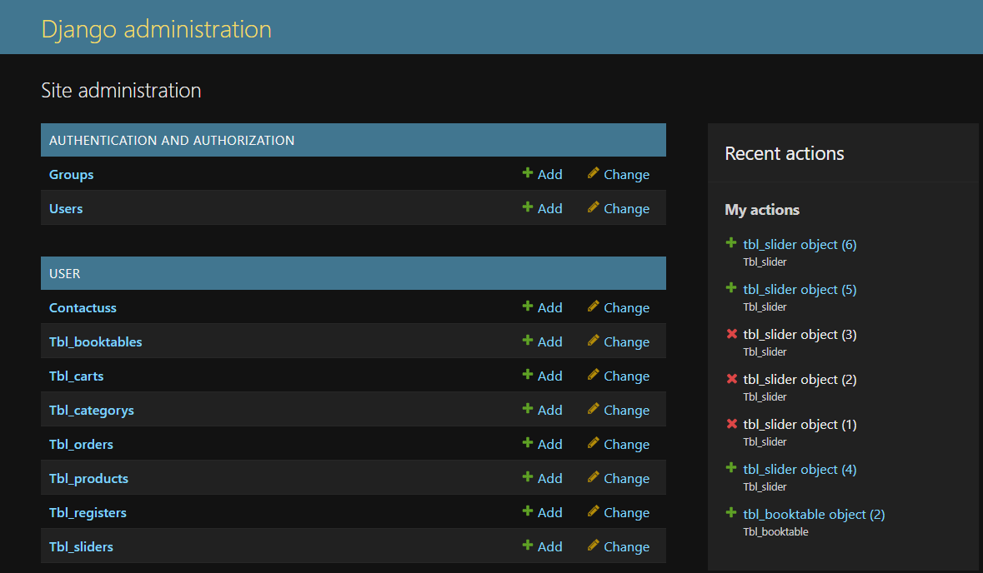

### STRUCTURE OF TABLES:

* + - * 1. **Group Table**

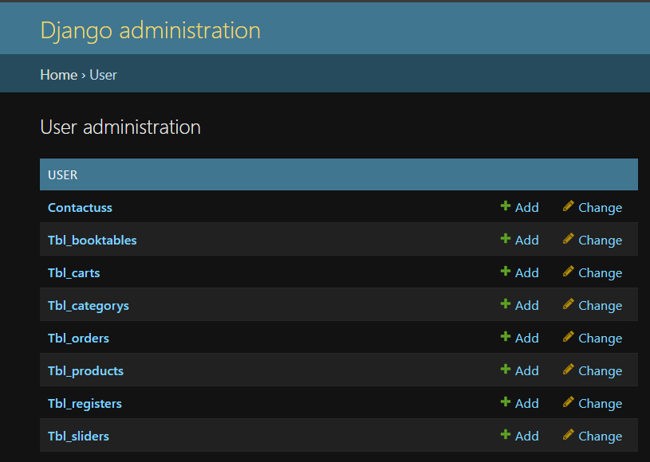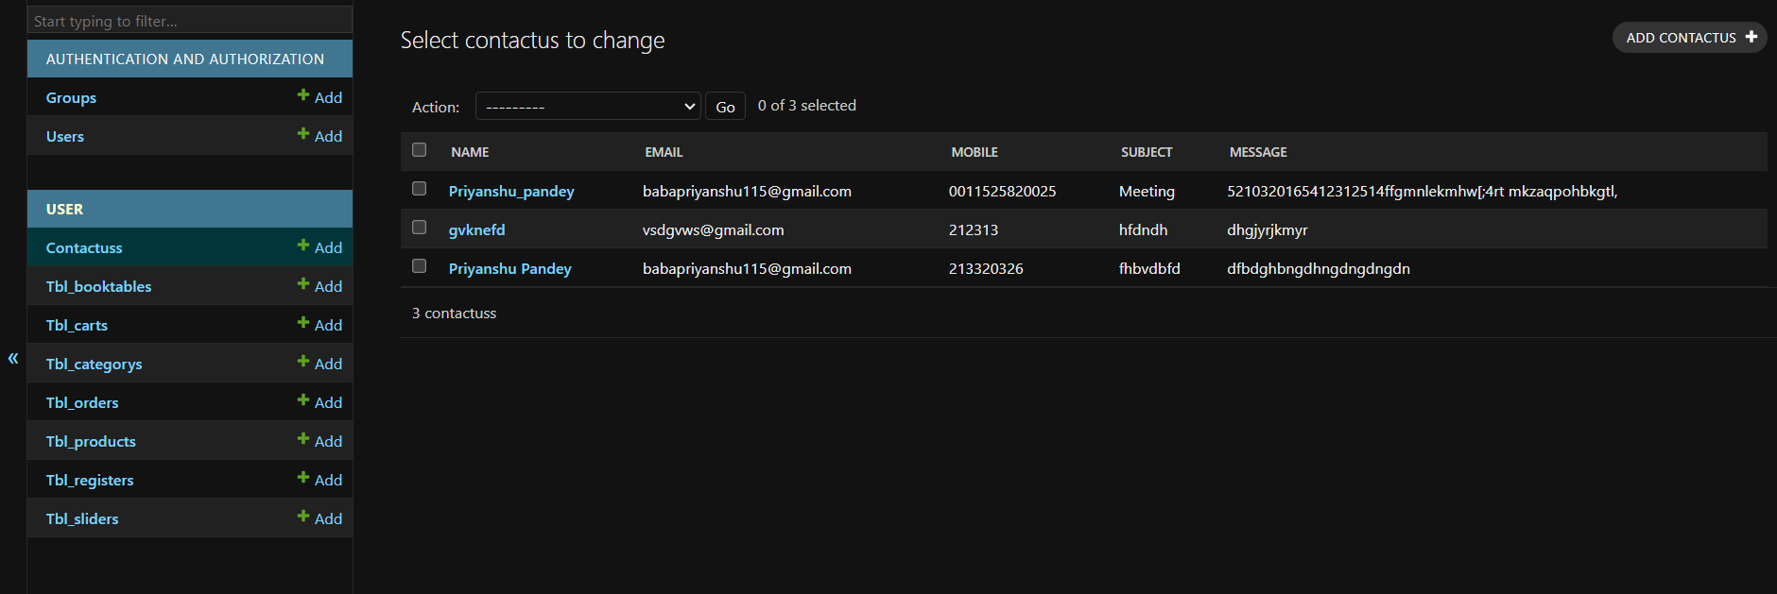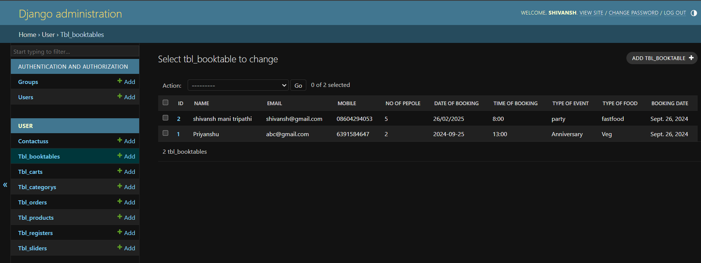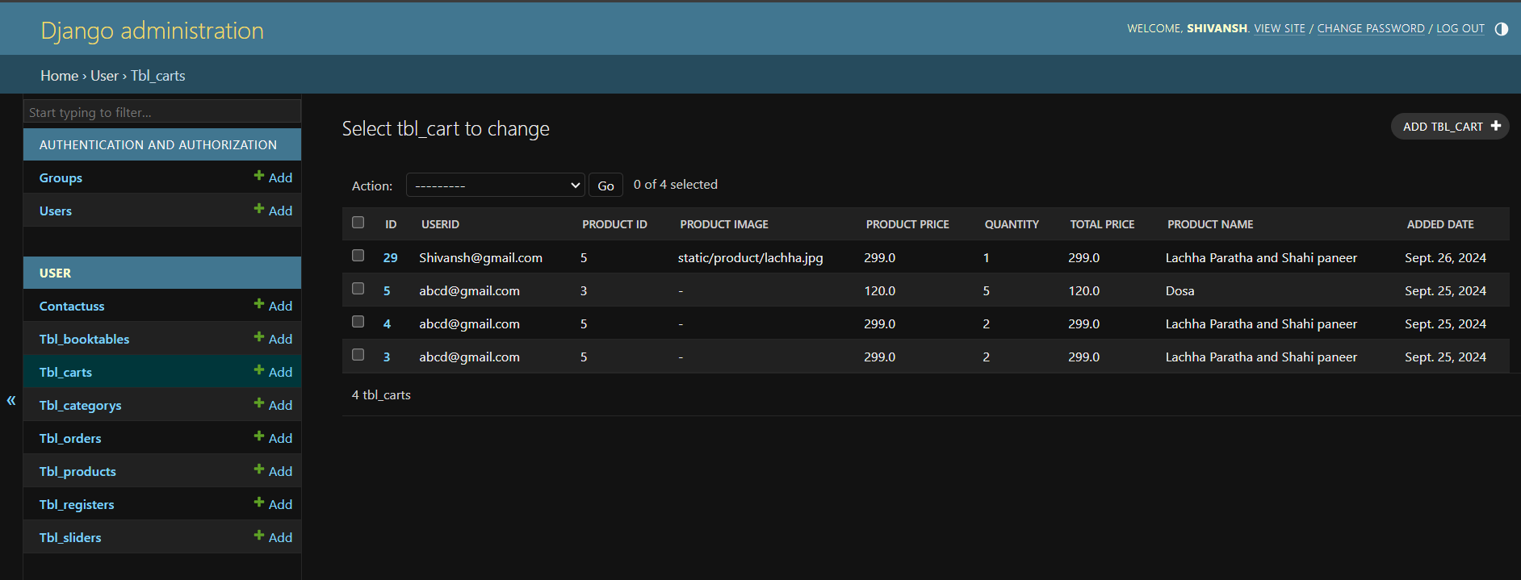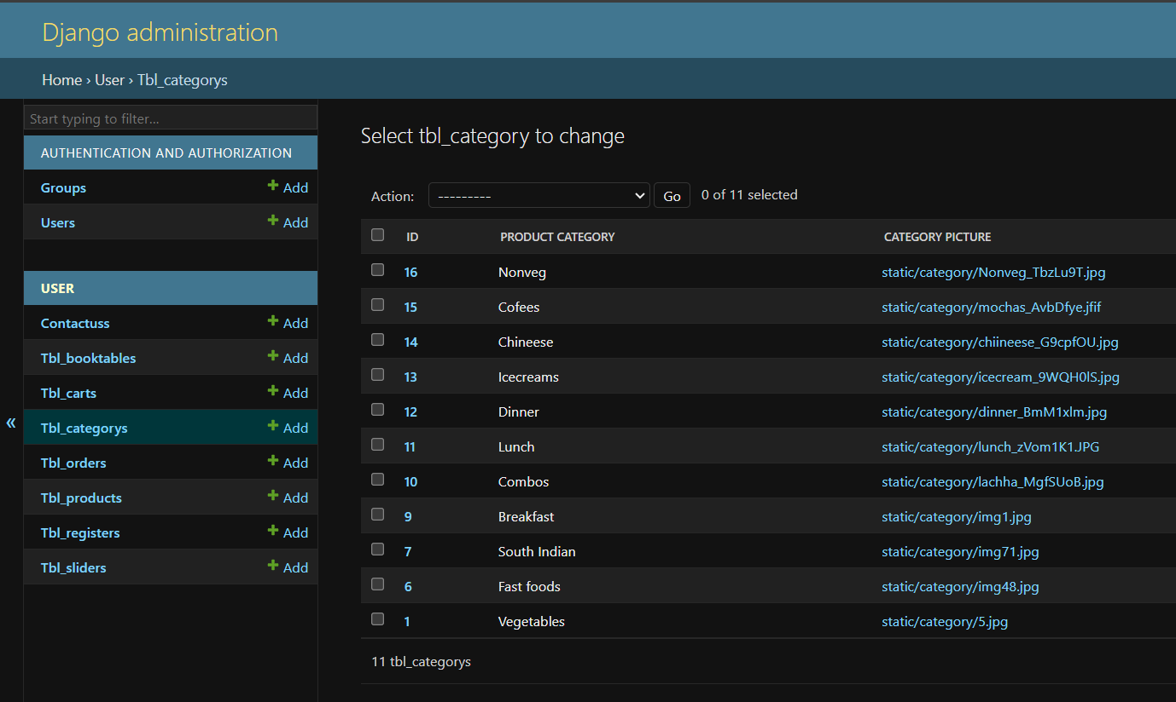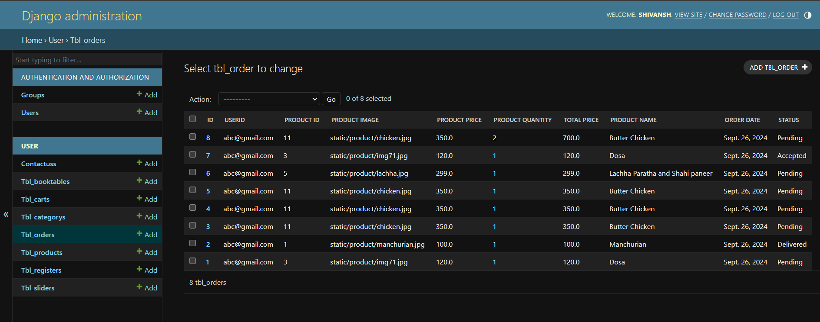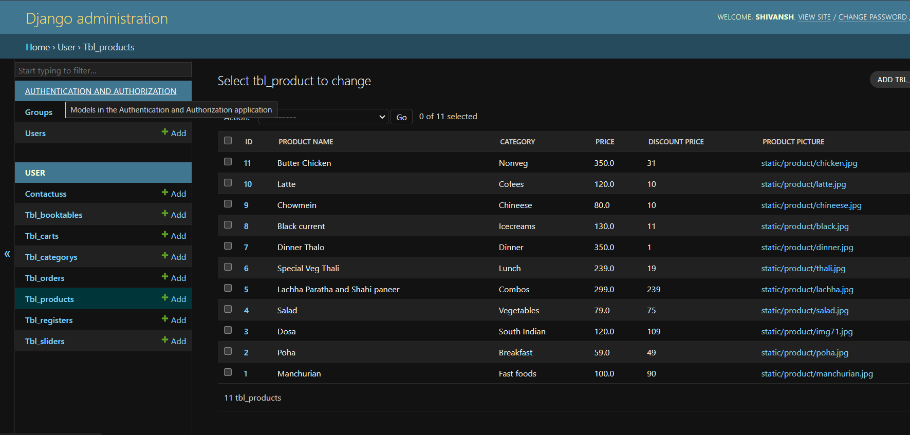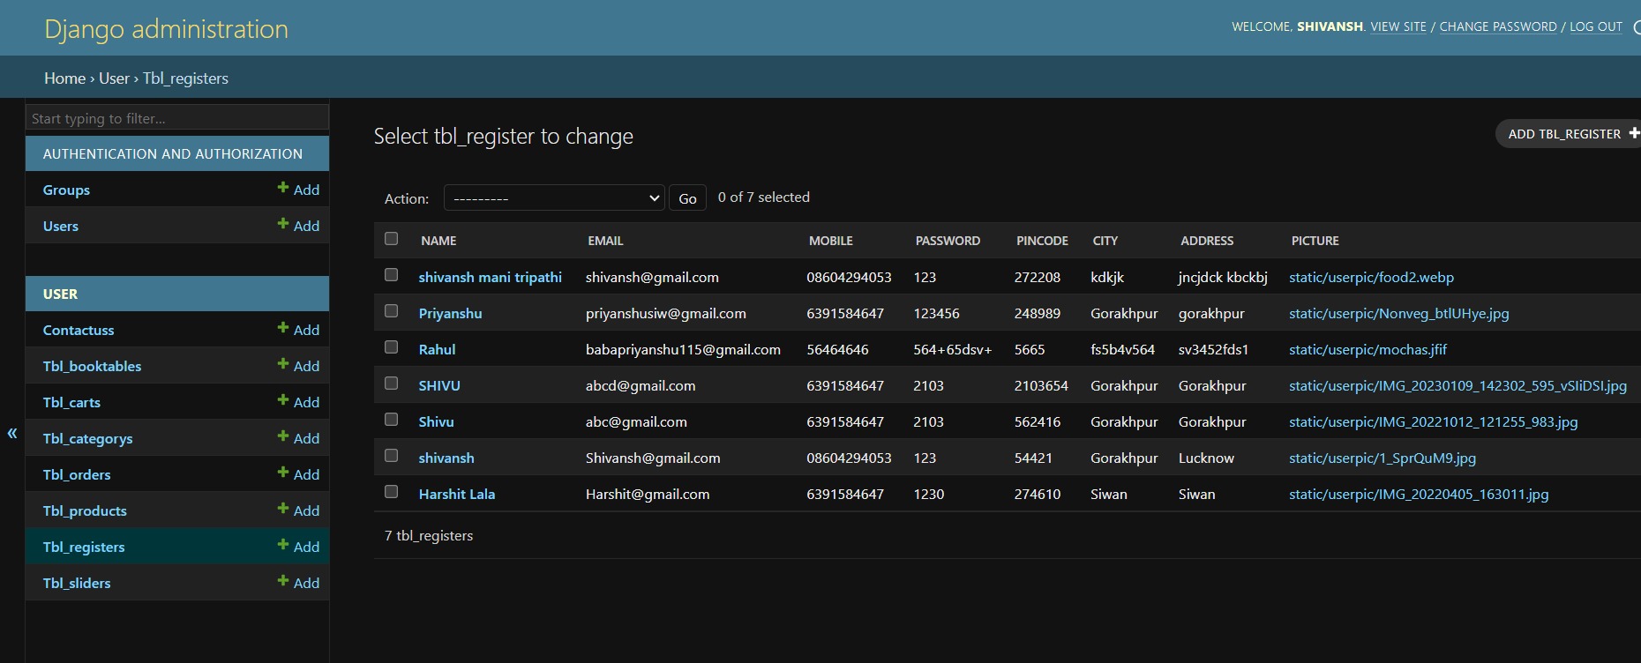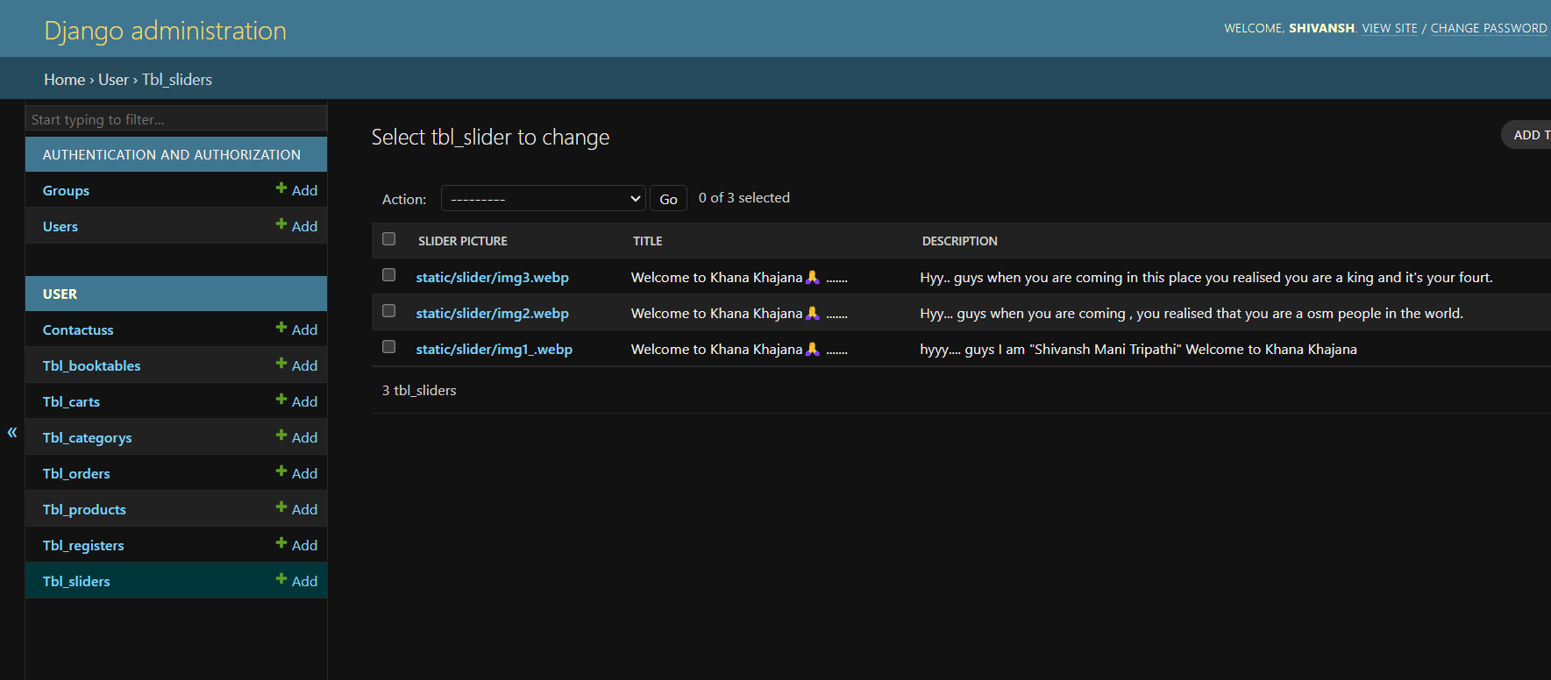

# TESTING

Testing is the integral part of any System Development Life Cycle insufficient and interested application tends to crash and result in loss of economic and manpower investment besides user’s dissatisfaction and downfall of reputation.

“Software Testing can be looked upon as one among much process, an organization performs, and that provides the last opportunity to correct any flaws in the developed system. Software Testing includes selecting test data that have more probability of giving errors.” The first step in System testing is to develop the plan that all aspect of system. Complements, Correctness, Reliability and Maintainability.

Software is to be tested for the best quality assurance, an assurance that system meets the specification and requirement for its intended use and performance.

System Testing is the most useful practical process of executing the program with the implicit intention of finding errors that makes the program fail.

## Types of Testing:

#### Black Box (Functional) Testing:

Testing against specification of system or component. Study it by examining its inputs and related outputs. Key is to devise inputs that have a higher likelihood of causing outputs that reveal the presence of defects. Use experience and knowledge of domain to identify such test cases. Failing this a systematic approach may be necessary. Equivalence partitioning is where the input to a program falls into a number of classes,

e.g., positive numbers vs. negative numbers. Programs normally behave the same way for each member of a class. Partitions exist for both input and output. Partitions may be discrete or overlap. Invalid data (i.e., outside the normal partitions) is one or more partitions that should be tested.

Internal System design is not considered in this type of testing. Tests are based on requirements and functionality.

This type of test case design method focuses on the functional requirements of the software, ignoring the control structure of the program. Black box testing attempts to find errors in the following categories:

* Incorrect or missing functions.
* Interface errors.
* Errors in data structures or external database access.
* Perform once errors.
* Initialization and termination errors.

#### White Box (Structural) Testing:

Testing based on knowledge of structure of component (e.g., by looking at source code). Advantage is that structure of code can be used to find out how many test case need to be performed. Knowledge of the algorithm (examination of the code) can be used to identify the equivalence partitions. Path testing is where the tester aims to exercise every independent execution path through the component. All conditional statements tested for both true and false cases. If a unit has n control statements, there will be up to 2nd possible paths through it. This demonstrates that it is much easier to test small program units than large ones. Flow graphs are a pictorial representation of the paths of control through a program (ignoring assignments, procedure calls and I/O statements).

Use flow graph to design test cases that execute each path. Static tools may be used to make this easier in programs that have a complex branching structure. Tools support. Dynamic program analyzers instrument a program with additional code. Typically, this will count how many times each statement is executed. At end print out report showing which statements have and have not been executed. Problems with flow graph derived testing:

* Data complexity could not take into account.
* We cannot test all paths in combination.
* In really only possible at unit and module testing stages because beyond that complexity is too high. This testing is based on knowledge of the internal logic of an application’s code. Also known as a Glass Box Testing. Internal software and code working should be known for this type of testing. Tests are based on coverage of code statements, branches, paths, conditions.

## Unit Testing:

Unit testing concentrates on each unit of the software as implemented in the code. This is done to check syntax and logical errors in programs. At this stage, the test focuses on each module individually, assuring that it functions properly as a unit. In our case, we used extensive white-box testing at the unit testing stage.

A developer and his team typically do the unit testing do the unit testing is done in parallel with coding; it includes testing each function and procedure.

#### Incremental Integration Testing:

Bottom-up approach for testing i.e., continuous testing of an application as new functionality is added; Application functionality and modules should be independent enough to test separately done by programmers or by testers.

#### Integration Testing:

Testing of integration modules to verify combined functionality after integration

Modules are typically code modules, individual applications, client and server and distributed systems.

#### Functional Testing:

This type of testing ignores the internal parts and focus on the output is as per requirement or not. Black box type testing geared to functionality requirements of an application

#### System Testing:

Entire system is tested as per the requirements. Black box type test that is based on overall requirement specifications covers all combined parts of a system.

#### End-to-End Testing:

Similar to system testing, involves testing of a complete application environment in a situation that mimics real-world use, such as interacting with a database, using network communications, or interacting with hardware, applications, or system if appropriate.

#### Regression Testing:

Testing the application as a whole for the modification in any module or functionality. Difficult to cover all the system in regression testing so typically automation tools are used for these testing types.

#### Acceptance Testing:

Normally this type of testing is done to verify if system meets the customer specified requirements. User or customers do this testing to determine whether to accept application.

#### Performance Testing:

Term often used interchangeably with “stress” and “load” testing, To check whether system meets performance requirements, used different performance and load tools to do this.

#### Alpha Testing:

In house virtual user environment can be created for this type of testing. Testing is done at the end of development. Still minor design changes may be made as a result of such testing.

#### Beta Testing:

Testing typically done by end-users or others. This is final testing before releasing application for commercial purpose.

## Input-output Forms(SCREENSHOTS AND CODING)

#### Project Screenshot

* + - * 1. **Home**

Index.html:-

{% extends 'base.html' %}  
{% load static %}  
  
{% block childpage %}  
<style>  
  
</style>  
  
  
 <div class="row slider" style="height:auto;background:transparent;">  
 <!-- Start slider -->  
 <div class="col-sm-12 p-0" >  
  
 <div id="carouselExampleCaptions" class="carousel slide carousel-fade" data-bs-ride="carousel">  
 <div class="carousel-indicators">  
 <button type="button" data-bs-target="#carouselExampleCaptions" data-bs-slide-to="0" class="active" aria-current="true" aria-label="Slide 1"></button>  
 <button type="button" data-bs-target="#carouselExampleCaptions" data-bs-slide-to="1" aria-label="Slide 2"></button>  
 <button type="button" data-bs-target="#carouselExampleCaptions" data-bs-slide-to="2" aria-label="Slide 3"></button>  
 </div>  
 <div class="carousel-inner">  
 {% for i in sliderdata %}  
 <div class="carousel-item active">  
 <img src="../{{i.slider_picture}}" style="background:transparent;max-height:500px;" class="d-block w-100" alt="...">  
 <div class="carousel-caption d-none d-md-block">  
 <h5>{{i.title}}</h5>  
 <p>{{i.description}}</p>  
 </div>  
 </div>  
 {% endfor %}  
 </div>  
 <button style="background:transparent;" class="carousel-control-prev" type="button" data-bs-target="#carouselExampleCaptions" data-bs-slide="prev">  
 <span class="carousel-control-prev-icon" aria-hidden="true"></span>  
 <span class="visually-hidden">Previous</span>  
 </button>  
 <button style="background:transparent;" class="carousel-control-next" type="button" data-bs-target="#carouselExampleCaptions" data-bs-slide="next">  
 <span class="carousel-control-next-icon" aria-hidden="true"></span>  
 <span class="visually-hidden">Next</span>  
 </button>  
</div>  
  
 </div>  
 <!-- End slider -->  
  
 </div>  
  
<!-- Heading start -->  
<div class="row mb-2 mb-5 mt-5" >  
 <div class="col-sm-1"></div>  
 <div class="col-sm-4">  
  
 </div>  
</div>  
<!-- Heading end -->  
  
<!-- Heading start -->  
<div class="row mb-2 mt-4" >  
 <div class="col-sm-1"></div>  
 <div class="col-sm-4">  
 <h2 class="m-0">Featured <b class="txt-color1">Categories</b></h2>  
 <hr>  
 </div>  
</div>  
<!-- Heading end -->  
 <div class="row category mt-3">  
  
 <div class="col-sm-1"></div>  
 <div class="col-sm-10">  
 <div class="row">  
 {% for x in cdata %}  
 <div class="col-sm-2 ">  
 <div class="card border-0 shadow mb-5 bg-body-teritary rounded " >  
 <img src="../{{x.category_picture}}" class="card-img-top" alt="..." style="180width:100 px;height:180px;aspect-ratio:3/4;">  
 <div class="card-body" style="background:#9268fc">  
 <a href="/foods?pid={{x.id}}" style="text-decoration:none;" class="text-dark fs-5">{{x.product_category}}</a>  
 </div>  
 </div>  
 </div>  
 {% endfor %}  
 </div>  
 </div>  
 <div class="col-sm-1"></div>  
 </div>  
  
 <!-- max discount start -->  
  
<!-- Heading start -->  
<div class="row mb-2 mt-4" >  
 <div class="col-sm-1"></div>  
 <div class="col-sm-4">  
 <h2 class="m-0">Best Offers | <b class="txt-color1">Meals</b></h2>  
 <hr>  
 </div>  
</div>  
<!-- Heading end -->  
 <div class="row maxdiscount">  
 <div class="col-sm-1"></div>  
 <div class="col-sm-10">  
  
 <div class="row">  
 {% for i in productdata %}  
 <div class="col-sm-3" >  
 <!-- start product -->  
  
  
  
 <div class="card border-0 shadow-lg p-3 mb-5 bg-body-teritary rounded">  
 <span class="position-absolute top-0 start-50 translate-middle badge rounded-pill bg-mycolor2">  
 <i class="fa-solid fa-indian-rupee-sign"></i>{{i.discount_price}}  
 <span class="visually-hidden"></span>  
 </span>  
 <img src="../{{i.product_picture}}" class="card-img-top " style="height:200px;">  
  
 <div class="card-body">  
 <h5 class="card-title">{{i.product_name}}</h5>  
 <i class="fa-solid fa-indian-rupee-sign"></i> {{i.discount_price}}  
 <!-- form start -->  
  
 <form action="/cart/">  
 <input type="hidden" name="pid" value="{{i.id}}"/>  
 <input type="hidden" name="pimage" value="{{i.product_picture}}"/>  
 <input type="hidden" name="pprice" value="{{i.price}}"/>  
 <input type="hidden" name="pname" value="{{i.product_name}}"/>  
  
 <!-- form end -->  
 <!-- cart count -->  
 <div class="input-group">  
 <i class="bg-info input-group-text fs-4" onclick="cminus{{i.id}}()">-</i>  
 <input type="text" class="form-control text-center fs-3" name="pquantity" id="carttxt{{i.id}}" value="0" readonly/>  
 <b class=" bg-info input-group-text fs-4" onclick="cplus{{i.id}}()">+</b>  
 </div>  
 <!-- end cart count -->  
  
 <br>  
 <input type="submit" class="btn text-light bg-success" value="ADD"/>  
  
</form>  
 </div>  
</div>  
 <!-- end product -->  
 </div>  
  
 <!-- javascript start -->  
<script>  
 var x{{i.id}}=0  
 function cplus{{i.id}}()  
 {  
 x{{i.id}}++;  
 document.getElementById("carttxt{{i.id}}").value=x{{i.id}}  
 }  
 function cminus{{i.id}}()  
 {  
 if(x{{i.id}}>0)  
 {  
 x{{i.id}}--;  
 document.getElementById("carttxt{{i.id}}").value=x{{i.id}}  
 }  
 }  
</script>  
<!-- javascript end -->  
  
 {% endfor %}  
 <div class="col-sm-1"></div>  
 </div>

<!-- why start -->  
  
 <div class="row">  
 <div class="col-sm-8">  
 <div class="p-2 mx-2 fs-5" style="font-weight:bold;color:black;background: linear-gradient(to bottom, #33ccff 0%, #ff99cc 100%);">Why Dine Devine ?</div>  
 <div class="row">  
 <div class="mt-3 fs-5" style="font-weight:bold;color:#4103fc;font-family:cursive;">Our Food Quality</div>  
 <div class="col-sm-12" style="font-family:sans-serif;letter-spacing:2px;">  
 Dinedevine is renowned for its exceptional food quality, which sets it apart in the culinary landscape. The restaurant prioritizes fresh, locally sourced ingredients, ensuring that each dish bursts with flavor and nutritional integrity.  
 </div>  
 </div>  
 <div class="row">  
 <div class="mt-3 fs-5" style="font-weight:bold;color:#4103fc;font-family:cursive;">Best Atmosphere</div>  
 <div class="col-sm-12" style="font-family:sans-serif;letter-spacing:2px;">  
 Dinedevine boasts an inviting atmosphere that perfectly complements its culinary offerings. The restaurant features a warm and sophisticated decor, with soft lighting and elegant furnishings that create a cozy yet upscale ambiance.  
 </div>  
 </div>  
 <div class="row">  
 <div class="mt-3 fs-5" style="font-weight:bold;font-family:cursive;color:#4103fc;">Low Cost</div>  
 <div class="col-sm-12" style="font-family:sans-serif;letter-spacing:2px;">  
 Dinedevine offers a selection of low-cost food options that don’t compromise on quality or flavor.  
 </div>  
 </div>  
 </div>  
 </div>  
  
 <!-- why end -->  
  
  
  
  
  
 <!-- Services start -->  
 <div class="container">  
 <div class="row heading text-center my-5 mx-auto">  
 <div class="col-sm-5 mx-auto text-center" >  
 <p style="background: linear-gradient(to bottom, #33ccff 0%, #ff99cc 100%);" class="fs-3 p-0 m-0"> <b style="color:green;">Our Services</b></p>  
 <hr />  
 </div>  
</div>  
 <div class="row my-5">  
 <div class="col-sm-3 text-center">  
 <i class="fa-solid fa-truck-fast fs-5 ic"></i>  
 <h2>Free Delivery</h2><b>on order above 199/-</b>  
 </div>  
 <div class="col-sm-3 text-center">  
 <i class="fa-solid fa-truck-fast fs-5 ic"></i>  
 <h2>Free Delivery</h2><b>on order above 199/-</b>  
 </div>  
 <div class="col-sm-3 text-center">  
 <i class="fa-solid fa-truck-fast fs-5 ic"></i>  
 <h2>Free Delivery</h2><b>on order above 199/-</b>  
 </div>  
 <div class="col-sm-3 text-center">  
 <i class="fa-solid fa-truck-fast fs-5 ic"></i>  
 <h2>Free Delivery</h2><b>on order above 199/-</b>  
 </div>  
 </div>  
 </div>  
 <!-- Service end -->  
  
  
  
  
 <!-- chef start -->  
 <div class="row" style="background: linear-gradient(to bottom, #33ccff 0%, #ff99cc 100%);margin-left:0;">  
 <div class="h1" style="color:rgb(56, 21, 83);" >Our Talented Chef <i class="fa-solid fa-utensils text-success"></i></div>  
 </div>  
 <div class="row chef my-4" style="margin-top:50px !important;">  
  
 <div class="col-sm-3 text-center" >  
  
 <div class="card mx-auto cardzoom" style="width: 18rem;">  
 <img src="{% static 'images/hero/img/team-1.jpg' %}" class="card-img-top" alt="..." height="350px" width="100px">  
 <div class="card-body">  
 <h5 class="card-title"><b>Mithailal</b></h5>  
 <h6 class="card-subtitle">Master Chef</h6>  
  
 </div>  
</div>  
  
 </div>  
  
  
 <div class="col-sm-3 text-center">  
 <div class="card mx-auto cardzoom" style="width: 18rem;">  
 <img src="{% static 'images/hero/img/team-2.jpg' %}" class="card-img-top" alt="..." height="350px" width="100px">  
 <div class="card-body">  
 <h5 class="card-title"><b>Gulablal</b></h5>  
 <h6 class="card-subtitle">Assistant Master Chef</h6>  
  
 </div>  
</div>  
 </div>  
 <div class="col-sm-3 text-center">  
 <div class="card mx-auto cardzoom" style="width: 18rem;">  
 <img src="{% static 'images/hero/img/team-3.jpg' %}" class="card-img-top" alt="..." height="350px" width="100px">  
 <div class="card-body">  
 <h5 class="card-title"><b>Champaklal</b></h5>  
 <h6 class="card-subtitle">Chef</h6>  
  
 </div>  
</div>  
 </div>  
 <div class="col-sm-3 text-center">  
 <div class="card mx-auto cardzoom" style="width: 18rem;">  
 <img src="{% static 'images/hero/img/team-4.jpg' %}" class="card-img-top" alt="..." height="350px" width="100px">  
 <div class="card-body">  
 <h5 class="card-title"><b>Manoj</b></h5>  
 <h6 class="card-subtitle">Chef</h6>  
  
 </div>  
</div>  
 </div>  
 </div>  
 <!-- chef page end -->  
 </div>  
{% endblock %}

base.html:-

<!DOCTYPE html>  
{% load static %}  
<html lang="en">  
<head>  
 <meta charset="UTF-8">  
 <title>FinalProject || DineDevine</title>  
 <link href="{% static 'images/logo/logo.png' %}" rel="icon">  
 <link href="{% static 'css/all.css' %}" rel="stylesheet">  
 <link href="{% static 'css/bootstrap.css' %}" rel="stylesheet">  
 <style>  
 body {  
background:lightgreen;  
 text-color:white;  
}  
 :root  
 {  
 --color1:green;  
 --color2:orange;  
 }  
 .bg-mycolor1  
 {  
 background:var(--color1) !important;  
 }  
 .bg-mycolor2  
 {  
 background:var(--color2) !important;  
 }  
 .txt-color1  
 {  
 color:var(--color1);  
 }  
 .txt-color1  
 {  
 color:var(--color2);  
 }  
 .bg-mycolor3  
 {  
 background:#03fc8c;  
  
 }  
 .g  
 {  
 box-shadow:0 0 50px blue;  
 }  
 .t1 a  
 {  
 text-decoration:none;  
 color:#212529;  
 }  
 .t1  
 {  
 font-size:15px;  
 }  
 .ico  
 {  
 border:1px solid #212529;  
 height:20px;  
 width:20px;  
 text-align:center;  
 line-height:20px;  
 transition:all .5s;  
 border-radius:2px;  
 }  
 .ico:hover  
 {  
 border:1px solid #31a650;  
 color:#31a650;  
 transform:rotate(360deg);  
 transition:all .5s;  
 }  
 #menu{  
 background:transparent !important;  
 }  
 #menu ul li a{  
 color:#000;  
 font-family:cursive;  
 }  
 .t3  
 {  
 background:transparent;  
 }  
  
  
 .ufooter  
 {  
 min-height:300px;  
 background:#edfced;  
 }  
 .ulinks a  
 {  
 text-decoration:none;  
 }  
 .oh h6  
 {  
 font-weight:bold;  
 color:tomato;  
 }  
 .ulinks h6  
 {  
 font-weight:bold;  
 color:tomato;  
 }  
 .add h6  
 {  
 font-weight:bold;  
 color:tomato;  
 }  
 /* About us section */  
  
 body {  
 font-family: Arial, Helvetica, sans-serif;  
 margin: 0;  
}  
  
html {  
 box-sizing: border-box;  
}  
  
*, *:before, *:after {  
 box-sizing: inherit;  
}  
  
.column {  
 float: left;  
 width: 33.3%;  
 margin-bottom: 16px;  
 padding: 0 8px;  
}  
  
.card {  
 box-shadow: 0 4px 8px 0 rgba(0, 0, 0, 0.2);  
 margin: 8px;  
}  
  
.about-section {  
 padding: 50px;  
 text-align: center;  
 background-color: #474e5d;  
 color: white;  
}  
  
.container {  
 padding: 0 16px;  
}  
  
.container::after, .row::after {  
 content: "";  
 clear: both;  
 display: table;  
}  
  
.title {  
 color: grey;  
}  
  
.button {  
 border: none;  
 outline: 0;  
 display: inline-block;  
 padding: 8px;  
 color: white;  
 background-color: #000;  
 text-align: center;  
 cursor: pointer;  
 width: 100%;  
}  
  
.button:hover {  
 background-color: #555;  
}  
  
@media screen and (max-width: 650px) {  
 .column {  
 width: 100%;  
 display: block;  
 }  
}  
 .cardzoom  
 {  
 transform:scale(1.0);  
 transition:2s;  
 }  
 .cardzoom:hover  
 {  
 transform:scale(1.1);  
 transition:all ease 2s;  
 box-shadow:0 0 3px #05eaff;  
 }  
  
 .ic  
 {  
 border-radius:50%;  
 border:1px solid black;  
 padding:15px;  
 }  
  
 .b .nav-item  
 {  
 text-color:black;  
 }  
 .b .nav-item:hover:not(.active) {  
 background-color: #05C4F9;  
 box-shadow:0 0 10px powderblue;  
 background:linea;  
 }  
 .b .nav-item a:active {  
background-color: #05C4F9;  
}  
 </style>  
</head>  
<body>  
<div class="container-fluid wrapper">  
 <div class="py-1 row t1 border-bottom border-success text-center bg-dark text-light">  
 <div class="col-sm-4">  
 <a href="/faqs/" class="text-light">FAQs</a> |  
 <a href="/about/" class="text-light">About us</a> |  
 <a href="/contact/" class="text-light">Contact & Support</a>  
 </div>  
 <div class="col-sm-4">  
 <i class="fa-solid fa-phone ico"></i>  
 +91 8604294053,+91 9919082048  
 </div>  
 <div class="col-sm-4 ">  
 <a target="_blank" href="https://www.facebook.com/" ><i class="text-light fa-brands fa-facebook ico"></i></a>  
 <a target="_blank" href="https://www.linkedin.com/ "><i class="text-light fa-brands fa-linkedin ico"></i></a>  
 <a target="_blank" href="https://www.instagram.com/ "><i class="text-light fa-brands fa-instagram ico"></i></a>  
 <a target="_blank" href="https://www.youtube.com/ "><i class="text-light fa-brands fa-youtube ico"></i></a>  
 <a target="_blank" href="https://www.twitter.com/ "><i class="text-light fa-brands fa-twitter ico"></i></a>  
 </div>  
 </div>  
 <div class="row t2 text-center py-3">  
 <div class="col-sm-4 fs-3 text-center ">  
 <h1 style="letter-spacing:1px;"><b> Khana </b> <b class="txt-color1 fs-1">Khajana</b> <i class="fa-solid fa-utensils text-success"></i></h1>  
 </div>  
 <div class="col-sm-4">  
 {% if request.session.user %}  
 <a href="/orderhistory/" style="background: linear-gradient(to bottom, #33ccff 0%, #ff99cc 100%);box-shadow:0 0 8px #07e2ed;" class="btn btn-sm text-light rounded-pill fs-5"><i class="fa-solid fa-clock-rotate-left"></i> Order History</a>  
 <a href="/myprofile/" style="background: linear-gradient(to bottom, #33ccff 0%, #ff99cc 100%);box-shadow:0 0 8px #07e2ed;" class="btn btn-sm text-light rounded-pill fs-5"><i class="fa-solid fa-user"></i> My Profile</a>  
 {% else %}  
 <h3 class="text-center" style="letter-spacing:1px;background: linear-gradient(to bottom, #33ccff 0%, #ff99cc 100%);"><b>Welcome to Dine Devine</b></h3>  
 {% endif %}  
 </div>  
 <div class="col-sm-4">  
 <a href="/showcart/" class="btn btn-sm" style="background: linear-gradient(to bottom, #33ccff 0%, #ff99cc 100%);height:30px;width:100px;">Cart <i class="fa-solid fa-bowl-food text-success"></i>  
 <i class="badge text-dark" style="font-size:14px;">  
 {% if request.session.user %}  
 {{request.session.cartitems}}  
 {% else %}  
 0  
 {% endif %}  
 </i>  
 </a>  
  
 {% if request.session.user %}  
 **&nbsp;**<img src="../{{request.session.userpic}}" height="50px" class="rounded-5 p-1">  
 <b>{{request.session.username}}</b>  
 {% else %}  
 <b><i class="fa-solid fa-user"></i>**&nbsp;** Guest User</b>  
 {% endif %}  
  
 </div>  
 </div>  
 <div class="row t3 sticky-top shadow-lg" style="min-height:40px;">  
  
 <div class="col-sm-7 m-0" >  
 <!-- Start menu -->  
  
 <nav class="navbar navbar-expand-lg navbar-light bg-light p-0" id="menu">  
 <button class="navbar-toggler" type="button" data-toggle="collapse" data-target="#navbarNav" aria-controls="navbarNav" aria-expanded="false" aria-label="Toggle navigation">  
 <span class="navbar-toggler-icon"></span>  
 </button>  
 <div class="collapse navbar-collapse" id="navbarNav">  
 <ul class="navbar-nav b" style="a:active : background-color: yellow;">  
 <li class="nav-item">  
 <a class="text-dark nav-link" href="/index/">**&nbsp;**Menus <i class="fa-solid fa-arrow-right-long"></i></a>  
 </li>  
 <li class="nav-item">  
 <a class="text-dark nav-link" href="/index/"><i class="fa-solid fa-house"></i> Home <span class="sr-only">(current)</span></a>  
 </li>  
 <li class="nav-item ">  
 <a class="text-dark nav-link" href="/foods/"><i class="fa-solid fa-burger"></i> Food</a>  
 </li>  
 <li class="nav-item">  
 <a class="text-dark nav-link" href="/about/"><i class="fa-regular fa-address-card"></i> About Us</a>  
 </li>  
 <li class="nav-item">  
 <a class="text-dark nav-link" href="/register/"><i class="fa-regular fa-registered"></i> Register</a>  
 </li>  
 <li class="nav-item">  
 <a class="text-dark nav-link" href="/contact/"><i class="fa-solid fa-phone"></i> Contact us</a>  
 </li>  
 <li class="nav-item">  
 <a class="text-dark nav-link" href="/faqs/"><i class="fa-solid fa-question"></i> FAQs</a>  
 </li>  
 <li class="nav-item">  
 {% if request.session.user %}  
 <a class="text-dark nav-link" href="/logout/"><i class="fa-solid fa-arrow-right-from-bracket"></i> Logout</a>  
 {% else %}  
 <a class="text-dark nav-link" href="/login/"><i class="fa-solid fa-right-to-bracket"></i> Login</a>  
 {% endif %}  
 </li>  
 <li class="nav-item">  
 <a class="text-dark nav-link" href="/booktable/"><i class="fa-solid fa-book"></i> Booktable</a>  
 </li>  
 </ul>  
 </div>  
</nav>  
  
 <!-- End menu -->  
 </div>  
 <div class="col-sm-5">  
 <div class="input-group">  
 <input type="search" name="search" placeholder="Search foods..." class=" border border-info" style="border-radius:10px 0 0 10px;width:500px;" />  
 <i class="bg-info input-group-text fs-4" ><i class="fa-solid fa-magnifying-glass"></i></i>  
  
 </div>  
 </div>  
 </div>  
  
 <div class="row">  
 <div class="col-sm-12 childpage mt-3" style="min-height:500px;">  
 {% block childpage %}  
  
 {% endblock %}  
 </div>  
 </div>  
</div>  
  
 <!-- about end -->  
  
 <!-- Footer start -->  
 <div class="row ufooter mt-3 text-bg-dark">  
 <div class="container">  
 <div class="row text-center" style="font-family:cursive; ">  
 <div Class= "col-sm-4 mt-1" >  
 <hr/>  
 <h5>KhanaKhajana.com</h5>  
 <hr/>  
  
 <img src="{% static 'image/logo.png' %}" style="height:180px;width:300px; margin-bottom:10px;">  
  
 </div>  
 <div class="col-sm-2 mt-1">  
 <hr/>  
 <h5>USEFUL LINKS</h5>  
 <hr/>  
 <br/>  
 <ul>  
 <li>Home</li>  
 <li>About Us</li>  
 <li>Blog Grid</li>  
 <li>Contact Us</li>  
 <li>Privacy Policy</li>  
 </ul>  
 </div>  
 <div class="col-sm-3 mt-1">  
 <hr/>  
 <h5> ADDRESS</h5>  
 <hr/>  
 <br/>  
 <ul>  
 <li>Near Gorakhnath Mandir </li>  
 <li>,besides of Gorakhnath Thana ,273209</li>  
 <li>Hotline: 8604294053 </li>  
 <li> Email: shivanshmanitripathi994@gmail.com</li>  
 <li> Email: shivtripathi994@gmail.com</li>  
 </ul>  
 </div>  
 <div class="col-sm-3 mt-1">  
 <hr/>  
 <h5> OPENING HOURS</h5>  
 <hr/>  
 <br/>  
 <ul>  
 <li>Monday:&nbsp &nbsp &nbsp &nbsp &nbsp 09:00 AM -22:00 PM</li>  
 <li>Tuesday:&nbsp &nbsp &nbsp &nbsp &nbsp 09:00 PM -22:00 AM </li>  
 <li>Wednesday:&nbsp &nbsp &nbsp &nbsp &nbsp 09:00 AM -22:00 PM</li>  
 <li>Thursday:&nbsp &nbsp &nbsp &nbsp &nbsp 08:00 AM -22:00 PM</li>  
 <li>Friday:&nbsp &nbsp &nbsp &nbsp &nbsp 09:00 AM -22:00 PM</li>  
 </ul>  
 </div>  
 </div>  
  
 </div>  
 </div>  
  
 <div class="row bfooter py-2" style="background:#31a650;font-family:cursive;">  
 <div class="col-sm-4 text-center">  
 <a href="#"><i class="fa-brands fa-linkedin ico mx-1 " style="border-radius:25px;border-color:black;border-style:dotted;color:#f7931e;"></i></a>  
 <a href="#"><i class="fa-brands fa-facebook ico mx-1" style="border-radius:25px;border-color:black;border-style:dotted;color:#f7931e;"></i></a>  
 <a href="#"><i class="fa-brands fa-instagram ico mx-1" style="border-radius:25px;border-color:black;border-style:dotted;color:#f7931e;"></i></a>  
 <a href="#"><i class="fa-brands fa-twitter ico mx-1" style="border-radius:25px;border-color:black;border-style:dotted;color:#f7931e;"></i></a>  
 <a href="#"><i class="fa-brands fa-youtube ico mx-1" style="border-radius:25px;border-color:black;border-style:dotted;color:#f7931e;"></i></a>  
 </div>  
 <div class="col-sm-4 text-center">  
 &#169 Developed by:<b class="txt-color2"><a href="/portfolio/"> Shivansh Mani Tripathi </a></b>  
 </div>  
 <div class="col-sm-4 text-center">  
 &#169 Techpile Technology pvt.ltd  
 </div>  
 </div>  
  
 <!-- bottom footer start -->

<script src="{% static 'js/bootstrap.bundle.js' %}"></script>  
<script src="https://code.jquery.com/jquery-3.5.1.slim.min.js"></script>  
 <script src="https://cdn.jsdelivr.net/npm/@popperjs/core@2.5.3/dist/umd/popper.min.js"></script>  
 <script src="https://stackpath.bootstrapcdn.com/bootstrap/4.5.2/js/bootstrap.min.js"></script>  
  
</body>  
</html>

Screen shoots:-

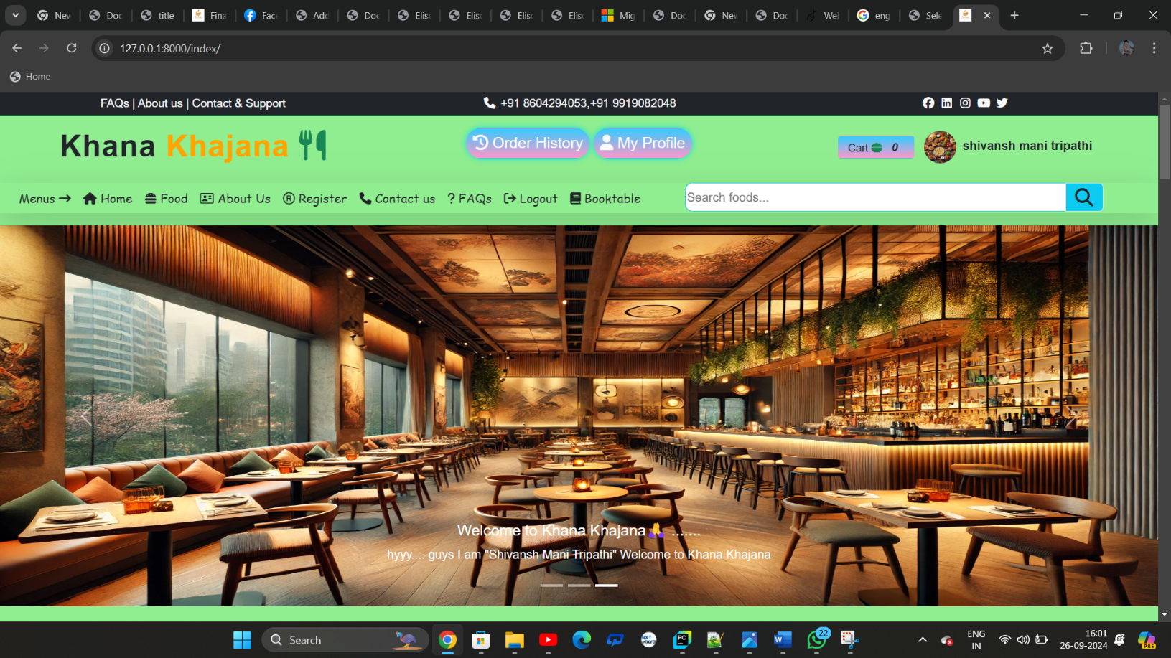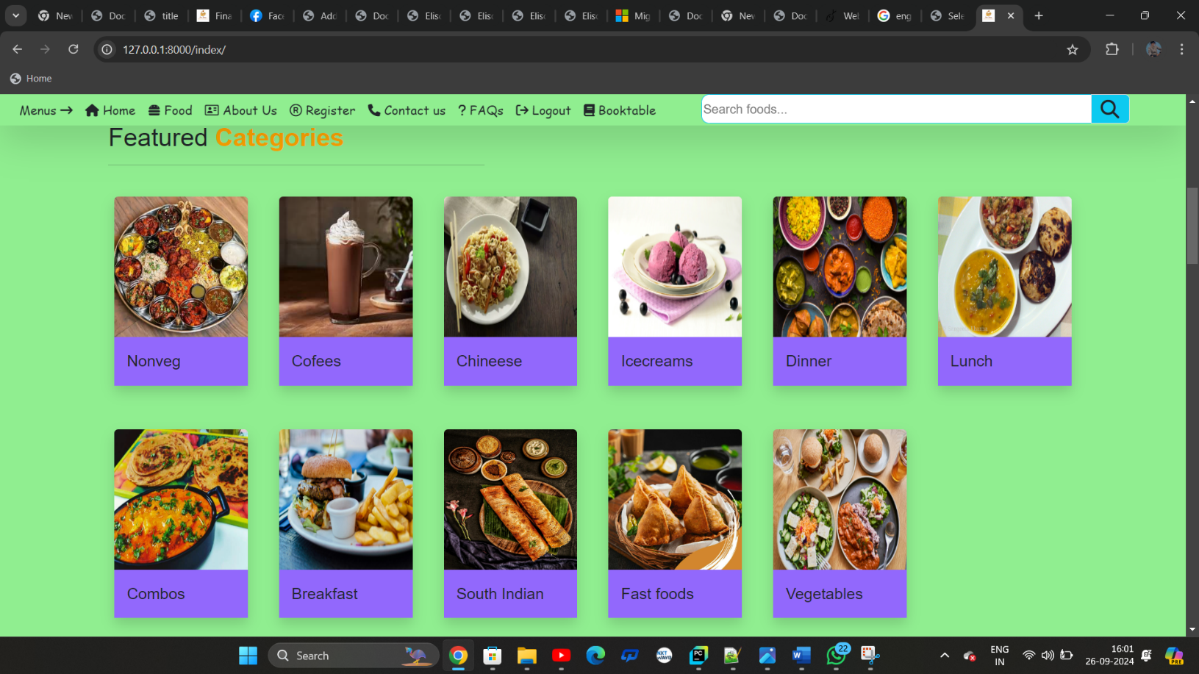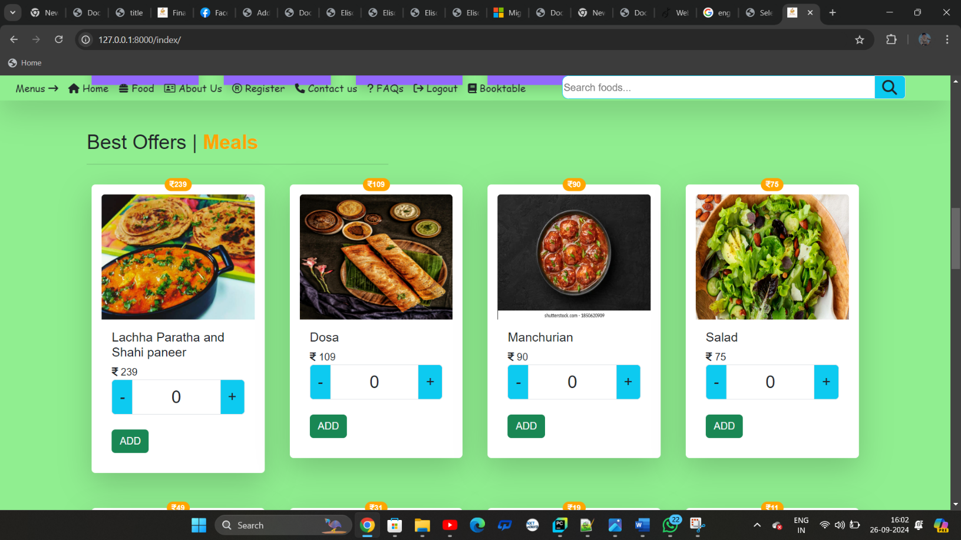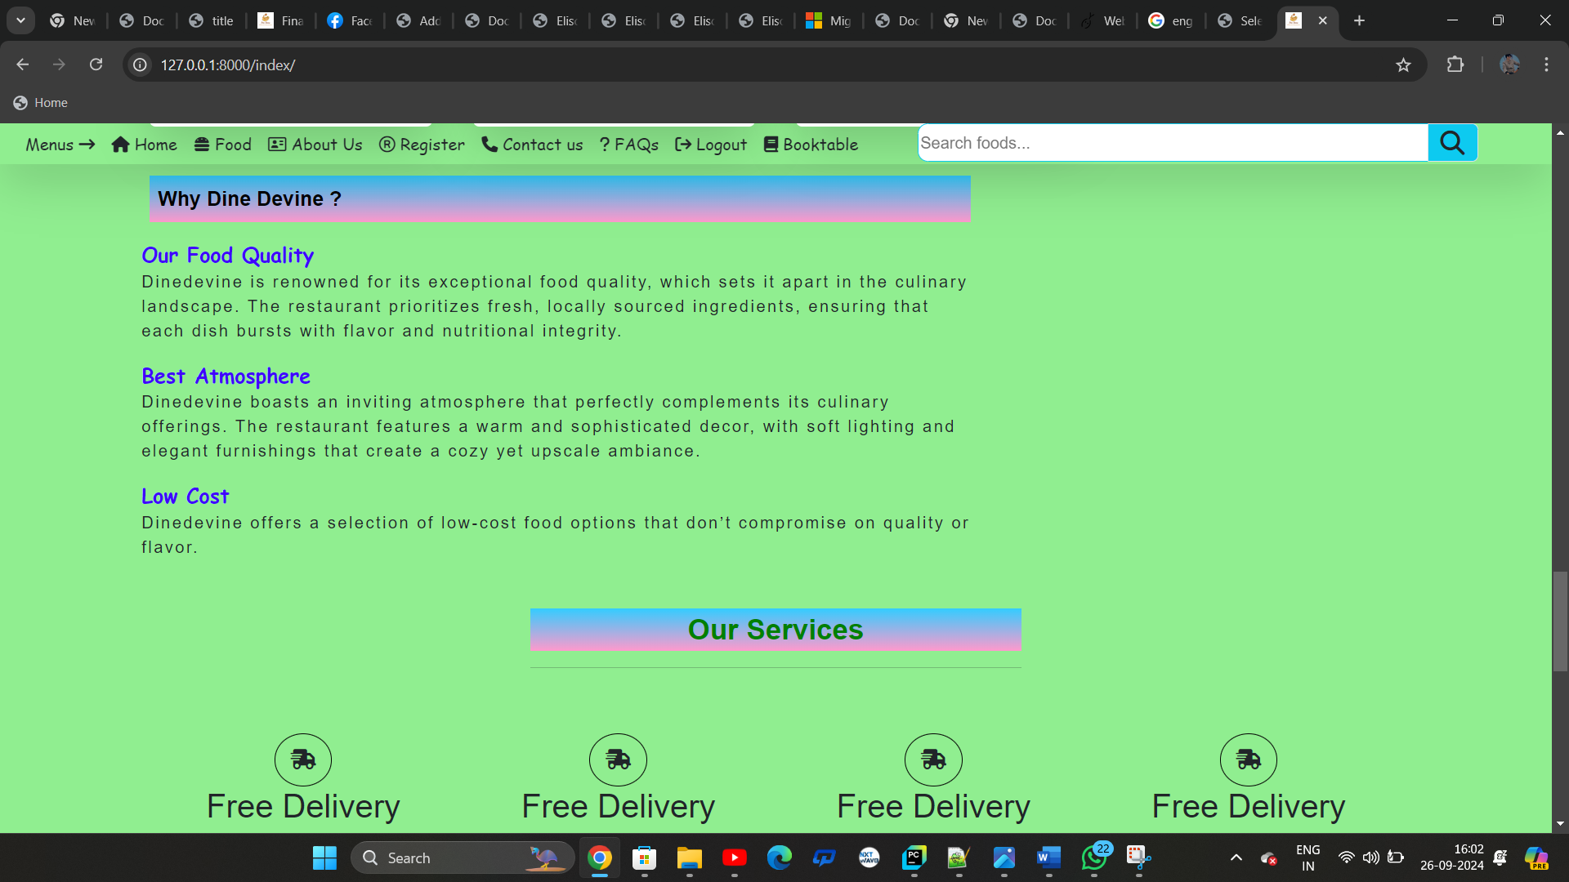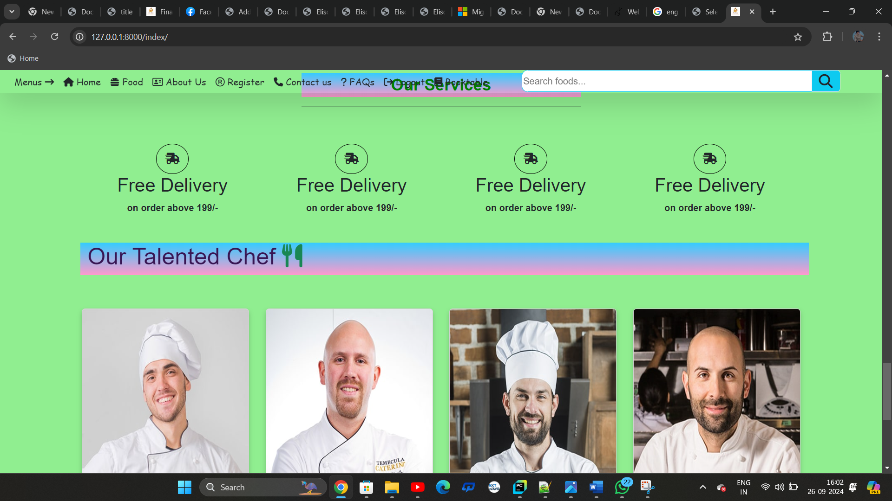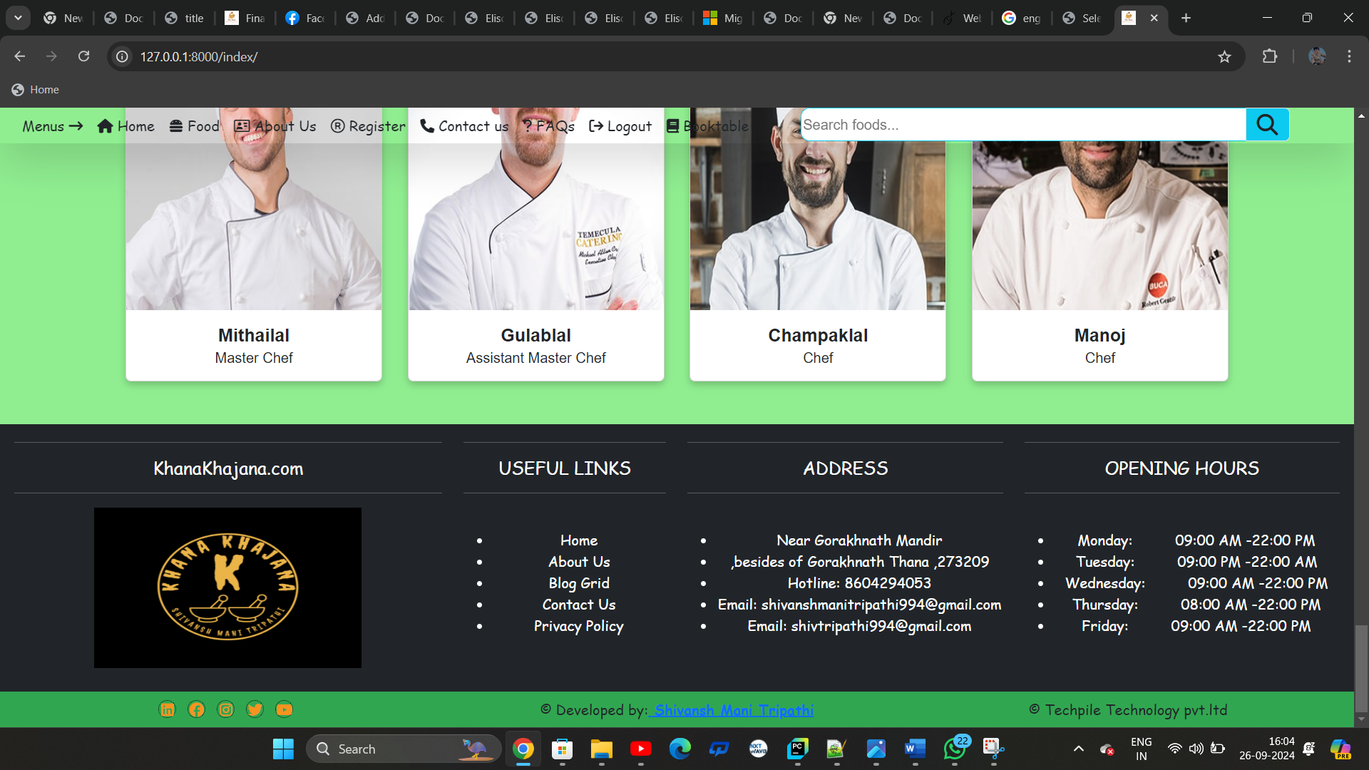

Foods:-

{% extends 'base.html' %}  
{% load static %}  
  
{% block childpage %}  
  
<!-- Heading start -->  
<div class="row mb-2 mt-4" >  
  
 <div class="col-sm-4">  
 <h2 class="m-0">Foods | <b class="txt-color1">Meals</b></h2>  
 <hr class="w-50">  
 </div>  
</div>  
<!-- Heading end -->  
  
<div class="row">  
 <div class="col-sm-3">  
 <ul class="list-group">  
 <li class="list-group-item text-light" style="background: linear-gradient(to bottom, #33ccff 0%, #ff99cc 100%);">Featured Categories <i class="fa-solid fa-layer-group"></i></li>  
 {% for x in categorydata %}  
 <img src="../{{x.category_picture}}" class="img-thumbnail" style="height:50px;width:50px;" />  
 <a href="/foods?pid={{x.id}}" style="text-decoration:none;color:#371245;font-family:cursive;" class=" fs-5"><b>{{x.product_category}}</b></a>  
  
 {% endfor %}  
 <li class="list-group-item text-light mt-3">  
 <a href="/foods/" style="text-decoration:none;color:#371245;font-family:cursive;" class="fs-5"><b>All Foods</b></a>  
 </li>  
 </ul>  
 </div>  
  
 <div class="col-sm-9">  
 <div class="row">  
  
 {% for i in productdata %}  
 <div class="col-sm-3" >  
 <!-- start product -->  
  
  
  
 <div class="card border-0 shadow-lg p-3 mb-5 bg-body-teritary rounded">  
 <span class="position-absolute top-0 start-50 translate-middle badge rounded-pill bg-mycolor2">  
 <i class="fa-solid fa-indian-rupee-sign"></i>{{i.discount_price}}  
 <span class="visually-hidden"></span>  
 </span>  
 <img src="../{{i.product_picture}}" class="card-img-top " style="height:200px;">  
  
 <div class="card-body">  
 <h5 class="card-title">{{i.product_name}}</h5>  
 <i class="fa-solid fa-indian-rupee-sign"></i> {{i.discount_price}}  
 <!-- form start -->  
  
 <form action="/fcart/">  
 <input type="hidden" name="pid" value="{{i.id}}"/>  
 <input type="hidden" name="pimage" value="{{i.product_picture}}"/>  
 <input type="hidden" name="pprice" value="{{i.price}}"/>  
 <input type="hidden" name="pname" value="{{i.product_name}}"/>  
  
  
  
 <!-- form end -->  
 <!-- cart count -->  
 <div class="input-group">  
 <i class="bg-info input-group-text fs-4" onclick="cminus{{i.id}}()">-</i>  
 <input type="text" class="form-control text-center fs-3" name="pquantity" id="carttxt{{i.id}}" value="0" readonly/>  
 <b class=" bg-info input-group-text fs-4" onclick="cplus{{i.id}}()">+</b>  
 </div>  
 <!-- end cart count -->  
  
 <br>  
 <input type="submit" class="btn text-light bg-success " value="ADD"/>  
  
</form>  
 </div>  
</div>  
 <!-- end product -->  
 </div>  
  
 <!-- javascript start -->  
<script>  
 var x{{i.id}}=0  
 function cplus{{i.id}}()  
 {  
 x{{i.id}}++;  
 document.getElementById("carttxt{{i.id}}").value=x{{i.id}}  
 }  
 function cminus{{i.id}}()  
 {  
 if(x{{i.id}}>0)  
 {  
 x{{i.id}}--;  
 document.getElementById("carttxt{{i.id}}").value=x{{i.id}}  
 }  
 }  
</script>  
<!-- javascript end -->  
  
 {% endfor %}  
 </div>  
 </div>  
  
</div>  
  
{% endblock %}

**Screen shoot:-**

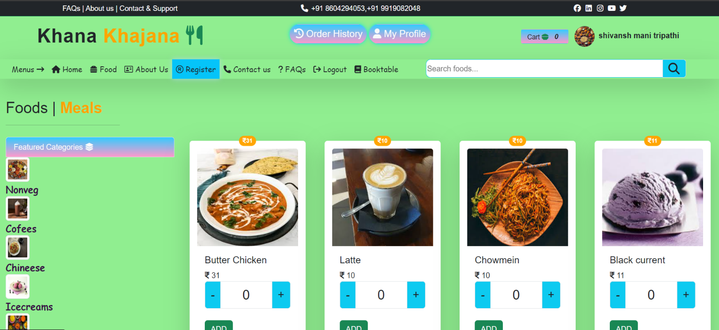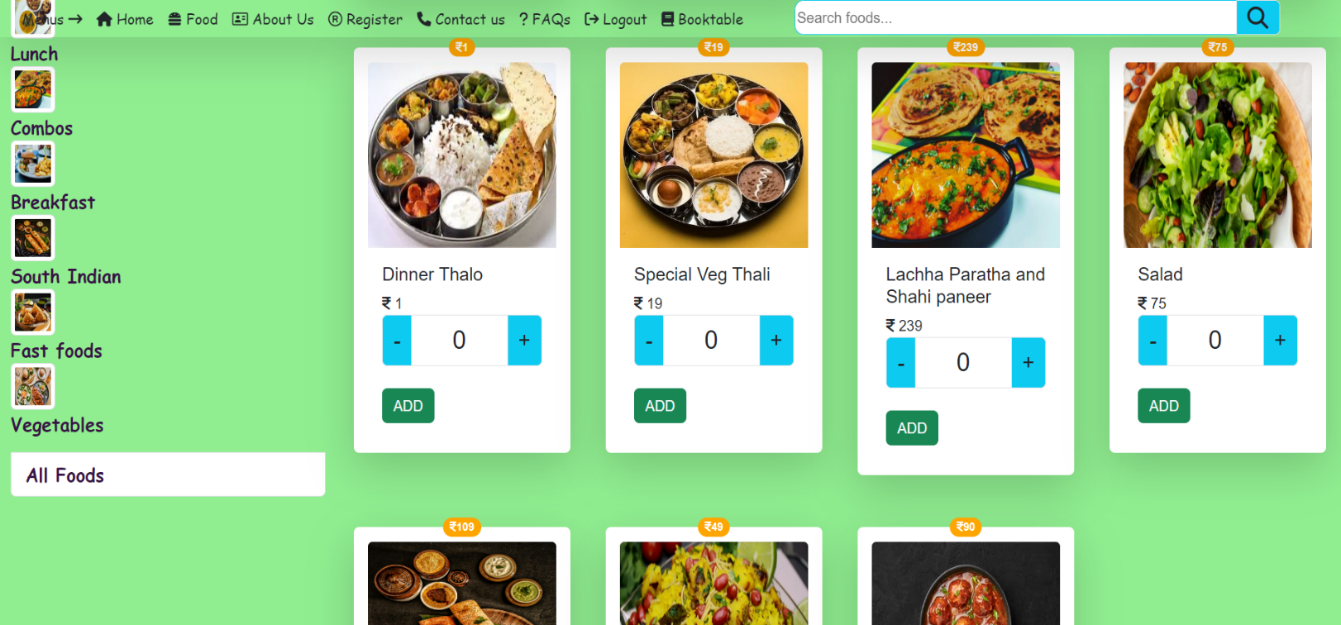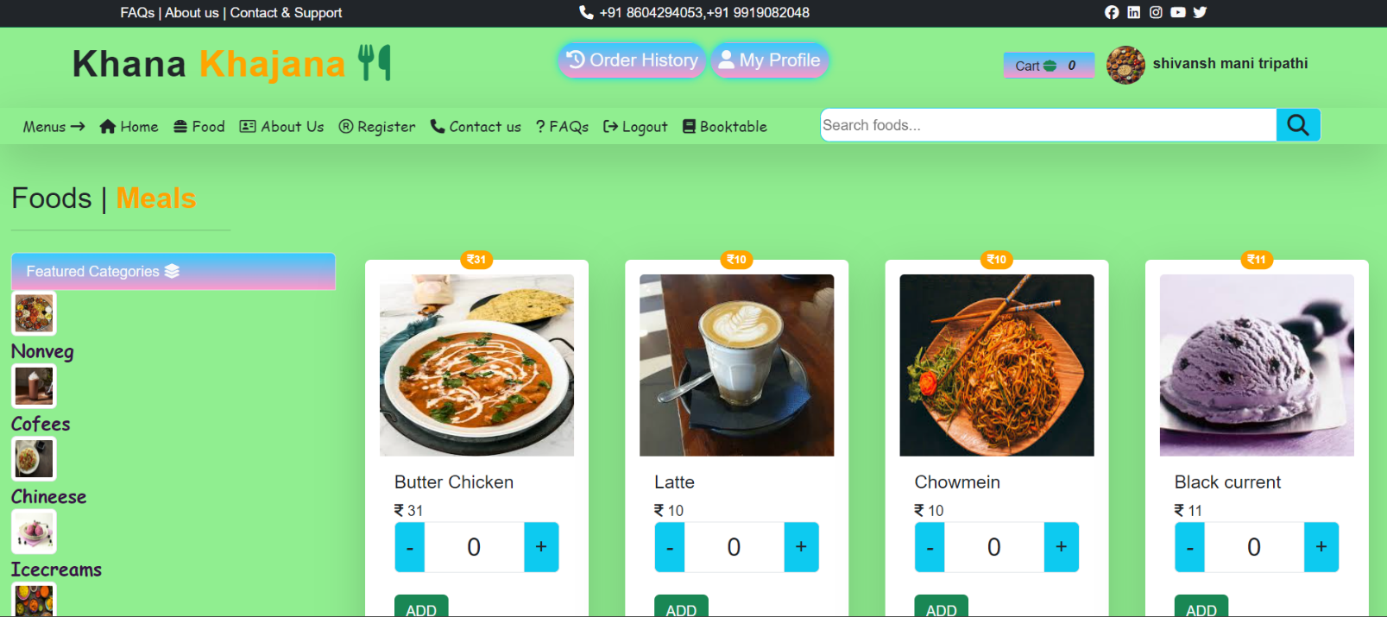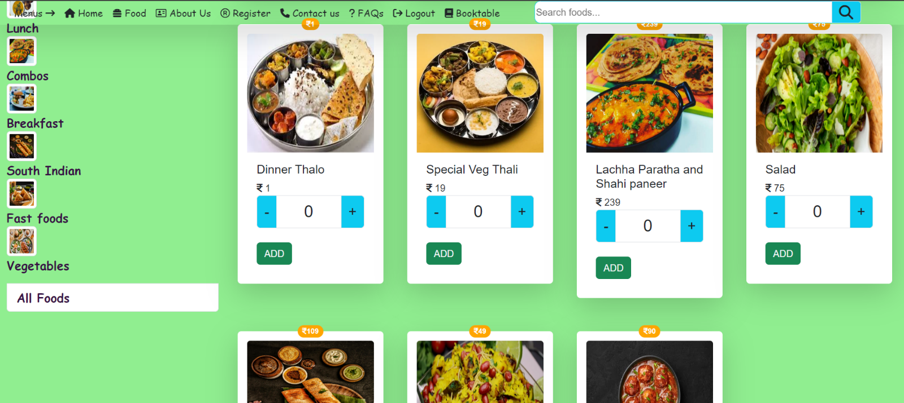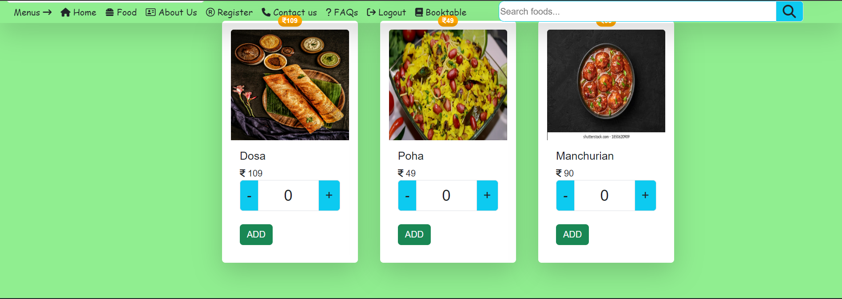

About us:-

**{% extends 'base.html' %}  
{% load static %}  
  
{% block childpage %}  
<!-->  
<style>  
  
* {  
 font-family: Nunito, sans-serif;  
}  
  
.text-blk {  
 margin-top: 0px;  
 margin-right: 0px;  
 margin-bottom: 0px;  
 margin-left: 0px;  
 padding-top: 0px;  
 padding-right: 0px;  
 padding-bottom: 0px;  
 padding-left: 0px;  
 line-height: 25px;  
}  
  
.responsive-container-block {  
box-shadow:0 0 20px #4CC8E4;  
 min-height: 75px;  
 height: fit-content;  
 width: 100%;  
 padding-top: 10px;  
 padding-right: 10px;  
 padding-bottom: 10px;  
 padding-left: 10px;  
 display: flex;  
 flex-wrap: wrap;  
 margin-top: 50px;  
 margin-right: auto;  
 margin-bottom: 50px;  
 margin-left: auto;  
 justify-content: flex-start;  
}  
  
.responsive-container-block.bigContainer {  
 padding-top: 10px;  
 padding-right: 30px;  
 padding-bottom: 10px;  
 padding-left: 30px;  
 background-image: url("https://workik-widget-assets.s3.amazonaws.com/widget-assets/images/bb29.png");  
 background-position-x: initial;  
 background-position-y: initial;  
 background-size: cover;  
 background-attachment: initial;  
 background-origin: initial;  
 background-clip: initial;  
 background-color: initial;  
 background-repeat-x: no-repeat;  
 background-repeat-y: no-repeat;  
}  
  
.responsive-container-block.Container {  
 max-width: 800px;  
 flex-direction: column;  
 align-items: center;  
 padding-top: 20px;  
 padding-right: 20px;  
 padding-bottom: 20px;  
 padding-left: 20px;  
 margin-top: 150px;  
 margin-right: auto;  
 margin-bottom: 150px;  
 margin-left: auto;  
 background-color: white;  
 border-top-left-radius: 10px;  
 border-top-right-radius: 10px;  
 border-bottom-right-radius: 10px;  
 border-bottom-left-radius: 10px;  
}  
  
.text-blk.heading {  
 font-size: 36px;  
 line-height: 45px;  
 font-weight: 800;  
 margin-top: 0px;  
 margin-right: 0px;  
 margin-bottom: 30px;  
 margin-left: 0px;  
}  
  
.text-blk.subHeading {  
 text-align: center;  
 font-size: 18px;  
 line-height: 26px;  
 margin-top: 0px;  
 margin-right: 0px;  
 margin-bottom: 60px;  
 margin-left: 0px;  
}  
  
.socialIcon {  
 width: 33px;  
 height: 33px;  
}  
  
.social-icons-container {  
 display: flex;  
 flex-direction: row;  
 align-items: flex-start;  
}  
  
.social-icon {  
 margin: 0 50px 0 50px;  
}  
  
.social-icon:hover {  
 cursor: pointer;  
}  
  
@media (max-width: 768px) {  
 .text-blk.heading {  
 font-size: 55px;  
 line-height: 65px;  
 }  
  
 .text-blk.subHeading {  
 font-size: 18px;  
 line-height: 24px;  
 }  
  
 .socialIcon {  
 width: 20px;  
 height: 20px;  
 }  
  
 .text-blk.subHeading {  
 line-height: 27px;  
 }  
  
 .text-blk.heading {  
 font-size: 32px;  
 line-height: 40px;  
 margin-top: 0px;  
 margin-right: 0px;  
 margin-bottom: 20px;  
 margin-left: 0px;  
 }  
  
 .social-icon {  
 margin: 0 25px 0 25px;  
 }  
}  
  
@media (max-width: 500px) {  
 .responsive-container-block.bigContainer {  
 padding-top: 10px;  
 padding-right: 20px;  
 padding-bottom: 10px;  
 padding-left: 20px;  
 }  
  
 .text-blk.heading {  
 font-size: 45px;  
 line-height: 55px;  
 margin-top: 0px;  
 margin-right: 0px;  
 margin-bottom: 20px;  
 margin-left: 0px;  
 }  
  
 .text-blk.subHeading {  
 font-size: 14px;  
 line-height: 22px;  
 margin-top: 0px;  
 margin-right: 0px;  
 margin-bottom: 30px;  
 margin-left: 0px;  
 }  
  
 .social-icons-container {  
 flex-wrap: wrap;  
 align-items: center;  
 justify-content: center;  
 }  
  
 .text-blk.subHeading {  
 font-size: 16px;  
 line-height: 23px;  
 }  
  
 .text-blk.heading {  
 font-size: 26px;  
 line-height: 30px;  
 }  
  
 .social-icon {  
 margin: 0 20px 0 20px;  
 }  
}  
  
</style>  
  
  
  
  
<div class="responsive-container-block bigContainer">  
 <div class="responsive-container-block Container">  
 <p class="text-blk heading text-info">  
 About Dine Devine  
 </p>  
 <p class="text-blk subHeading">  
 Food is the key element for every human being for the survival on the earth but not every food is that much tasty or applicable for all ages of people. Besides, preparation of the foods is also another issue for consideration. In my city, Mumbai, I have a favourite restaurant that offers different types of prepared food.  
  
 As I am a food-lover, I like to taste foods from different parts of the city and every weekend I start peeping at different restaurants. I taste all types of foods and finally I turn into a regular client for the best one. The restaurant named Zodiac Grill is located at the lobby level of the Taj Mahal Palace Hotel in Mumbai. It is located almost in the centre area of the city and thus easily accessible for all.  
  
 I liked the restaurant most for different reasons. The first and important cause is its decoration. The entire restaurant is decorated with zodiac signs (the sign also belongs to me) and the sitting arrangement was superb. Moreover, I was in love when I had the delicious smoked salmon before me. In other restaurants, I did not have the fish in a smoked form and the taste was excellent. Besides, the service was also fantastic. I had experienced delays and other sorts of problems in other places where I went to have my meals, but here I had no such troubles. Everything was in order and I was served with the necessary services even before asking for help. The best thing about the restaurant is its multi-national cuisine. The foods are truly superb!  
  
 When I first went to the restaurant, I ordered a tasting menu. It was a smoked salmon and caviar. The preparation of the foods took short moments than the regular hours and the serving method was praiseworthy too. I also ordered for tiger prawn and also took some vegetables too. When I ordered a chicken menu, I found that nothing could be compared to the item and it was prepared as the way that the meats were melting immediately I took them into my mouth.  
 </p>  
 <div class="social-icons-container">  
 <a class="social-icon">  
 <img class="socialIcon image-block " src="https://workik-widget-assets.s3.amazonaws.com/widget-assets/images/bb33.png">  
 </a>  
 <a class="social-icon">  
 <img class="socialIcon image-block" src="https://workik-widget-assets.s3.amazonaws.com/widget-assets/images/bb34.png">  
 </a>  
 <a class="social-icon">  
 <img class="socialIcon image-block" src="https://workik-widget-assets.s3.amazonaws.com/widget-assets/images/bb35.png">  
 </a>  
 <a class="social-icon">  
 <img class="socialIcon image-block" src="https://workik-widget-assets.s3.amazonaws.com/widget-assets/images/bb36.png">  
 </a>  
 </div>  
 </div>  
</div>  
<div class="row chef mt-5">  
 <div class="col-sm-3 text-center">  
  
 <div class="card mx-auto cardzoom" style="width: 18rem;">  
 <img src="{% static 'images/hero/img/team-1.jpg' %}" class="card-img-top" alt="..." height="350px" width="100px">  
 <div class="card-body">  
 <h5 class="card-title"><b>Mithailal</b></h5>  
 <h6 class="card-subtitle">Master Chef</h6>  
  
 </div>  
</div>  
  
 </div>  
  
 <div class="col-sm-3 text-center">  
  
 <div class="card mx-auto cardzoom" style="width: 18rem;">  
 <img src="{% static 'images/hero/img/team-1.jpg' %}" class="card-img-top" alt="..." height="350px" width="100px">  
 <div class="card-body">  
 <h5 class="card-title"><b>Mithailal</b></h5>  
 <h6 class="card-subtitle">Master Chef</h6>  
  
 </div>  
</div>  
  
 </div>  
  
 <div class="col-sm-3 text-center">  
  
 <div class="card mx-auto cardzoom" style="width: 18rem;">  
 <img src="{% static 'images/hero/img/team-1.jpg' %}" class="card-img-top" alt="..." height="350px" width="100px">  
 <div class="card-body">  
 <h5 class="card-title"><b>Mithailal</b></h5>  
 <h6 class="card-subtitle">Master Chef</h6>  
  
 </div>  
</div>  
  
 </div>  
</div>  
-->  
  
  
<!-- About start -->  
<div class="container text-dark" style="background:#41fad2;">  
<div class="row heading text-center my-5 mx-auto">  
 <div class="col-sm-5 mx-auto text-center" >  
 <h1 style="color:#fc0585;text-shadow:0 0 3px #0694a1;" class="mb-4"><b class="txt-color2">About </b>Us <i class="fa-regular fa-address-card"></i></h1>  
  
 <i>  
  
  
 <hr>  
 </i>  
 </div>  
</div>  
  
  
  
  
  
 <div class="row my-4">  
 <div class="col-sm-6 pt-3 px-3" style="letter-spacing:2px;word-spacing:1px;margin:auto;line-height:40px;text-align:justify;">  
 <h3>About us</h3>  
 <p>  
 Welcome to <strong style="font-family:cursive;">DineDevine</strong>, where passion for great food and exceptional service comes together to create memorable dining experiences. Nestled in the heart of Gorakhpur, we’ve been delighting guests since 2000, offering a menu that celebrates the best of [Cuisine Type] with a modern twist.  
At <strong style="font-family:cursive;">DineDevine</strong>, we’re dedicated to using only the finest, locally-sourced ingredients to craft dishes that are both innovative and timeless. Our talented chefs blend traditional techniques with creative flair, ensuring each meal is a feast for the senses.  
We believe dining is about more than just food; it’s about creating moments of connection and enjoyment. Whether you're here for a casual meal with friends, a romantic dinner, or a special celebration, our warm and inviting atmosphere is designed to make every visit special.  
  
 </p>  
 </div>  
  
 <div class="col-sm-6">  
 <img src="{% static 'images/hero/img/about-1.jpg' %}" height="400px" width="400px" style="box-shadow:0 0 20px violet;margin-left:120px;margin-top:50px;" class="img-fluid" />  
 </div>  
  
 </div>  
 <div class="row mb-5">  
 <div class="col-sm-6">  
 <img src="{% static 'images/hero/img/about-2.jpg' %}" height="400px" width="400px" style="box-shadow:0 0 20px violet;margin-left:60px;" />  
 </div>  
 <div class="col-sm-6 pt-3 px-3" style="letter-spacing:2px;word-spacing:1px;margin:auto;line-height:50px;text-align:justify;">  
  
 <p>  
Our commitment to sustainability is central to our mission. By partnering with local farms and purveyors, we not only support our community but also reduce our environmental footprint.  
  
Thank you for choosing <strong style="font-family:cursive;">DineDevine</strong>. We’re thrilled to share our passion for exceptional dining with you and look forward to welcoming you soon.  
  
The <strong style="font-family:cursive;">DineDevine</strong> Team.  
  
 </p>  
 </div>  
 </div>  
</div>  
<!-- About end -->  
{% endblock %}  
  
Screen Shoot:-**

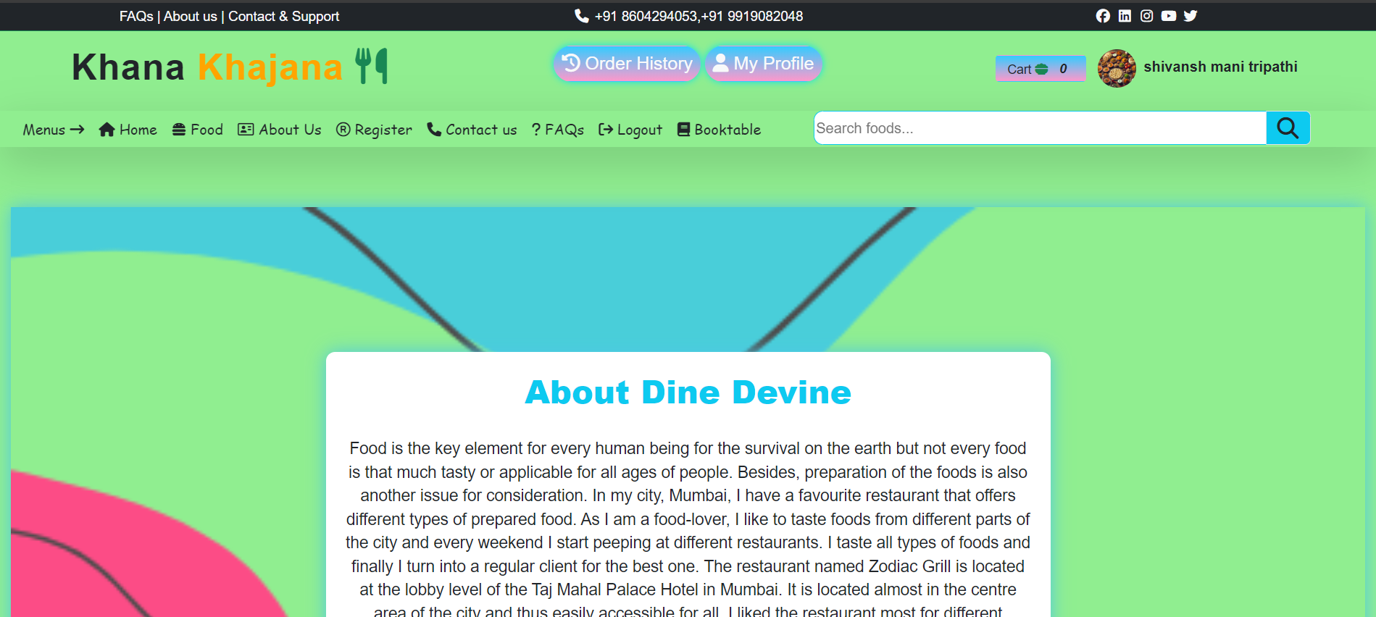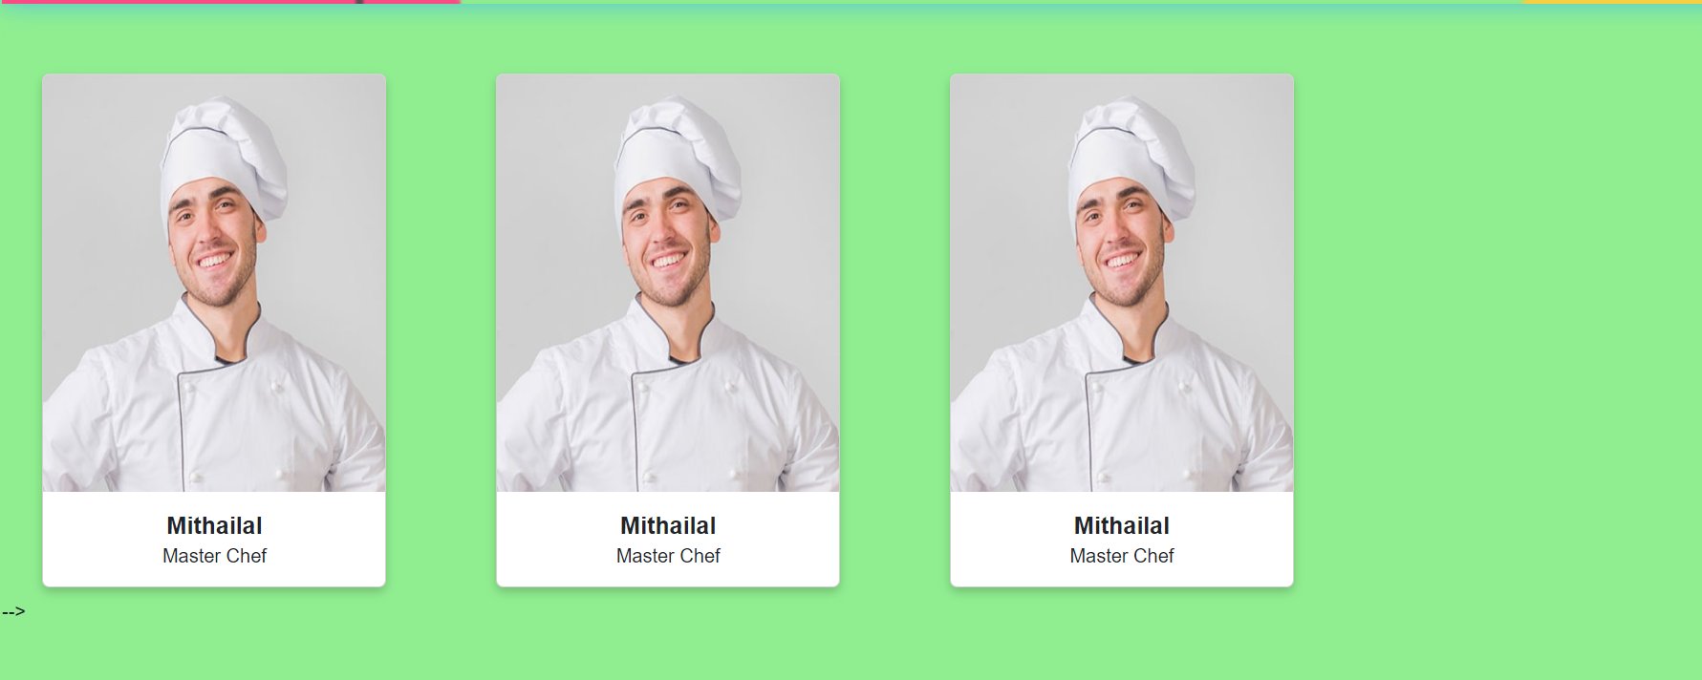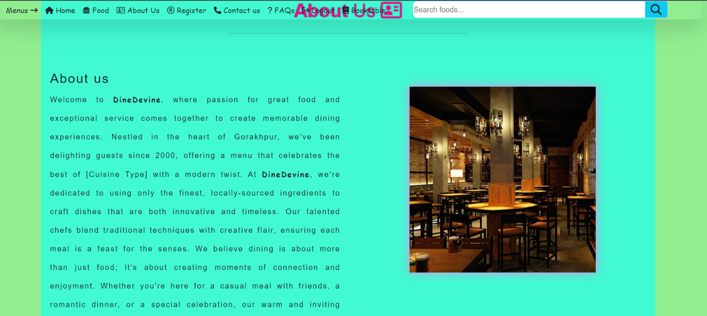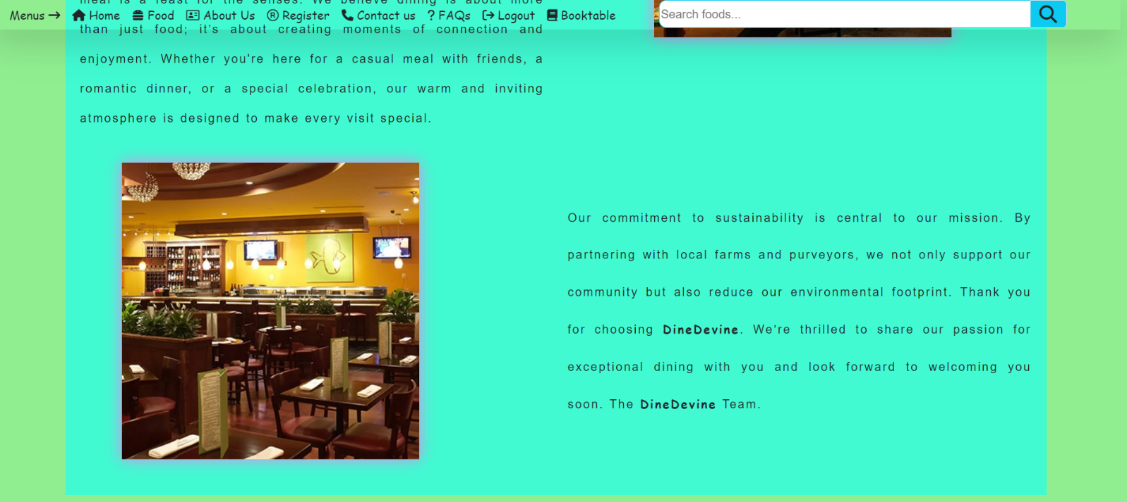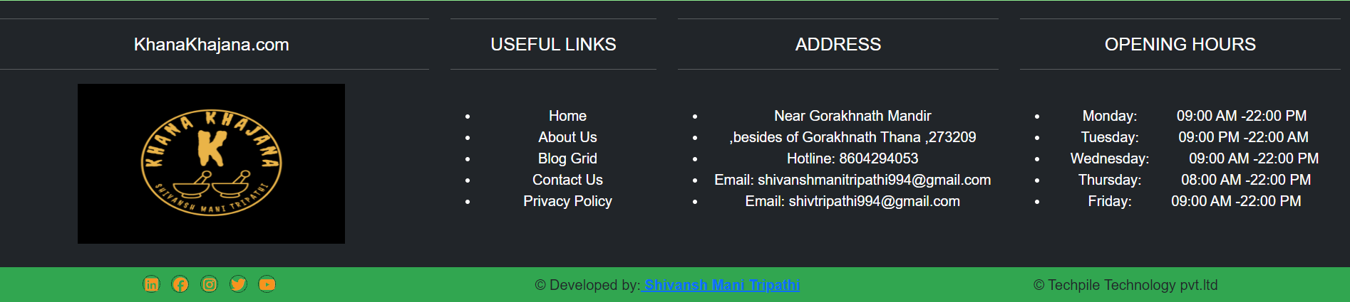 **Register:-**

**{% extends 'base.html' %}  
{% load static %}  
  
{% block childpage %}  
<style>  
 .form-control  
 {  
 height:50px;  
 background:#e9eaec;  
 border-radius:0px !important;  
 }  
 .input-group-text  
 {  
 height:50px;  
 text-align:center !important;  
 background:rgba(0,0,0,.7);  
 border-radius:0px !important;  
 color:white;  
 }  
</style>  
  
<!-- Heading start -->  
<div class="row mb-2 mt-4 mx-auto text-center" >  
 <div class="col-sm-4"></div>  
 <div class="col-sm-4">  
 <h2 class="m-0">Register <b class="txt-color1">Now</b></h2>  
 <hr>  
 </div>  
</div>  
<!-- Heading end -->  
  
<div class="container">  
 <div class="row heading text-center my-5 mx-auto">  
  
</div>  
  
 <div class="row m-5">  
 <div class="col-sm-2"></div>  
 <div class="col-sm-8 ">  
  
  
 <form autocomplete="off" method="post" enctype="multipart/form-data">  
  
 {% csrf_token %}  
  
 <div class="row mt-4">  
 <div class="col-sm-6">  
  
 <div class="input-group flex-nowrap">  
 <span class="input-group-text" ><i class="fa-solid fa-user"></i></span>  
 <input type="text" name="name" required class="form-control" placeholder="Enter your name.." aria-label="Username" aria-describedby="addon-wrapping">  
</div>  
  
 </div>  
 <div class="col-sm-6">  
  
 <div class="input-group flex-nowrap">  
 <span class="input-group-text"><i class="fa-solid fa-envelope"></i></span>  
 <input type="email" name="email" required class="form-control" placeholder="Enter your email.." aria-label="Username" aria-describedby="addon-wrapping">  
</div>  
  
 </div>  
 </div>  
  
 <div class="row mt-4">  
 <div class="col-sm-6">  
  
 <div class="input-group flex-nowrap">  
 <span class="input-group-text"><i class="fa-solid fa-user"></i></span>  
 <input type="password" name="passwd" required class="form-control" placeholder="Enter your password.." aria-label="Username" aria-describedby="addon-wrapping">  
</div>  
  
 </div>  
 <div class="col-sm-6">  
  
 <div class="input-group flex-nowrap">  
 <span class="input-group-text" ><i class="fa-solid fa-user"></i></span>  
 <input type="number" name="mobile" required class="form-control" placeholder="Enter your contact number.." aria-label="Username" aria-describedby="addon-wrapping">  
</div>  
  
 </div>  
 </div>  
  
 <div class="row mt-4">  
 <div class="col-sm-6">  
  
 <div class="input-group flex-nowrap">  
 <span class="input-group-text" ><i class="fa-solid fa-user"></i></span>  
 <input type="text" name="address" required class="form-control" placeholder="Enter your address.." aria-label="Username" aria-describedby="addon-wrapping">  
</div>  
  
 </div>  
 <div class="col-sm-6">  
  
 <div class="input-group flex-nowrap">  
 <span class="input-group-text"><i class="fa-solid fa-user"></i></span>  
 <input type="text" name="city" required class="form-control" placeholder="Enter your city.." aria-label="Username" aria-describedby="addon-wrapping">  
</div>  
  
 </div>  
 </div>  
  
 <div class="row mt-4">  
 <div class="col-sm-6">  
  
 <div class="input-group flex-nowrap">  
 <span class="input-group-text" ><i class="fa-solid fa-user"></i></span>  
 <input type="number" name="pincode" required class="form-control" placeholder="Enter your pincode.." aria-label="Username" aria-describedby="addon-wrapping">  
</div>  
  
 </div>  
 <div class="col-sm-6">  
  
 <div class="input-group flex-nowrap">  
 <span class="input-group-text"><i class="fa-solid fa-user"></i></span>  
 <input type="file" name="fu" required class="form-control">  
</div>  
  
 </div>  
 </div>  
  
  
<input style="box-shadow:0 0 8px powderblue;" type="submit" value="Register now" class="btn rounded-0 my-3 from-control bg-mycolor1 text-light w-25"/>  
</form>  
 </div>  
  
 <div class="col-sm-2"></div>  
 </div>  
</div>  
  
{% endblock %}**

**Screen Shoot:-**

**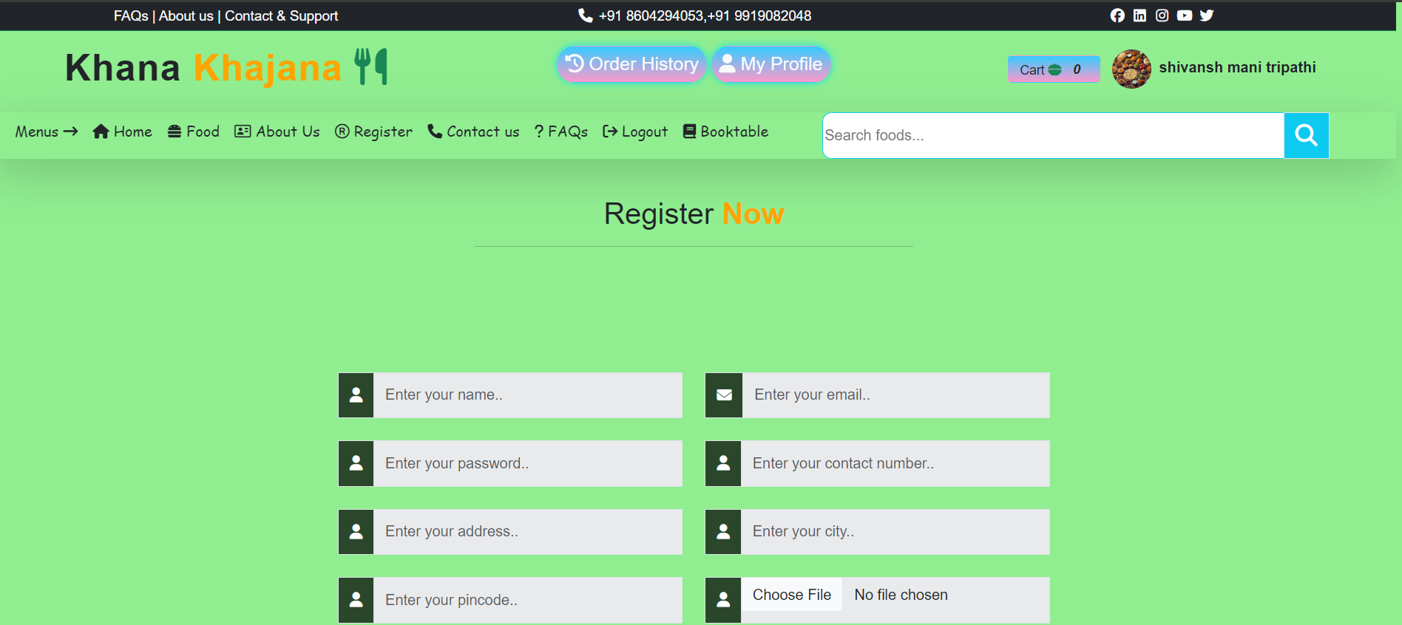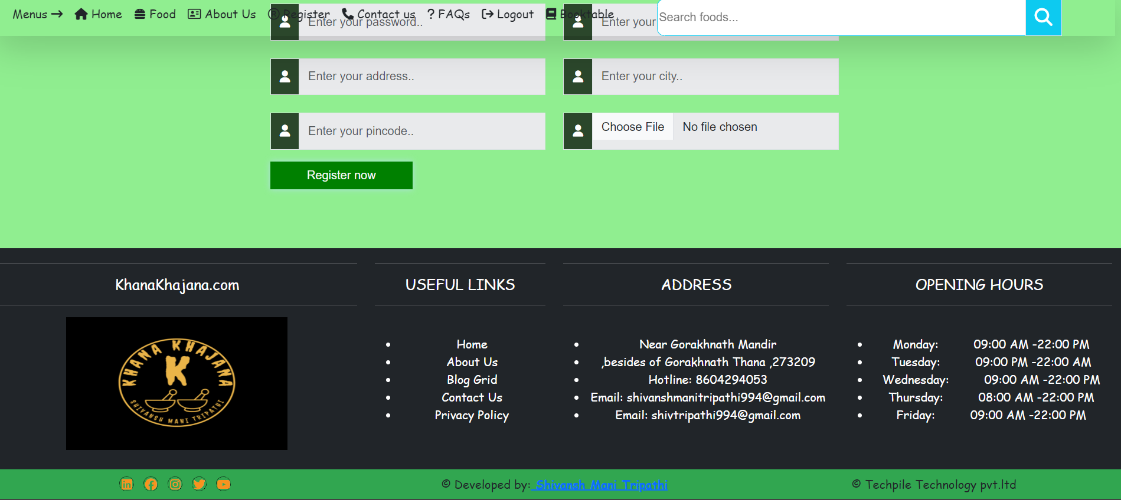  
  
  
Contact us:-**

**{% extends 'base.html' %}  
{% load static %}  
  
{% block childpage %}  
<style>  
 .form-control  
 {  
 height:50px;  
 }  
  
 .contactLocation {  
 padding: 40px;  
 border: 1px solid #dedede;  
 border-radius: 4px;  
 background: #f8f9fa;  
 border-bottom: 1px #dedede solid;  
}  
 .col {  
 -ms-flex-preferred-size: 0;  
 flex-basis: 0;  
 -ms-flex-positive: 1;  
 flex-grow: 1;  
 max-width: 100%;  
}  
 .contact p a  
 {  
 text-decoration:none;  
 }  
 .contact p a:hover  
 {  
 color:red;  
 }  
  
</style>  
<div class="row heading text-center my-5 mx-auto">  
 <div class="col-sm-5 mx-auto text-center" >  
 <p style="text-shadow:0 0 10px #fff;" class="fs-3 p-0 m-0"><i class="fa-solid fa-phone"></i> <b style="color:#0377fc;">Contact</b> us</p>  
 <i>  
 Dinedevine boasts an inviting atmosphere that perfectly complements its culinary offerings.  
 The restaurant features a warm and sophisticated decor.  
  
 <hr>  
 </i>  
 </div>  
</div>  
  
  
<!-- start contact us -->  
<div class="row">  
 <div class="mx-auto col-sm-10">  
 <div class="row">  
 <div class="col-sm-6" style="box-shadow:0 0 5px #D3F3DF;">  
 <div class="col contactLocation">  
 <h4 class="divHeading">Contact Info</h4>  
 <div class="row">  
 <div class="col-sm-4" style="width:80px;background:#f53b07;margin-left:10px; height:5px;"></div>  
 </div>  
 <br>  
 <div class="contact">  
 <i class="fas fa-map-marker-alt"></i>  
 <strong>Office Address</strong>  
 <p>  
 Atal tiraha,<br>  
 Barhaj,Deoria,<br>  
 Uttar Pradesh 274601  
 </p>  
 </div>  
 <div class="contact">  
 <i class="fas fa-phone-alt"></i>  
 <strong>Call Us</strong>  
 <b>For Delivery or Enquiry</b>  
 <p class="d-flex">  
 <a href="tel:+91 6391584647">+91 6391584647, </a>  
 <a href="tel:+91 8528883886" class="ps-3">&nbsp;&nbsp;+91 8528883886, </a>  
 </p>  
 </div>  
 <div class="contact">  
 <i class="far fa-envelope"></i>  
 <strong>Mail Us</strong>  
 <p>  
 <a href="babapriyanshu115@gmail.com">babapriyanshu115@gmail.com</a>  
 </p>  
 </div>  
 <div class="contact">  
 <i class="fa-brands fa-square-instagram"></i>  
 <strong>Instagram</strong>  
 <p>  
 <a href="#">priyanshupandey3351</a>  
 </p>  
 </div>  
 <div class="contact">  
 <i class="fa-brands fa-youtube"></i>  
 <strong>Youtube</strong>  
 <p>  
 <a href="#">Dine_Devine</a>  
 </p>  
 </div>  
 </div>  
 </div>  
  
  
 <div class="col-sm-6">  
 <form autocomplete="off" style="font-family:cursive;" method="post">  
 {% csrf_token %}  
 Name :<br><input type="text" required placeholder="Name" class="form-control shadow-lg mb-1 bg-body-teritary" name="name">  
 Email :<br><input type="email" required placeholder="Email" class="form-control shadow-lg mb-1 bg-body-teritary" name="email">  
 Mobile :<br><input type="number" required placeholder="Mobile Number" class="form-control shadow-lg mb-1 bg-body-teritary" name="mobile">  
 Subject :<br><input type="text" required placeholder="Subject" class="form-control shadow-lg mb-1 bg-body-teritary" name="subject">  
 Your Message :<br><textarea style="min-height:90px;" class="form-control shadow-lg mb-1 bg-body-teritary" name="msg" placeholder="Your message"></textarea> <br>  
 <input type="submit" name="save" class="form-control shadow-lg mb-3 w-25 mx-auto bg-mycolor1">  
 </form>  
 </div>  
 </div>  
 </div>  
</div>  
<!-- end contact us -->  
  
<div class="row heading text-center my-5 mx-auto">  
 <div class="col-sm-5 mx-auto text-center">  
 <p class="fs-3 p-0 m-0"><i class="fa-solid fa-location-dot txt-color2"></i> <b style="color:#0377fc;">Find</b> us on <b style="color:#0377fc;">Google map</b></p>  
 <hr>  
 </div>  
</div>  
  
<div class="row gmap">  
 <div class="col-sm-10 mx-auto">  
 <iframe src="https://www.google.com/maps/embed?pb=!1m18!1m12!1m3!1d7137.44675647644!2d83.22771609357913!3d26.561153100000006!2m3!1f0!2f0!3f0!3m2!1i1024!2i768!4f13.1!3m3!1m2!1s0x399114b99ffb4bc9%3A0x67df7573d8f3259a!2sMahamaya%20Polytechnic%20Of%20Information%20Technology%2C%20Hariharpur%2CGorakhpur!5e0!3m2!1sen!2sin!4v1726643632494!5m2!1sen!2sin" style="width:100%;min-height:350px;max-height:400px;border:0;" allowfullscreen="" loading="lazy" referrerpolicy="no-referrer-when-downgrade"></iframe>  
 </div>  
</div>**

**Screen Shoot:-**

**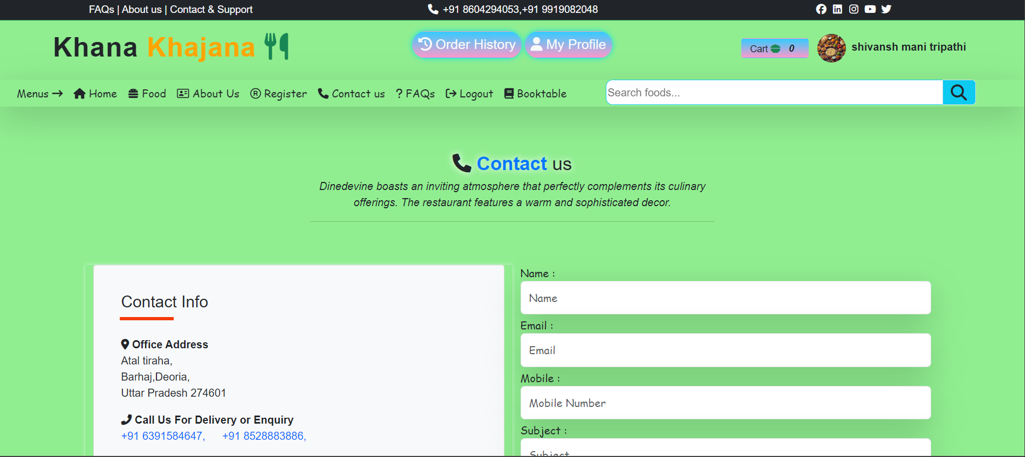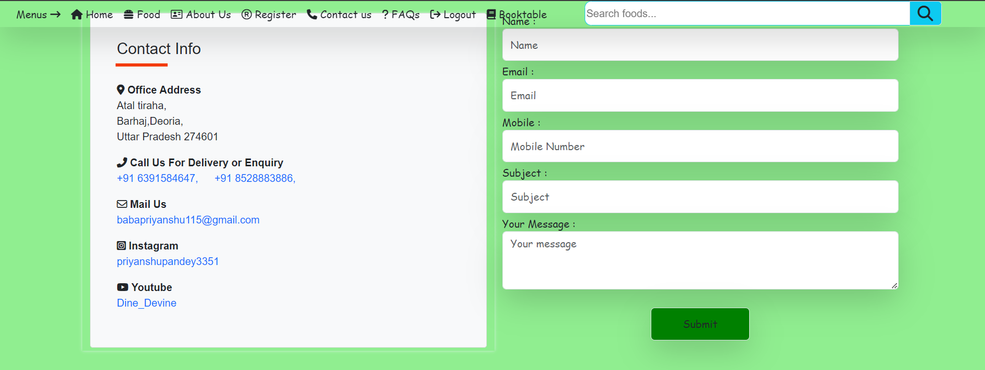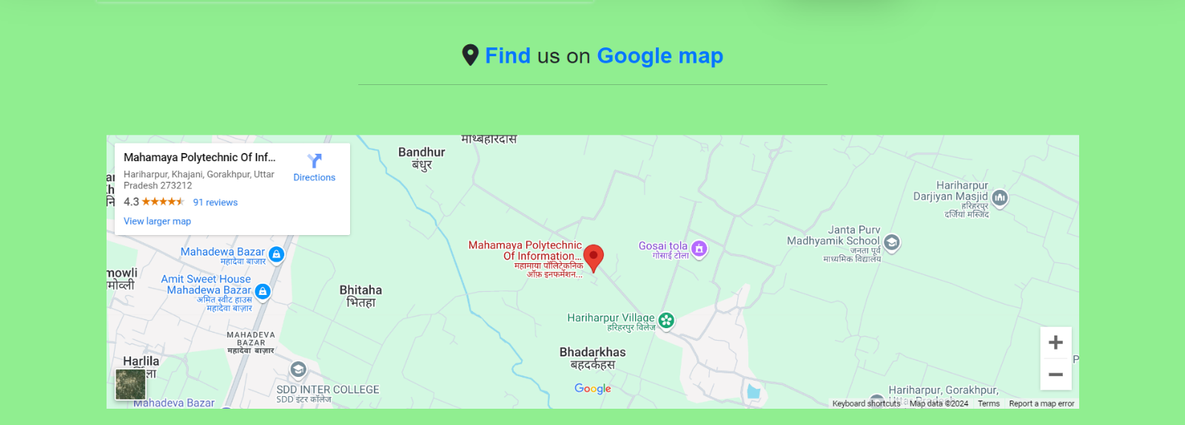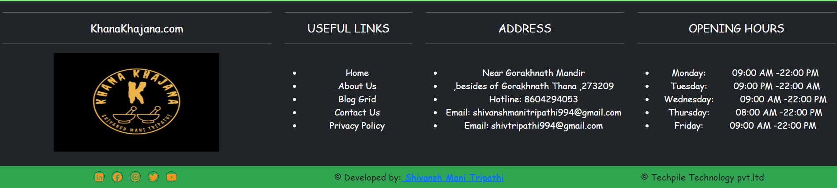  
  
FAQs:-**

**{% extends 'base.html' %}  
{% load static %}  
  
{% block childpage %}  
  
<div class="container">  
 <div class="row py-3">  
 <div class="my-2 mx-5 fs-3"><b class="txt-color2">Our</b> popular <b class="txt-color1 ">FAQs</b></div>  
 <div class="col-sm-2"></div>  
 <div class="col-sm-8">  
  
 <div class="accordion" id="accordionExample">  
 <div class="accordion-item mt-3 shadow-lg">  
 <h2 class="accordion-header" id="headingOne">  
 <button class="accordion-button" type="button" data-bs-toggle="collapse" data-bs-target="#collapseOne" aria-expanded="false" aria-controls="collapseOne">  
 1. What are your operating hours?  
 </button>  
 </h2>  
 <div id="collapseOne" class="accordion-collapse collapse show" aria-labelledby="headingOne" data-bs-parent="#accordionExample">  
 <div class="accordion-body">  
 We are open daily from 11:00 AM to 10:00 PM  
 </div>  
 </div>  
 </div>  
 <div class="accordion-item mt-3 shadow-lg">  
 <h2 class="accordion-header" id="headingTwo">  
 <button class="accordion-button " type="button" data-bs-toggle="collapse" data-bs-target="#collapseTwo" aria-expanded="false" aria-controls="collapseTwo">  
 2. Can I make a reservation?  
 </button>  
 </h2>  
 <div id="collapseTwo" class="accordion-collapse collapse" aria-labelledby="headingTwo" data-bs-parent="#accordionExample">  
 <div class="accordion-body">  
 Yes, reservations can be made online via our website or by calling us at [Phone Number].  
 </div>  
 </div>  
 </div>  
 <div class="accordion-item mt-3 shadow-lg">  
 <h2 id="headingThree">  
 <button class="accordion-button " type="button" data-bs-toggle="collapse" data-bs-target="#collapseThree" aria-expanded="false" aria-controls="collapseThree">  
 3. Do you offer takeout or delivery?  
 </button>  
 </h2>  
 <div id="collapseThree" class="accordion-collapse collapse" aria-labelledby="headingThree" data-bs-parent="#accordionExample">  
 <div class="accordion-body">  
 Yes, we offer both takeout and delivery. Orders can be placed through our website or by phone.  
 </div>  
 </div>  
 </div>  
  
  
  
  
  
 <div class="accordion-item mt-3 shadow-lg">  
 <h2 class="accordion-header" id="headingFour">  
 <button class="accordion-button" type="button" data-bs-toggle="collapse" data-bs-target="#collapseFour" aria-expanded="false" aria-controls="collapseFour">  
 4. Are there vegetarian or vegan options available?  
  
 </button>  
 </h2>  
 <div id="collapseFour" class="accordion-collapse collapse show" aria-labelledby="headingOne" data-bs-parent="#accordionExample">  
 <div class="accordion-body">  
 Yes, our menu includes a variety of vegetarian and vegan dishes. Please check our “Vegetarian Dishes” and “Vegan Options” sections for details.  
 </div>  
 </div>  
 </div>  
 <div class="accordion-item mt-3 shadow-lg">  
 <h2 class="accordion-header" id="headingFive">  
 <button class="accordion-button " type="button" data-bs-toggle="collapse" data-bs-target="#collapseFive" aria-expanded="false" aria-controls="collapseFive">  
 5. Where can I view the menu ?  
 </button>  
 </h2>  
 <div id="collapseFive" class="accordion-collapse collapse" aria-labelledby="headingTwo" data-bs-parent="#accordionExample">  
 <div class="accordion-body">  
 Our complete menu is available online in the “Menu” section of our website.  
 </div>  
 </div>  
 </div>  
 <div class="accordion-item mt-3 shadow-lg">  
 <h2 class="accordion-header" id="headingSix">  
 <button class="accordion-button " type="button" data-bs-toggle="collapse" data-bs-target="#collapseSix" aria-expanded="false" aria-controls="collapseSix">  
 6. Do you have a menu for children?  
 </button>  
 </h2>  
 <div id="collapseSix" class="accordion-collapse collapse" aria-labelledby="headingThree" data-bs-parent="#accordionExample">  
 <div class="accordion-body">  
 Yes, we offer a special menu for kids with dishes designed to please young palates.  
 </div>  
 </div>  
 </div>  
 <div class="accordion-item mt-3 shadow-lg">  
 <h2 class="accordion-header" id="headingSeven">  
 <button class="accordion-button" type="button" data-bs-toggle="collapse" data-bs-target="#collapseSeven" aria-expanded="false" aria-controls="collapseSeven">  
 7. Do you offer gift cards?  
 </button>  
 </h2>  
 <div id="collapseSeven" class="accordion-collapse collapse show" aria-labelledby="headingOne" data-bs-parent="#accordionExample">  
 <div class="accordion-body">  
 Yes, gift cards are available for purchase online or at our restaurant.  
 </div>  
 </div>  
 </div>  
 <div class="accordion-item mt-3 shadow-lg">  
 <h2 class="accordion-header" id="headingEight">  
 <button class="accordion-button " type="button" data-bs-toggle="collapse" data-bs-target="#collapseEight" aria-expanded="false" aria-controls="collapseEight">  
 8. Are pets allowed?  
 </button>  
 </h2>  
 <div id="collapseEight" class="accordion-collapse collapse" aria-labelledby="headingTwo" data-bs-parent="#accordionExample">  
 <div class="accordion-body">  
 Service animals are welcome inside the restaurant. Pets are permitted in our outdoor seating area.  
 </div>  
 </div>  
 </div>  
 <div class="accordion-item mt-3 shadow-lg">  
 <h2 class="accordion-header" id="headingNine">  
 <button class="accordion-button " type="button" data-bs-toggle="collapse" data-bs-target="#collapseNine" aria-expanded="false" aria-controls="collapseNine">  
 9. Can I host a private event at your restaurant?  
 </button>  
 </h2>  
 <div id="collapseNine" class="accordion-collapse collapse" aria-labelledby="headingThree" data-bs-parent="#accordionExample">  
 <div class="accordion-body">  
 Yes, we offer private dining options for events. Contact us to discuss your event details and availability.  
 </div>  
 </div>  
 </div>  
  
 <div class="accordion-item mt-3 shadow-lg">  
 <h2 class="accordion-header" id="headingTen">  
 <button class="accordion-button " type="button" data-bs-toggle="collapse" data-bs-target="#collapseTen" aria-expanded="false" aria-controls="collapseTen">  
 10. How can I provide feedback about my experience?  
 </button>  
 </h2>  
 <div id="collapseTen" class="accordion-collapse collapse" aria-labelledby="headingThree" data-bs-parent="#accordionExample">  
 <div class="accordion-body">  
 We welcome your feedback. Please leave a review on our website, social media, or email us directly at [Email Address].</div>  
 </div>  
 </div>  
</div>  
  
 </div>  
 <div class="col-sm-2"></div>  
 </div>  
</div>  
  
{% endblock %}**

**Screen Shoot:-**

**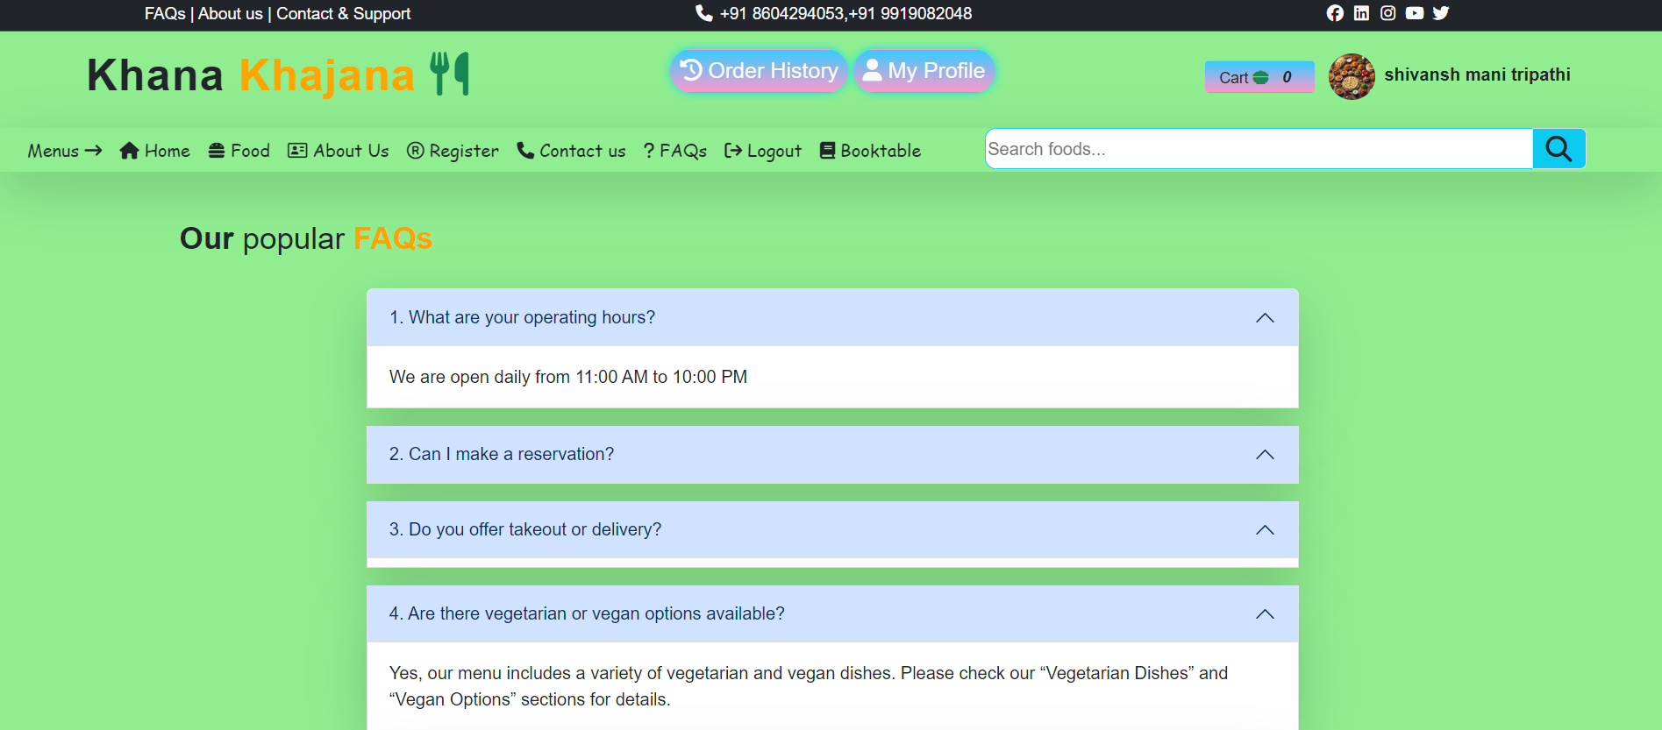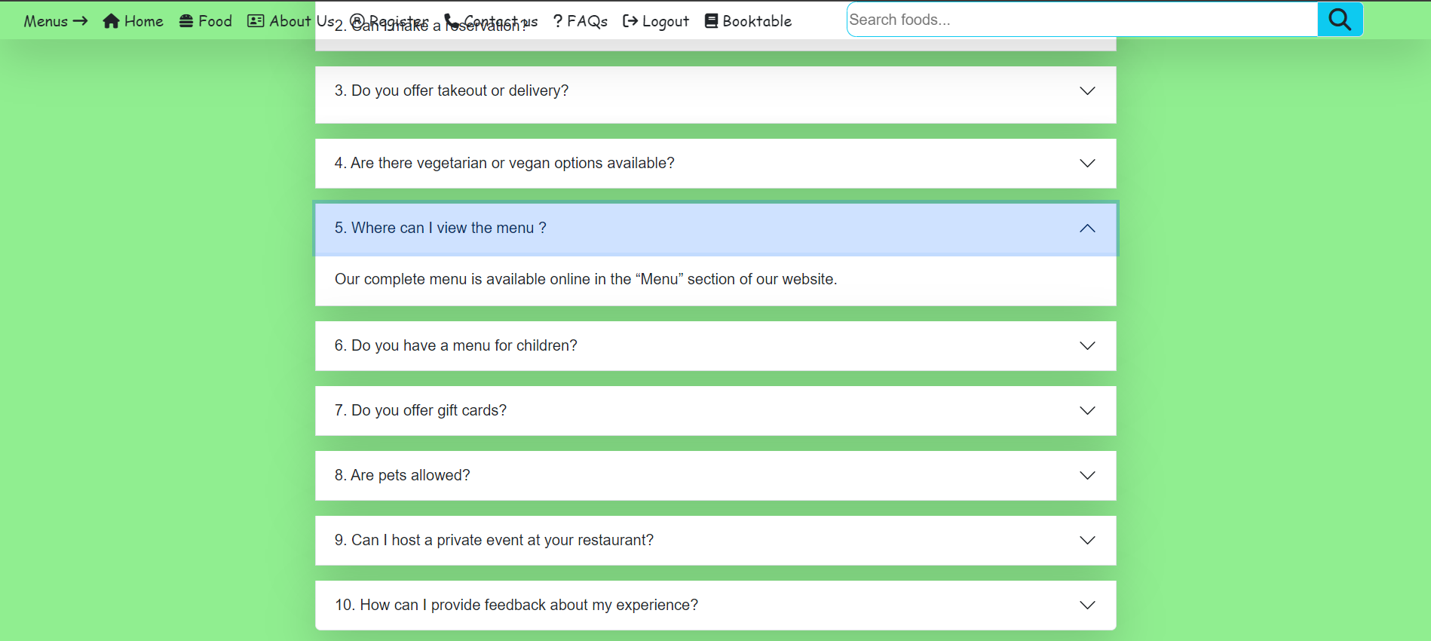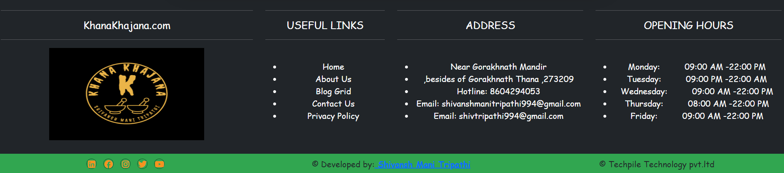  
  
  
Login:-**

**{% extends 'base.html' %}  
{% load static %}  
  
{% block childpage %}  
  
<style>  
 .form-control{  
 height:50px;  
 border:0 !important;  
 }  
</style>  
  
 <!-- Heading start Login now -->  
  
 <div class="row mb-2 mt-4">  
 <div class="col-sm-5 mx-auto text-center">  
 <p class="fs-3 m-0">Login</b><b class="txt-color2"> Here.</b></p>  
<i>  
 Chef X boasts an inviting atmosphere that perfectly complements its culinary offerings.  
 The restaurant features a warm and sophisticated decor.  
  
 <hr>  
 </i>  
 </div>  
 </div>  
 <!-- Heading end Login now -->  
  
<div class="row">  
 <div class="col-sm-4"></div>  
<div class="col-sm-4" mx-auto>  
 <form method="post">  
 {% csrf_token %}  
 Userid</br><input type="email" required placeholder="Username..." class="form-control shadow-lg mb-2" name="userid"/>  
  
 Password</br><input type="password" class="form-control shadow-lg mb-2" name="passwd" placeholder="Password..."/>  
 <div class="text-center">  
 <input type="submit" value="Login" class="form-control border-0 mt-3 w-25 mx-auto btn bg-mycolor2 text-light border-0"/>  
 </div>  
 </form>  
 </div>  
 </div>  
</div>  
  
  
{% endblock %}**

**Screen Shoot:-**

**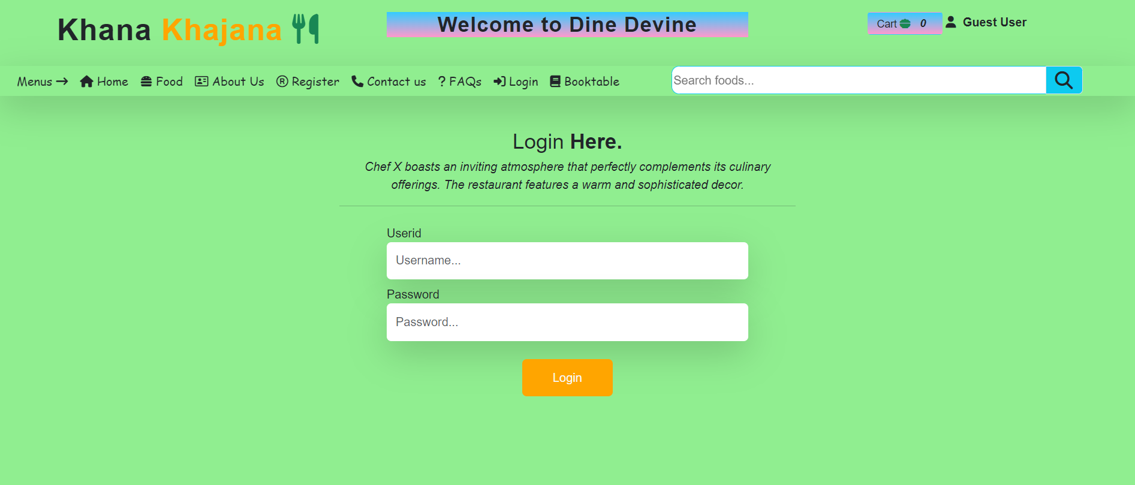  
  
  
Logout:-**

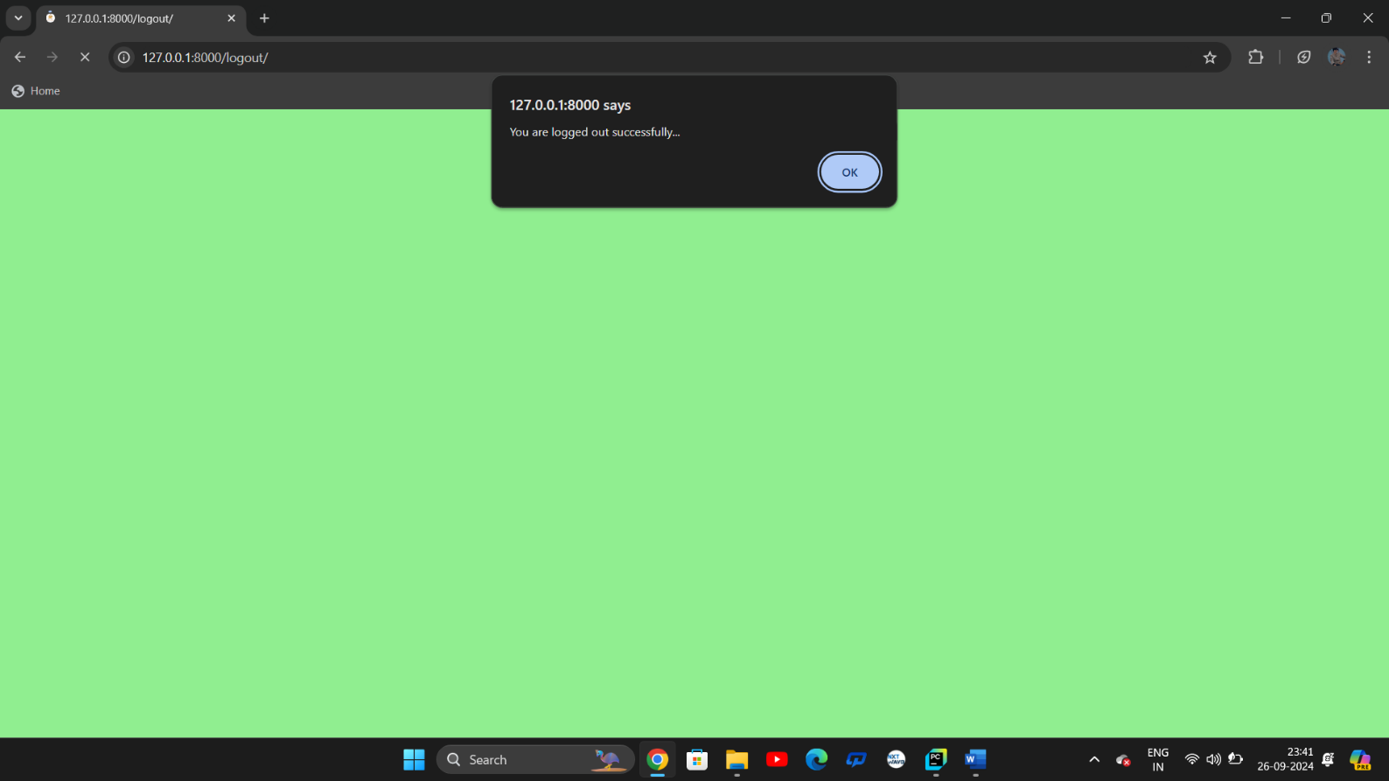

**Book Table:-**

**{% extends 'base.html' %}  
{% load static %}  
  
{% block childpage %}  
<style>  
 .form-control  
 {  
 height:50px;  
 margin-bottom:1%;  
 background:rgba(0,0,0,.3);  
 }  
</style>  
  
  
<!-- Heading start -->  
<div class="row mb-2 mt-4" >  
 <div class="col-sm-4" style="margin-left:125px;">  
 <h2 class="mx-2 rounded-1 " style="padding:10px 40px;background: linear-gradient(to bottom, #33ccff 0%, #ff99cc 100%);color:#fff;"><b>BOOK TABLE</b></h2>  
 </div>  
</div>  
<!-- Heading end -->  
<div class="row">  
 <div class="col-sm-1"></div>  
 <div class="col-sm-5 mx-auto my-4" style="font-weight:bold;font-family:cursive;">  
 <form method="post">  
 {% csrf_token %}  
 Name :  
 <input type="text" required name="name" placeholder="Name" class="form-control"/>  
 Email :  
 <input type="email" required name="email" placeholder="Email" class="form-control"/>  
 Mobile :  
 <input type="number" required name="mobile" placeholder="Mobile number" class="form-control"/>  
 No. of pepole :  
 <input type="number" required name="pepole" placeholder="Number of pepole" class="form-control"/>  
 Date for your booking :  
 <input type="date" required name="bdate" class="form-control"/>  
 Time for your booking :  
 <input type="time" required name="btime" class="form-control"/>  
 Type of food :  
 <select required class="form-control" name="foodtype">  
 <option>-- Select Food Type --</option>  
 <option>Veg</option>  
 <option>Non-Veg</option>  
 <option>Vegan</option>  
 </select>  
 Type of Event :  
 <select required class="form-control" name="eventtype">  
 <option>-- Select Event Type --</option>  
 <option>Birthday</option>  
 <option>Anniversary</option>  
 <option>Get Toghether</option>  
 <option>Farewell Party</option>  
 <option>Fresher's Party</option>  
 </select>  
 <br>  
 <input type="submit" value="Book Now" class="btn text-light" style="background:#340850;"/>  
  
 </form>  
 </div>  
 <div class="col-sm-5"></div>  
 <div class="col-sm-1"></div>  
</div>  
{% endblock %}**

**Screen Shoot:-**

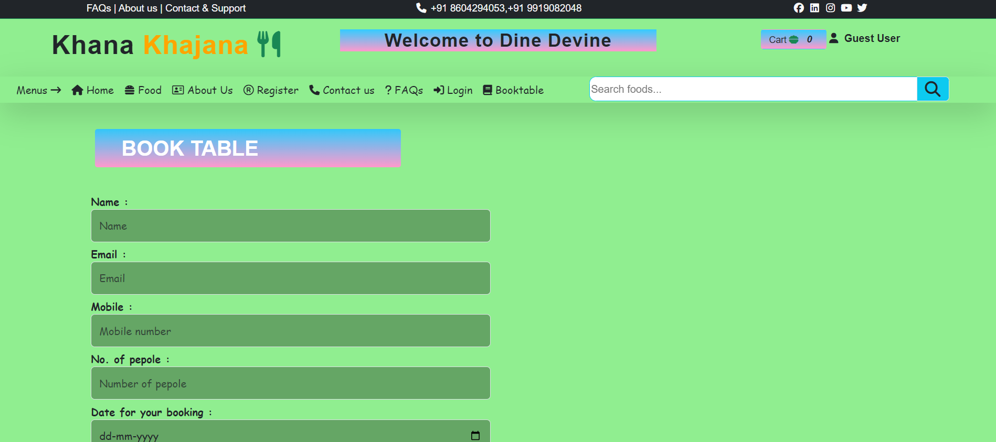

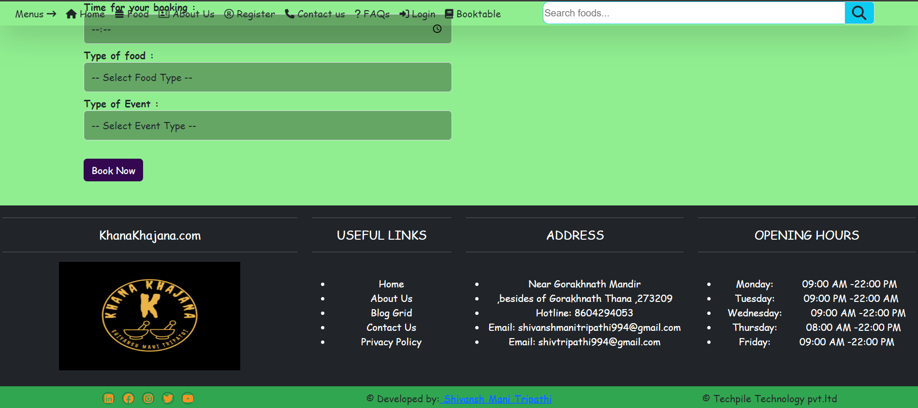

**My Portfolio:-**

**<!DOCTYPE html>  
{% load static %}  
<!--[if lt IE 7 ]><html class="ie ie6" lang="en"> <![endif]-->  
<!--[if IE 7 ]><html class="ie ie7" lang="en"> <![endif]-->  
<!--[if IE 8 ]><html class="ie ie8" lang="en"> <![endif]-->  
<!--[if (gte IE 9)|!(IE)]><!--><html lang="en"> <!--<![endif]-->  
  
<!-- Mirrored from marketifythemes.net/html/elisc/index-one-page.html by HTTrack Website Copier/3.x [XR&CO'2014], Fri, 13 Sep 2024 06:11:14 GMT -->  
<head>  
<meta http-equiv="Content-Type" content="text/html; charset=utf-8" />  
<meta name="description" content="Name of your web site">  
<meta name="author" content="Marketify">  
<meta name="viewport" content="width=device-width, initial-scale=1, maximum-scale=1">  
  
<title>Elisc</title>  
  
<link href="https://fonts.googleapis.com/css2?family=Karla:ital,wght@0,200;0,300;0,400;0,500;0,600;0,700;0,800;1,200;1,300;1,400;1,500;1,600;1,700;1,800&amp;display=swap" rel="stylesheet">  
<link href="https://fonts.googleapis.com/css2?family=Inter:wght@100;200;300;400;500;600;700;800;900&amp;display=swap" rel="stylesheet">  
<link href="https://fonts.googleapis.com/css2?family=Kristi&amp;display=swap" rel="stylesheet">  
<link rel="stylesheet" type="text/css" href="{% static 'css/plugins.css'%}" />  
<link rel="stylesheet" type="text/css" href="{% static 'css/style.css' %}" />  
<!--[if lt IE 9]> <script type="text/javascript" src="{% static 'js/modernizr.custom.js' %}"></script> <![endif]-->  
  
</head>  
<body>  
  
<div id="preloader">  
<div class="loader_line"></div>  
</div>  
  
  
<div class="elisc_tm_all_wrap" data-magic-cursor="show">  
<div class="dodo_tm_one_page_wrapper">  
  
<div class="elisc_tm_topbar">  
<div class="topbar_inner">  
<div class="logo" data-type="image">  
<a class="image" href="#"><img src="{% static 'img/logo/logo.png" alt /></a>  
<a class="text" href="#"><span>R.Elisc</span></a>  
</div>  
<div class="trigger">  
<div class="hamburger hamburger--slider">  
<div class="hamburger-box">  
<div class="hamburger-inner"></div>  
</div>  
</div>  
</div>  
</div>  
</div>  
<div class="elisc_tm_mobile_menu">  
<div class="inner">  
<div class="wrapper">  
<div class="avatar">  
<div class="image" data-img-url="img/about/1.jpg' %}"></div>  
</div>  
<div class="menu_list">  
<ul class="anchor_nav">  
<li class="current"><a href="#home">Home</a></li>  
<li><a href="#about">About</a></li>  
<li><a href="#service">Services</a></li>  
<li><a href="#portfolio">Portfolio</a></li>  
<li><a href="#news">Blog</a></li>  
<li><a href="#contact">Contact</a></li>  
</ul>  
</div>  
<div class="social">  
<ul>  
<li><a href="#"><img class="svg" src="{% static 'img/svg/social/facebook.svg' %}" alt /></a></li>  
<li><a href="#"><img class="svg" src="{% static 'img/svg/social/twitter.svg' %}" alt /></a></li>  
<li><a href="#"><img class="svg" src="{% static 'img/svg/social/instagram.svg' %}" alt /></a></li>  
<li><a href="#"><img class="svg" src="{% static 'img/svg/social/dribbble.svg' %}" alt /></a></li>  
<li><a href="#"><img class="svg" src="{% static 'img/svg/social/tik-tok.svg' %}" alt /></a></li>  
</ul>  
</div>  
<div class="copyright">  
<p>Copyright &copy; 2023</p>  
</div>  
</div>  
</div>  
</div>  
  
  
<div class="elisc_tm_sidebar">  
<div class="sidebar_inner">  
<div class="author">  
<div class="image">  
<img src="{% static 'img/thumbs/1-1.jpg' %}" alt />  
<div class="main" data-img-url="img/about/1.jpg' %}"></div>  
</div>  
<div class="name">  
<h3><span>Rohit Yadav<span class="back">Rohit Yadav</span></span></h3>  
</div>  
</div>  
<div class="menu scrollable">  
<ul class="anchor_nav">  
<li class="current"><a href="#home">Home</a></li>  
<li><a href="#about">About</a></li>  
<li><a href="#service">Services</a></li>  
<li><a href="#portfolio">Portfolio</a></li>  
<li><a href="#news">Blog</a></li>  
<li><a href="#contact">Contact</a></li>  
</ul>  
</div>  
<div class="copyright">  
<div class="social">  
<ul>  
<li><a href="#"><i class="icon-facebook-1"></i></a></li>  
<li><a href="#"><i class="icon-twitter-1"></i></a></li>  
<li><a href="#"><i class="icon-linkedin-1"></i></a></li>  
</ul>  
</div>  
<div class="text">  
<p>Copyright © 2023 Robert Elisc. All rights reserved.</p>  
</div>  
</div>  
</div>  
</div>  
  
  
<div class="elisc_tm_mainpart">  
<div class="mainpart_inner">  
  
<div class="elisc_tm_section animated" id="home">  
<div class="elisc_tm_home">  
<div class="tm_content">  
<div class="details">  
<div class="left">  
<div class="title">  
<h3>Hi, I'm <span class="blueColor">Rohit Yadav!</span></h3>  
<h3>  
<span class="cd-headline rotate-1">  
<span class="blc">Creative</span>  
<span class="cd-words-wrapper">  
<b class="is-visible">Designer</b>  
<b>Coder</b>  
<b>Player</b>  
</span>  
</span>  
</h3>  
<h3>Based in Florida</h3>  
</div>  
<div class="subtitle">  
<p>I'm a Florida based web designer &amp; front‑end developer with <span class="blueColor">10+ years</span> of experience</p>  
</div>  
<div class="buttons">  
<div class="elisc_tm_button">  
<a class="anchor" href="#portfolio">Got a project?</a>  
</div>  
<div class="elisc_tm_button" data-style="border">  
<a class="anchor" href="#contact">Let's talk</a>  
</div>  
</div>  
<div class="info">  
<ul>  
<li><a href="tel:+77 022 444 05 05">+77 022 444 05 05</a></li>  
<li><a href="https://marketifythemes.net/cdn-cgi/l/email-protection#98ebede8e8f7eaecd8fdf4f1ebfbb6fbf7f5"><span class="_cf_email_" data-cfemail="7e0d0b0e0e110c0a3e1b12170d1d501d1113">[email&#160;protected]</span></a></li>  
<li><a class="href_location" href="#">Ave Street Avenue, New York</a></li>  
</ul>  
</div>  
</div>  
<div class="right">  
<img src="{% static 'img/about/2.png" alt />  
</div>  
</div>  
</div>  
</div>  
</div>  
  
  
<div class="elisc_tm_section" id="about">  
<div class="elisc_tm_about">  
<div class="tm_content">  
<div class="elisc_tm_biography">  
<div class="left">  
<div class="title">  
<span class="mini">- Nice to meet you!</span>  
<h3 class="name">Robert Elisc</h3>  
<span class="job">  
<span class="cd-headline rotate-1">  
<span class="blc">Web designer &amp;</span>  
<span class="cd-words-wrapper">  
<b class="is-visible">Developer</b>  
<b>Coder</b>  
<b>Player</b>  
</span>  
</span>  
</span>  
</div>  
<div class="elisc_tm_button">  
<a class="anchor" href="#portfolio">Got a project?</a>  
</div>  
</div>  
<div class="right">  
<div class="text">  
<p>Hello there! My name is <span class="yellowColor">Rohit YADAV</span>. I am a web designer &amp; developer, and I'm very passionate and dedicated to my work.</p>  
<p>With 20 years experience as a professional a graphic designer, I have acquired the skills and knowledge necessary to make your project a success. I enjoy every step of the design process, from discussion and collaboration.</p>  
</div>  
<div class="info">  
<ul>  
<li>  
<span>Age</span>  
<span>22</span>  
</li>  
<li>  
<span>Born In</span>  
<span><a class="href_location" href="#">Chandigarh, India</a></span>  
</li>  
<li>  
<span>Mail</span>  
<span><a href="https://marketifythemes.net/cdn-cgi/l/email-protection#f0838580809f8284b0959c998393de939f9d"><span class="_cf_email_" data-cfemail="45363035352a37310520292c36266b262a28">[email&#160;protected]</span></a></span>  
</li>  
<li>  
<span>Phone</span>  
<span><a href="tel:+77 022 444 05 05">+77 022 444 05 05</a></span>  
</li>  
</ul>  
</div>  
</div>  
</div>  
<div class="elisc_tm_counter">  
<ul>  
<li>  
<div class="list_inner">  
<h3>10+</h3>  
<span>Years of Experience</span>  
</div>  
</li>  
<li>  
<div class="list_inner">  
<h3>50+</h3>  
<span>Projects Completed</span>  
</div>  
</li>  
<li>  
<div class="list_inner">  
<h3>30+</h3>  
<span>Happy Clients</span>  
</div>  
</li>  
</ul>  
</div>  
</div>  
<div class="elisc_tm_experience">  
<div class="tm_content">  
<div class="elisc_tm_title">  
<span>- Experience</span>  
<h3>Everything about me!</h3>  
</div>  
<div class="list">  
<ul>  
<li>  
<img class="popup_image" src="{% static 'img/experience/1.jpg' %}" alt />  
<div class="list_inner">  
<div class="short">  
<div class="job">  
<span class="yellowColor">-2018 - Present</span>  
<h3>Web Developer</h3>  
</div>  
<div class="place">  
<span>-Envato Market</span>  
</div>  
</div>  
<div class="text">  
<p>Website development is the process of building, programming, coding and maintaining websites and web applications.</p>  
</div>  
<a class="elisc_tm_full_link" href="#"></a>  
  
<div class="hidden_details">  
<div class="descriptions">  
<p>Elisc is a leading web design agency with an award-winning design team that creates innovative, effective websites that capture your brand, improve your conversion rates, and maximize your revenue to help grow your business and achieve your goals.</p>  
<p>In today’s digital world, your website is the first interaction consumers have with your business. That's why almost 95 percent of a user’s first impression relates to web design. It’s also why web design services can have an immense impact on your company’s bottom line.</p>  
<p>That’s why more companies are not only reevaluating their website’s design but also partnering with Elisc, the web design agency that’s driven more than $2.4 billion in revenue for its clients. With over 50 web design awards under our belt, we're confident we can design a custom website that drives sales for your unique business.</p>  
</div>  
</div>  
  
</div>  
</li>  
<li>  
<img class="popup_image" src="{% static 'img/experience/2.jpg' %}" alt />  
<div class="list_inner">  
<div class="short">  
<div class="job">  
<span class="yellowColor">-2016 - 2018</span>  
<h3>Senior Designer</h3>  
</div>  
<div class="place">  
<span>-ABC Studio</span>  
</div>  
</div>  
<div class="text">  
<p>Website development is the process of building, programming, coding and maintaining websites and web applications.</p>  
</div>  
<a class="elisc_tm_full_link" href="#"></a>  
  
<div class="hidden_details">  
<div class="descriptions">  
<p>Elisc is a leading web design agency with an award-winning design team that creates innovative, effective websites that capture your brand, improve your conversion rates, and maximize your revenue to help grow your business and achieve your goals.</p>  
<p>In today’s digital world, your website is the first interaction consumers have with your business. That's why almost 95 percent of a user’s first impression relates to web design. It’s also why web design services can have an immense impact on your company’s bottom line.</p>  
<p>That’s why more companies are not only reevaluating their website’s design but also partnering with Elisc, the web design agency that’s driven more than $2.4 billion in revenue for its clients. With over 50 web design awards under our belt, we're confident we can design a custom website that drives sales for your unique business.</p>  
</div>  
</div>  
  
</div>  
</li>  
<li>  
<img class="popup_image" src="{% static 'img/experience/3.jpg' %}" alt />  
<div class="list_inner">  
<div class="short">  
<div class="job">  
<span class="yellowColor">-2015 - 2016</span>  
<h3>UX Designer</h3>  
</div>  
<div class="place">  
<span>-Colorlib</span>  
</div>  
</div>  
<div class="text">  
<p>Website development is the process of building, programming, coding and maintaining websites and web applications.</p>  
</div>  
<a class="elisc_tm_full_link" href="#"></a>  
  
<div class="hidden_details">  
<div class="descriptions">  
<p>Elisc is a leading web design agency with an award-winning design team that creates innovative, effective websites that capture your brand, improve your conversion rates, and maximize your revenue to help grow your business and achieve your goals.</p>  
<p>In today’s digital world, your website is the first interaction consumers have with your business. That's why almost 95 percent of a user’s first impression relates to web design. It’s also why web design services can have an immense impact on your company’s bottom line.</p>  
<p>That’s why more companies are not only reevaluating their website’s design but also partnering with Elisc, the web design agency that’s driven more than $2.4 billion in revenue for its clients. With over 50 web design awards under our belt, we're confident we can design a custom website that drives sales for your unique business.</p>  
</div>  
</div>  
  
</div>  
</li>  
<li>  
<img class="popup_image" src="{% static 'img/experience/4.jpg' %}" alt />  
<div class="list_inner">  
<div class="short">  
<div class="job">  
<span class="yellowColor">-2013 - 2015</span>  
<h3>Freelancer</h3>  
</div>  
<div class="place">  
<span>-Vivaco Corp.</span>  
</div>  
</div>  
<div class="text">  
<p>Website development is the process of building, programming, coding and maintaining websites and web applications.</p>  
</div>  
<a class="elisc_tm_full_link" href="#"></a>  
  
<div class="hidden_details">  
<div class="descriptions">  
<p>Elisc is a leading web design agency with an award-winning design team that creates innovative, effective websites that capture your brand, improve your conversion rates, and maximize your revenue to help grow your business and achieve your goals.</p>  
<p>In today’s digital world, your website is the first interaction consumers have with your business. That's why almost 95 percent of a user’s first impression relates to web design. It’s also why web design services can have an immense impact on your company’s bottom line.</p>  
<p>That’s why more companies are not only reevaluating their website’s design but also partnering with Elisc, the web design agency that’s driven more than $2.4 billion in revenue for its clients. With over 50 web design awards under our belt, we're confident we can design a custom website that drives sales for your unique business.</p>  
</div>  
</div>  
  
</div>  
</li>  
</ul>  
</div>  
</div>  
</div>  
</div>  
</div>  
  
  
<div class="elisc_tm_section" id="service">  
<div class="elisc_tm_services">  
<div class="tm_content">  
<div class="elisc_tm_service_title">  
<div class="elisc_tm_title">  
<span>- Services</span>  
<h3>My Services</h3>  
</div>  
<a href="https://marketifythemes.net/cdn-cgi/l/email-protection#c9babcb9b9a6bbbd89aca5a0baaae7aaa6a4"><span class="_cf_email_" data-cfemail="82f1f7f2f2edf0f6c2e7eeebf1e1ace1edef">[email&#160;protected]</span></a>  
</div>  
<div class="service_list">  
<ul>  
<li>  
<img class="popup_image" src="{% static 'img/service/2.jpg' %}" alt />  
<div class="list_inner">  
<div class="details">  
<div class="title">  
<span>01</span>  
<h3>Web Design</h3>  
</div>  
<div class="text">  
<p>Web development is the process of building, programming...</p>  
</div>  
<div class="elisc_tm_read_more">  
<a href="#">Read More<span><img class="svg" src="{% static 'img/svg/rightArrow.svg' %}" alt /></span></a>  
</div>  
</div>  
<a class="elisc_tm_full_link" href="#"></a>  
  
<div class="hidden_details">  
<div class="descriptions">  
<p>Elisc is a leading web design agency with an award-winning design team that creates innovative, effective websites that capture your brand, improve your conversion rates, and maximize your revenue to help grow your business and achieve your goals.</p>  
<p>In today’s digital world, your website is the first interaction consumers have with your business. That's why almost 95 percent of a user’s first impression relates to web design. It’s also why web design services can have an immense impact on your company’s bottom line.</p>  
<p>That’s why more companies are not only reevaluating their website’s design but also partnering with Elisc, the web design agency that’s driven more than $2.4 billion in revenue for its clients. With over 50 web design awards under our belt, we're confident we can design a custom website that drives sales for your unique business.</p>  
</div>  
</div>  
  
</div>  
</li>  
<li>  
<img class="popup_image" src="{% static 'img/service/3.jpg' %}" alt />  
<div class="list_inner">  
<div class="details">  
<div class="title">  
<span>02</span>  
<h3>UI/UX Design</h3>  
</div>  
<div class="text">  
<p>Web development is the process of building, programming...</p>  
</div>  
<div class="elisc_tm_read_more">  
<a href="#">Read More<span><img class="svg" src="{% static 'img/svg/rightArrow.svg' %}" alt /></span></a>  
</div>  
</div>  
<a class="elisc_tm_full_link" href="#"></a>  
  
<div class="hidden_details">  
<div class="descriptions">  
<p>Elisc is a leading web design agency with an award-winning design team that creates innovative, effective websites that capture your brand, improve your conversion rates, and maximize your revenue to help grow your business and achieve your goals.</p>  
<p>In today’s digital world, your website is the first interaction consumers have with your business. That's why almost 95 percent of a user’s first impression relates to web design. It’s also why web design services can have an immense impact on your company’s bottom line.</p>  
<p>That’s why more companies are not only reevaluating their website’s design but also partnering with Elisc, the web design agency that’s driven more than $2.4 billion in revenue for its clients. With over 50 web design awards under our belt, we're confident we can design a custom website that drives sales for your unique business.</p>  
</div>  
</div>  
  
</div>  
</li>  
<li>  
<img class="popup_image" src="{% static 'img/service/4.jpg' %}" alt />  
<div class="list_inner">  
<div class="details">  
<div class="title">  
<span>03</span>  
<h3>Mobile Application</h3>  
</div>  
<div class="text">  
<p>Web development is the process of building, programming...</p>  
</div>  
<div class="elisc_tm_read_more">  
<a href="#">Read More<span><img class="svg" src="{% static 'img/svg/rightArrow.svg' %}" alt /></span></a>  
</div>  
</div>  
<a class="elisc_tm_full_link" href="#"></a>  
  
<div class="hidden_details">  
<div class="descriptions">  
<p>Elisc is a leading web design agency with an award-winning design team that creates innovative, effective websites that capture your brand, improve your conversion rates, and maximize your revenue to help grow your business and achieve your goals.</p>  
<p>In today’s digital world, your website is the first interaction consumers have with your business. That's why almost 95 percent of a user’s first impression relates to web design. It’s also why web design services can have an immense impact on your company’s bottom line.</p>  
<p>That’s why more companies are not only reevaluating their website’s design but also partnering with Elisc, the web design agency that’s driven more than $2.4 billion in revenue for its clients. With over 50 web design awards under our belt, we're confident we can design a custom website that drives sales for your unique business.</p>  
</div>  
</div>  
  
</div>  
</li>  
<li>  
<img class="popup_image" src="{% static 'img/service/5.jpg' %}" alt />  
<div class="list_inner">  
<div class="details">  
<div class="title">  
<span>04</span>  
<h3>User Research</h3>  
</div>  
<div class="text">  
<p>Web development is the process of building, programming...</p>  
</div>  
<div class="elisc_tm_read_more">  
<a href="#">Read More<span><img class="svg" src="{% static 'img/svg/rightArrow.svg' %}" alt /></span></a>  
</div>  
</div>  
<a class="elisc_tm_full_link" href="#"></a>  
  
<div class="hidden_details">  
<div class="descriptions">  
<p>Elisc is a leading web design agency with an award-winning design team that creates innovative, effective websites that capture your brand, improve your conversion rates, and maximize your revenue to help grow your business and achieve your goals.</p>  
<p>In today’s digital world, your website is the first interaction consumers have with your business. That's why almost 95 percent of a user’s first impression relates to web design. It’s also why web design services can have an immense impact on your company’s bottom line.</p>  
<p>That’s why more companies are not only reevaluating their website’s design but also partnering with Elisc, the web design agency that’s driven more than $2.4 billion in revenue for its clients. With over 50 web design awards under our belt, we're confident we can design a custom website that drives sales for your unique business.</p>  
</div>  
</div>  
  
</div>  
</li>  
<li>  
<img class="popup_image" src="{% static 'img/service/6.jpg' %}" alt />  
<div class="list_inner">  
<div class="details">  
<div class="title">  
<span>05</span>  
<h3>Animation</h3>  
</div>  
<div class="text">  
<p>Web development is the process of building, programming...</p>  
</div>  
<div class="elisc_tm_read_more">  
<a href="#">Read More<span><img class="svg" src="{% static 'img/svg/rightArrow.svg' %}" alt /></span></a>  
</div>  
</div>  
<a class="elisc_tm_full_link" href="#"></a>  
  
<div class="hidden_details">  
<div class="descriptions">  
<p>Elisc is a leading web design agency with an award-winning design team that creates innovative, effective websites that capture your brand, improve your conversion rates, and maximize your revenue to help grow your business and achieve your goals.</p>  
<p>In today’s digital world, your website is the first interaction consumers have with your business. That's why almost 95 percent of a user’s first impression relates to web design. It’s also why web design services can have an immense impact on your company’s bottom line.</p>  
<p>That’s why more companies are not only reevaluating their website’s design but also partnering with Elisc, the web design agency that’s driven more than $2.4 billion in revenue for its clients. With over 50 web design awards under our belt, we're confident we can design a custom website that drives sales for your unique business.</p>  
</div>  
</div>  
  
</div>  
</li>  
<li>  
<img class="popup_image" src="{% static 'img/service/7.jpg' %}" alt />  
<div class="list_inner">  
<div class="details">  
<div class="title">  
<span>06</span>  
<h3>Game Development</h3>  
</div>  
<div class="text">  
<p>Web development is the process of building, programming...</p>  
</div>  
<div class="elisc_tm_read_more">  
<a href="#">Read More<span><img class="svg" src="{% static 'img/svg/rightArrow.svg' %}" alt /></span></a>  
</div>  
</div>  
<a class="elisc_tm_full_link" href="#"></a>  
  
<div class="hidden_details">  
<div class="descriptions">  
<p>Elisc is a leading web design agency with an award-winning design team that creates innovative, effective websites that capture your brand, improve your conversion rates, and maximize your revenue to help grow your business and achieve your goals.</p>  
<p>In today’s digital world, your website is the first interaction consumers have with your business. That's why almost 95 percent of a user’s first impression relates to web design. It’s also why web design services can have an immense impact on your company’s bottom line.</p>  
<p>That’s why more companies are not only reevaluating their website’s design but also partnering with Elisc, the web design agency that’s driven more than $2.4 billion in revenue for its clients. With over 50 web design awards under our belt, we're confident we can design a custom website that drives sales for your unique business.</p>  
</div>  
</div>  
  
</div>  
</li>  
</ul>  
</div>  
<div class="elisc_tm_video">  
<img class="placeholder" src="{% static 'img/thumbs/4-2.jpg' %}" alt />  
<div class="image" data-img-url="img/service/1.jpg' %}"></div>  
<div class="overlay"></div>  
<span class="play"><img class="svg" src="{% static 'img/svg/play.svg' %}" alt /></span>  
<div class="text">  
<h3>Intro Video</h3>  
</div>  
<a class="elisc_tm_full_link popup-youtube" href="https://www.youtube.com/watch?v=7e90gBu4pas"></a>  
</div>  
</div>  
</div>  
</div>  
  
  
<div class="elisc_tm_section" id="portfolio">  
<div class="elisc_tm_portfolio">  
<div class="tm_content">  
<div class="elisc_tm_portfolio_title">  
<div class="elisc_tm_title">  
<span>- Projects</span>  
<h3>Recent completed works</h3>  
</div>  
<div class="buttons">  
<a class="prev_button" href="#"><img class="svg" src="{% static 'img/svg/prev.svg' %}" alt /></a>  
<a class="next_button" href="#"><img class="svg" src="{% static 'img/svg/next.svg' %}" alt /></a>  
</div>  
</div>  
<div class="portfolio_list">  
<ul class="owl-carousel gallery_zoom">  
<li>  
<div class="list_inner">  
<div class="image">  
<img src="{% static 'img/thumbs/31-36.jpg' %}" alt />  
<div class="main" data-img-url="img/portfolio/1.jpg' %}"></div>  
<a class="elisc_tm_full_link popup-youtube" href="https://www.youtube.com/watch?v=7e90gBu4pas"></a>  
</div>  
<div class="details">  
<span class="category"><a href="#">Youtube</a></span>  
<h3 class="title"><a class="line_effect popup-youtube" href="https://www.youtube.com/watch?v=7e90gBu4pas">New Technology</a></h3>  
</div>  
</div>  
</li>  
<li>  
<div class="list_inner">  
<div class="image">  
<img src="{% static 'img/thumbs/31-36.jpg' %}" alt />  
<div class="main" data-img-url="img/portfolio/2.jpg' %}"></div>  
<a class="elisc_tm_full_link popup-vimeo" href="https://vimeo.com/337293658"></a>  
</div>  
<div class="details">  
<span class="category"><a href="#">Vimeo</a></span>  
<h3 class="title"><a class="line_effect popup-vimeo" href="https://vimeo.com/337293658">Firogo Majestic Ltd.</a></h3>  
</div>  
</div>  
</li>  
<li>  
<div class="list_inner">  
<div class="image">  
<img src="{% static 'img/thumbs/31-36.jpg' %}" alt />  
<div class="main" data-img-url="img/portfolio/3.jpg' %}"></div>  
<a class="elisc_tm_full_link soundcloude_link mfp-iframe audio" href="https://w.soundcloud.com/player/?url=https%3A//api.soundcloud.com/tracks/471954807&amp;color=%23ff5500&amp;auto_play=true&amp;hide_related=false&amp;show_comments=true&amp;show_user=true&amp;show_reposts=false&amp;show_teaser=true&amp;visual=true"></a>  
</div>  
<div class="details">  
<span class="category"><a href="#">Soundcloud</a></span>  
<h3 class="title"><a class="line_effect soundcloude_link mfp-iframe audio" href="https://w.soundcloud.com/player/?url=https%3A//api.soundcloud.com/tracks/471954807&amp;color=%23ff5500&amp;auto_play=true&amp;hide_related=false&amp;show_comments=true&amp;show_user=true&amp;show_reposts=false&amp;show_teaser=true&amp;visual=true">Creative Building</a></h3>  
</div>  
</div>  
</li>  
<li>  
<div class="list_inner">  
<div class="image">  
<img src="{% static 'img/thumbs/31-36.jpg' %}" alt />  
<div class="main" data-img-url="img/portfolio/4.jpg' %}"></div>  
<a class="elisc_tm_full_link portfolio_popup" href="#"></a>  
</div>  
<div class="details">  
<span class="category"><a href="#">Modalbox</a></span>  
<h3 class="title"><a class="line_effect portfolio_popup" href="#">Beautiful Boat</a></h3>  
</div>  
</div>  
  
<div class="hidden_content_portfolio">  
<div class="popup_details">  
<div class="main_details">  
<div class="textbox">  
<p>We live in a world where we need to move quickly and iterate on our ideas as flexibly as possible. Building mockups strikes the ideal balance ease of modification. Building mockups strikes the ideal balance ease of modification.</p>  
<p>Mockups are useful both for the creative phase of the project - for instance when you're trying to figure out your user flows or the proper visual hierarchy - and the production phase when they phase when they will represent the target product. Building mockups strikes the ideal balance ease of modification.</p>  
</div>  
<div class="detailbox">  
<ul>  
<li>  
<span class="first">Client</span>  
<span>Alvaro Morata</span>  
</li>  
<li>  
<span class="first">Category</span>  
<span><a href="#">Modalbox</a></span>  
</li>  
<li>  
<span class="first">Date</span>  
<span>April 10, 2023</span>  
</li>  
<li>  
<span class="first">Share</span>  
<ul class="share">  
<li><a href="#"><img class="svg" src="{% static 'img/svg/social/facebook.svg' %}" alt /></a></li>  
<li><a href="#"><img class="svg" src="{% static 'img/svg/social/twitter.svg' %}" alt /></a></li>  
<li><a href="#"><img class="svg" src="{% static 'img/svg/social/instagram.svg' %}" alt /></a>  
</li>  
</ul>  
</li>  
</ul>  
</div>  
</div>  
<div class="additional_images">  
<ul>  
<li>  
<div class="list_inner">  
<div class="my_image">  
<img src="{% static 'img/thumbs/4-2.jpg' %}" alt />  
<div class="main" data-img-url="img/portfolio/5.jpg' %}"></div>  
</div>  
</div>  
</li>  
<li>  
<div class="list_inner">  
<div class="my_image">  
<img src="{% static 'img/thumbs/4-2.jpg' %}" alt />  
<div class="main" data-img-url="img/portfolio/6.jpg' %}"></div>  
</div>  
</div>  
</li>  
<li>  
<div class="list_inner">  
<div class="my_image">  
<img src="{% static 'img/thumbs/4-2.jpg' %}" alt />  
<div class="main" data-img-url="img/portfolio/7.jpg' %}"></div>  
</div>  
</div>  
</li>  
</ul>  
</div>  
</div>  
</div>  
  
</li>  
</ul>  
<div class="elisc_tm_button" data-position="center">  
<a href="#">View all projects</a>  
</div>  
</div>  
</div>  
</div>  
  
<div class="elisc_tm_partners">  
<div class="tm_content">  
<div class="elisc_tm_title">  
<span>- Clients</span>  
<h3>Customers &amp; clients</h3>  
</div>  
<div class="partners_inner">  
<ul>  
<li>  
<div class="list_inner">  
<img src="{% static 'img/partners/1.png" alt />  
<a class="elisc_tm_full_link" a href="#"></a>  
</div>  
</li>  
<li>  
<div class="list_inner">  
<img src="{% static 'img/partners/2.png" alt />  
<a class="elisc_tm_full_link" a href="#"></a>  
</div>  
</li>  
<li>  
<div class="list_inner">  
<img src="{% static 'img/partners/3.png" alt />  
<a class="elisc_tm_full_link" a href="#"></a>  
</div>  
</li>  
<li>  
<div class="list_inner">  
<img src="{% static 'img/partners/4.png" alt />  
<a class="elisc_tm_full_link" a href="#"></a>  
</div>  
</li>  
<li>  
<div class="list_inner">  
<img src="{% static 'img/partners/5.png" alt />  
<a class="elisc_tm_full_link" a href="#"></a>  
</div>  
</li>  
<li>  
<div class="list_inner">  
<img src="{% static 'img/partners/6.png" alt />  
<a class="elisc_tm_full_link" a href="#"></a>  
</div>  
</li>  
<li>  
<div class="list_inner">  
<img src="{% static 'img/partners/7.png" alt />  
<a class="elisc_tm_full_link" a href="#"></a>  
</div>  
</li>  
<li>  
<div class="list_inner">  
<img src="{% static 'img/partners/8.png" alt />  
<a class="elisc_tm_full_link" a href="#"></a>  
</div>  
</li>  
</ul>  
</div>  
</div>  
</div>  
  
  
<div class="elisc_tm_testimonial_wrapper">  
<div class="tm_content">  
<div class="elisc_tm_testimonials">  
<div class="elisc_tm_title" data-position="center">  
<span>- Testimonial</span>  
<h3>What client's say?</h3>  
</div>  
<div class="testimonials_list">  
<ul class="owl-carousel owl-theme">  
<li>  
<div class="text">  
<p>I rarely like to write reviews, but the Marketify team truly deserve a standing ovation for their customer support, customisation and most importantly, friendliness and professionalism.</p>  
</div>  
<div class="short">  
<div class="image">  
<div class="main" data-img-url="img/testimonials/1.jpg' %}"></div>  
</div>  
<div class="detail">  
<h3>John Doe</h3>  
</div>  
</div>  
<p class="job">User Interface Design at PCL Lab</p>  
</li>  
<li>  
<div class="text">  
<p>Really the Code Quality, Customer Support, and design are awesome and its good support they are giving. They give an instant solution to our needs. Really awesome. I will strongly recommend to my friends.</p>  
</div>  
<div class="short">  
<div class="image">  
<div class="main" data-img-url="img/testimonials/2.jpg' %}"></div>  
</div>  
<div class="detail">  
<h3>Keita Smith</h3>  
</div>  
</div>  
<p class="job">Senior Designer at Behance</p>  
</li>  
<li>  
<div class="text">  
<p>Loved the template design, documentation, customizability and the customer support from Marketify team! I am a noob in programming but the Marketify team helped me successfully.</p>  
</div>  
<div class="short">  
<div class="image">  
<div class="main" data-img-url="img/testimonials/3.jpg' %}"></div>  
</div>  
<div class="detail">  
<h3>Alan Walker</h3>  
</div>  
</div>  
<p class="job">Sales Manager at Vivaco Shop</p>  
</li>  
</ul>  
</div>  
</div>  
</div>  
</div>  
  
</div>  
  
  
<div class="elisc_tm_section" id="news">  
<div class="elisc_tm_news fn_w_sminiboxes">  
<div class="tm_content">  
<div class="wrapper">  
<div class="left fn_w_sminibox">  
<div class="elisc_tm_sticky_section">  
<div class="elisc_tm_title">  
<span>- Blog</span>  
<h3>My blog &amp; news</h3>  
</div>  
<div class="elisc_tm_button">  
<a class="anchor" href="#contact">Get in touch</a>  
</div>  
</div>  
</div>  
<div class="right fn_w_sminibox">  
<div class="elisc_tm_sticky_section">  
<div class="list">  
<ul>  
<li>  
<img class="popup_image" src="{% static 'img/news/1.jpg' %}" alt />  
<div class="list_inner">  
<div class="info">  
<div class="meta">  
<img class="svg" src="{% static 'img/svg/calendar.svg' %}" alt /> <span>April 12, 2023</span>  
</div>  
<div class="title">  
<h3><a href="#">12 unique examples of portfolio websites</a></h3>  
</div>  
</div>  
<div class="elisc_tm_read_more">  
<a class="line_effect" href="#">Learn More<span><img class="svg" src="{% static 'img/svg/rightArrow.svg' %}" alt /></span></a>  
</div>  
  
<div class="news_hidden_details">  
<div class="news_popup_informations">  
<div class="text">  
<p>Elisc is a leading web design agency with an award-winning design team that creates innovative, effective websites that capture your brand, improve your conversion rates, and maximize your revenue to help grow your business and achieve your goals.</p>  
<p>In today’s digital world, your website is the first interaction consumers have with your business. That's why almost 95 percent of a user’s first impression relates to web design. It’s also why web design services can have an immense impact on your company’s bottom line.</p>  
<p>That’s why more companies are not only reevaluating their website’s design but also partnering with Kura, the web design agency that’s driven more than $2.4 billion in revenue for its clients. With over 50 web design awards under our belt, we're confident we can design a custom website that drives sales for your unique business.</p>  
</div>  
</div>  
</div>  
  
</div>  
</li>  
<li>  
<img class="popup_image" src="{% static 'img/news/2.jpg' %}" alt />  
<div class="list_inner">  
<div class="info">  
<div class="meta">  
<img class="svg" src="{% static 'img/svg/calendar.svg' %}" alt /> <span>April 01, 2023</span>  
</div>  
<div class="title">  
<h3><a href="#">Dealing with spring allergy symptoms</a></h3>  
</div>  
</div>  
<div class="elisc_tm_read_more">  
<a class="line_effect" href="#">Learn More<span><img class="svg" src="{% static 'img/svg/rightArrow.svg' %}" alt /></span></a>  
</div>  
  
<div class="news_hidden_details">  
<div class="news_popup_informations">  
<div class="text">  
<p>Elisc is a leading web design agency with an award-winning design team that creates innovative, effective websites that capture your brand, improve your conversion rates, and maximize your revenue to help grow your business and achieve your goals.</p>  
<p>In today’s digital world, your website is the first interaction consumers have with your business. That's why almost 95 percent of a user’s first impression relates to web design. It’s also why web design services can have an immense impact on your company’s bottom line.</p>  
<p>That’s why more companies are not only reevaluating their website’s design but also partnering with Kura, the web design agency that’s driven more than $2.4 billion in revenue for its clients. With over 50 web design awards under our belt, we're confident we can design a custom website that drives sales for your unique business.</p>  
</div>  
</div>  
</div>  
  
</div>  
</li>  
<li>  
<img class="popup_image" src="{% static 'img/news/3.jpg' %}" alt />  
<div class="list_inner">  
<div class="info">  
<div class="meta">  
<img class="svg" src="{% static 'img/svg/calendar.svg' %}" alt /> <span>March 30, 2023</span>  
</div>  
<div class="title">  
<h3><a href="#">Why we should read fewer books</a></h3>  
</div>  
</div>  
<div class="elisc_tm_read_more">  
<a class="line_effect" href="#">Learn More<span><img class="svg" src="{% static 'img/svg/rightArrow.svg' %}" alt /></span></a>  
</div>  
  
<div class="news_hidden_details">  
<div class="news_popup_informations">  
<div class="text">  
<p>Elisc is a leading web design agency with an award-winning design team that creates innovative, effective websites that capture your brand, improve your conversion rates, and maximize your revenue to help grow your business and achieve your goals.</p>  
<p>In today’s digital world, your website is the first interaction consumers have with your business. That's why almost 95 percent of a user’s first impression relates to web design. It’s also why web design services can have an immense impact on your company’s bottom line.</p>  
<p>That’s why more companies are not only reevaluating their website’s design but also partnering with Kura, the web design agency that’s driven more than $2.4 billion in revenue for its clients. With over 50 web design awards under our belt, we're confident we can design a custom website that drives sales for your unique business.</p>  
</div>  
</div>  
</div>  
  
</div>  
</li>  
<li>  
<img class="popup_image" src="{% static 'img/news/4.jpg' %}" alt />  
<div class="list_inner">  
<div class="info">  
<div class="meta">  
<img class="svg" src="{% static 'img/svg/calendar.svg' %}" alt /> <span>March 15, 2023</span>  
</div>  
<div class="title">  
<h3><a href="#">Skills and tools for efficient web design</a></h3>  
</div>  
</div>  
<div class="elisc_tm_read_more">  
<a class="line_effect" href="#">Learn More<span><img class="svg" src="{% static 'img/svg/rightArrow.svg' %}" alt /></span></a>  
</div>  
  
<div class="news_hidden_details">  
<div class="news_popup_informations">  
<div class="text">  
<p>Elisc is a leading web design agency with an award-winning design team that creates innovative, effective websites that capture your brand, improve your conversion rates, and maximize your revenue to help grow your business and achieve your goals.</p>  
<p>In today’s digital world, your website is the first interaction consumers have with your business. That's why almost 95 percent of a user’s first impression relates to web design. It’s also why web design services can have an immense impact on your company’s bottom line.</p>  
<p>That’s why more companies are not only reevaluating their website’s design but also partnering with Kura, the web design agency that’s driven more than $2.4 billion in revenue for its clients. With over 50 web design awards under our belt, we're confident we can design a custom website that drives sales for your unique business.</p>  
</div>  
</div>  
</div>  
  
</div>  
</li>  
<li>  
<img class="popup_image" src="{% static 'img/news/5.jpg' %}" alt />  
<div class="list_inner">  
<div class="info">  
<div class="meta">  
<img class="svg" src="{% static 'img/svg/calendar.svg' %}" alt /> <span>Feb 20, 2023</span>  
</div>  
<div class="title">  
<h3><a href="#">How to use python for web scraping</a></h3>  
</div>  
</div>  
<div class="elisc_tm_read_more">  
<a class="line_effect" href="#">Learn More<span><img class="svg" src="{% static 'img/svg/rightArrow.svg' %}" alt /></span></a>  
</div>  
  
<div class="news_hidden_details">  
<div class="news_popup_informations">  
<div class="text">  
<p>Elisc is a leading web design agency with an award-winning design team that creates innovative, effective websites that capture your brand, improve your conversion rates, and maximize your revenue to help grow your business and achieve your goals.</p>  
<p>In today’s digital world, your website is the first interaction consumers have with your business. That's why almost 95 percent of a user’s first impression relates to web design. It’s also why web design services can have an immense impact on your company’s bottom line.</p>  
<p>That’s why more companies are not only reevaluating their website’s design but also partnering with Kura, the web design agency that’s driven more than $2.4 billion in revenue for its clients. With over 50 web design awards under our belt, we're confident we can design a custom website that drives sales for your unique business.</p>  
</div>  
</div>  
</div>  
  
</div>  
</li>  
<li>  
<img class="popup_image" src="{% static 'img/news/6.jpg' %}" alt />  
<div class="list_inner">  
<div class="info">  
<div class="meta">  
<img class="svg" src="{% static 'img/svg/calendar.svg' %}" alt /> <span>Feb 11, 2023</span>  
</div>  
<div class="title">  
<h3><a href="#">Best wireframe tools for web designers</a></h3>  
</div>  
</div>  
<div class="elisc_tm_read_more">  
<a class="line_effect" href="#">Learn More<span><img class="svg" src="{% static 'img/svg/rightArrow.svg' %}" alt /></span></a>  
</div>  
  
<div class="news_hidden_details">  
<div class="news_popup_informations">  
<div class="text">  
<p>Elisc is a leading web design agency with an award-winning design team that creates innovative, effective websites that capture your brand, improve your conversion rates, and maximize your revenue to help grow your business and achieve your goals.</p>  
<p>In today’s digital world, your website is the first interaction consumers have with your business. That's why almost 95 percent of a user’s first impression relates to web design. It’s also why web design services can have an immense impact on your company’s bottom line.</p>  
<p>That’s why more companies are not only reevaluating their website’s design but also partnering with Kura, the web design agency that’s driven more than $2.4 billion in revenue for its clients. With over 50 web design awards under our belt, we're confident we can design a custom website that drives sales for your unique business.</p>  
</div>  
</div>  
</div>  
  
</div>  
</li>  
<li>  
<img class="popup_image" src="{% static 'img/news/7.jpg' %}" alt />  
<div class="list_inner">  
<div class="info">  
<div class="meta">  
<img class="svg" src="{% static 'img/svg/calendar.svg' %}" alt /> <span>Jan 31, 2023</span>  
</div>  
<div class="title">  
<h3><a href="#">Why we’re crazy about animations</a></h3>  
</div>  
</div>  
<div class="elisc_tm_read_more">  
<a class="line_effect" href="#">Learn More<span><img class="svg" src="{% static 'img/svg/rightArrow.svg' %}" alt /></span></a>  
</div>  
  
<div class="news_hidden_details">  
<div class="news_popup_informations">  
<div class="text">  
<p>Elisc is a leading web design agency with an award-winning design team that creates innovative, effective websites that capture your brand, improve your conversion rates, and maximize your revenue to help grow your business and achieve your goals.</p>  
<p>In today’s digital world, your website is the first interaction consumers have with your business. That's why almost 95 percent of a user’s first impression relates to web design. It’s also why web design services can have an immense impact on your company’s bottom line.</p>  
<p>That’s why more companies are not only reevaluating their website’s design but also partnering with Kura, the web design agency that’s driven more than $2.4 billion in revenue for its clients. With over 50 web design awards under our belt, we're confident we can design a custom website that drives sales for your unique business.</p>  
</div>  
</div>  
</div>  
  
</div>  
</li>  
</ul>  
</div>  
</div>  
</div>  
</div>  
</div>  
</div>  
</div>  
  
  
<div class="elisc_tm_section" id="contact">  
<div class="elisc_tm_contact">  
<div class="tm_content">  
<div class="wrapper">  
<div class="left">  
<div class="elisc_tm_title">  
<span>- Let's Connect</span>  
<h3>Get in touch</h3>  
</div>  
<div class="text">  
<p>I'm currently avaliable to take on new projects, so feel free to send me a message about anything that you want to run past me. You can contact anytime at 24/7</p>  
</div>  
<div class="info">  
<ul>  
<li>  
<a href="tel:+77 022 444 05 05">+77 022 444 05 05</a>  
</li>  
<li>  
<a href="https://marketifythemes.net/cdn-cgi/l/email-protection#f3808683839c8187b3969f9a8090dd909c9e"><span class="_cf_email_" data-cfemail="473432373728353307222b2e34246924282a">[email&#160;protected]</span></a>  
</li>  
<li>  
<a class="href_location" href="#">Ave Street Avenue, New York</a>  
</li>  
</ul>  
</div>  
</div>  
<div class="right">  
<div class="fields">  
<form action="https://marketifythemes.net/" method="post" class="contact_form" id="contact_form">  
<div class="returnmessage" data-success="Your message has been received, We will contact you soon."></div>  
<div class="empty_notice"><span>Please Fill Required Fields</span></div>  
<div class="first">  
<ul>  
<li>  
<input id="name" type="text" placeholder="Enter your name" autocomplete="off">  
</li>  
<li>  
<input id="email" type="text" placeholder="Your email" autocomplete="off">  
</li>  
</ul>  
</div>  
<div class="last">  
<textarea id="message" placeholder="Write something..."></textarea>  
</div>  
<div class="elisc_tm_button">  
<a id="send_message" href="#">Submit now</a>  
</div>  
  
</form>  
</div>  
</div>  
</div>  
<div class="elisc_tm_map">  
<div class="mapouter"><div class="gmap_canvas"><iframe width="100%" height="375" id="gmap_canvas" src="{% static 'https://maps.google.com/maps?q=2880%20Broadway,%20New%20York&amp;t=&amp;z=13&amp;ie=UTF8&amp;iwloc=&amp;output=embed" frameborder="0" scrolling="no" marginheight="0" marginwidth="0"></iframe><a href="https://www.embedgooglemap.net/blog/divi-discount-code-elegant-themes-coupon"></a><br><style>.mapouter{position:relative;text-align:right;height:375px;width:100%;}</style><a href="https://www.embedgooglemap.net/">how to add google map</a><style>.gmap_canvas {overflow:hidden;background:none!important;height:375px;width:100%;}</style></div></div>  
  
</div>  
</div>  
</div>  
</div>  
  
</div>  
</div>  
  
</div>  
  
<div class="mouse-cursor cursor-outer"></div>  
<div class="mouse-cursor cursor-inner"></div>  
  
</div>  
  
  
<script data-cfasync="false" src="{% static '../../cdn-cgi/scripts/5c5dd728/cloudflare-static/email-decode.min.js' %}"></script><script src="{% static 'js/jquery.js' %}"></script>  
<!--[if lt IE 10]> <script type="text/javascript" src="{% static 'js/ie8.js' %}"></script> <![endif]-->  
<script src="{% static 'js/plugins.js' %}"></script>  
<script src="{% static 'js/init.js' %}"></script>  
  
</body>  
  
<!-- Mirrored from marketifythemes.net/html/elisc/index-one-page.html by HTTrack Website Copier/3.x [XR&CO'2014], Fri, 13 Sep 2024 06:11:28 GMT -->  
</html>**

**Screen Shoot:-**

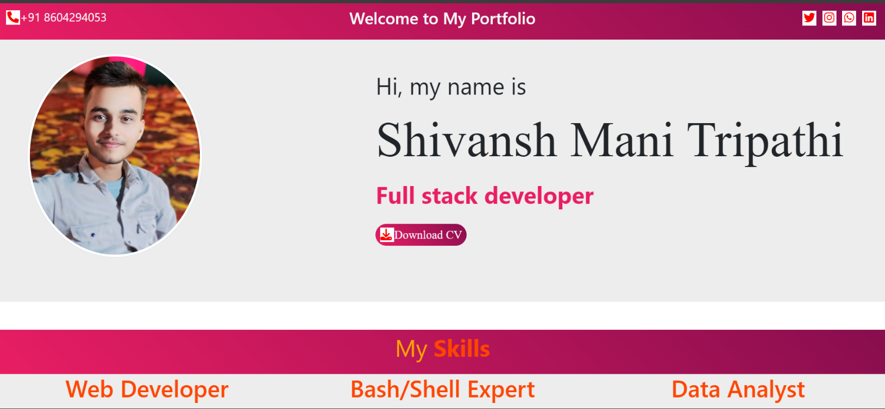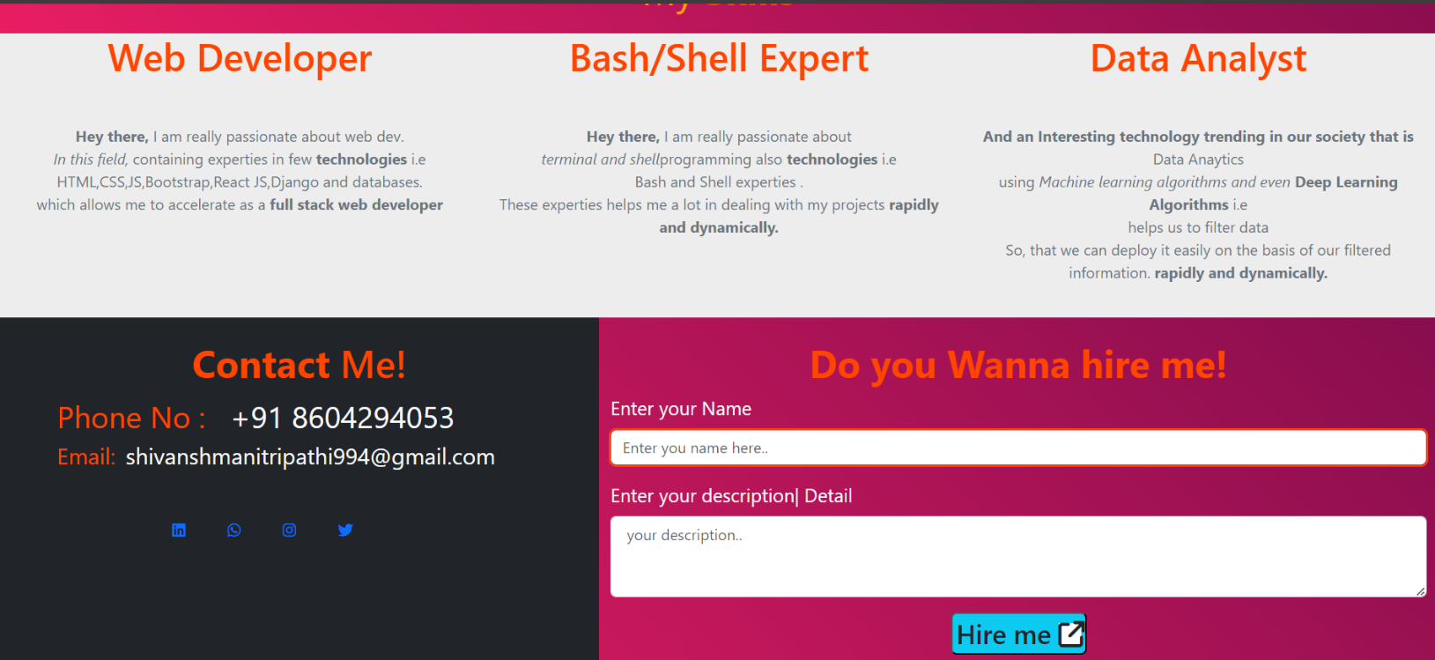

# FUTURE SCOPE

*Following modification or upgrades can be done in system.*

1. More than one company can be integrated through this software.
2. Web services can be used to know exact donation status of packets.
3. Client can check there donation delivery status online.

# CONCLUSION:

At the last the Conclusion of project is to develop a web-application which the help programmer to get help from the site, so that they can develop their project and application Different Technologies and make a group of programmer. A **Group** is a social unit of any size that shares common values, ideas and code and queries. The portal doesn’t have to be expensive. It supports multiple programmer goals.

**Dine Devine** is not only a web portal; it is a live product of board of technical education. In future we will add more and more features on it.